_os.a1

# _preface

This will be our group document for both documentation and checklists.

[Canva Link](https://www.canva.com/design/DAGWGBAFG6U/JFS13aw0cr-Ppd8wG6juIg/edit?utm_content=DAGWGBAFG6U&utm_campaign=designshare&utm_medium=link2&utm_source=sharebutton)

| Roles | |
| --- | --- |
| Jesalva Kriston Jomari Ballesteros, 231165R | Leader |
| Sim Jia Xiang, 241907M | Contributor |
| Joshy Dhiraj, 240136M | Contributor |
| Wong Jun Lin, 242844E | Contributor |

Some of the tasks are as easy as logging in and toggling a button, so use the following login credentials:

| Master Credentials | |
| --- | --- |
| Microsoft Account Email | osa_assignment_vm_acc@outlook.com |
| Microsoft Account Password | drab@s-4meP7A0u6oPh1 |
| Password for Windows | Th1s1sMYp@ssw0rd$ |

# _tasks

Split by their themes:

1. System security and account management
2. Network stuff and access control
3. Device protection and malware stuff
4. Protection & backups

| Allocations | |
| --- | --- |
| System security and account management | Jia Xiang |
| Network stuff and access control | Dhiraj |
| Device protection and malware stuff | Jun Lin |
| Protection & backups | Kriston |

## _System security and account management (Jia Xiang)

Tasks:

* ~~(1) Verify that All Disk Partitions are Formatted with NTFS~~
* ~~(2) Ensure Guest Account is Disabled~~
* ~~(3) Disable or Delete Unnecessary Accounts~~
* ~~(4) Use Account Passwords~~
* ~~(5) Set Stronger Password Policies~~
* ~~(6) Set Account Lockout Policy~~
* ~~(16) Secure System from PowerShell Exploits~~

Documentation:

### (1) Verify that All Disk Partitions are Formatted with NTFS

1. Open File Explorer and go into “*This PC*”

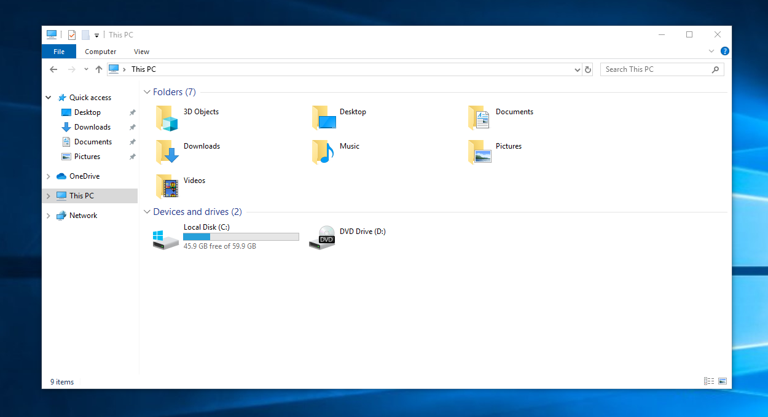

1. Right-click the Disk and click on properties.  
   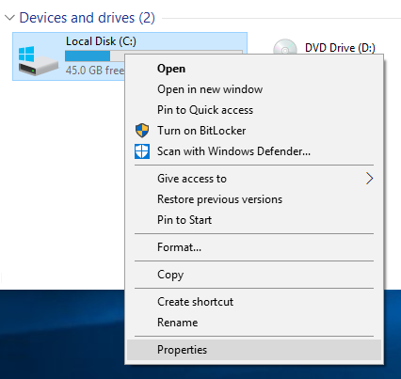
2. Within the general section of properties, locate file system to verify if the disk is formatted with **NTFS  
   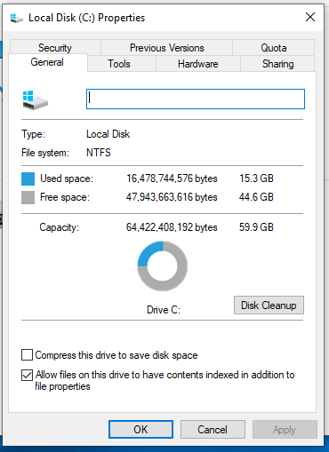**
3. Repeat steps 2 and 3 for all disk partitions in the computer.

### (2) Ensure Guest Account is Disabled

1. In the Windows search bar at the bottom left, type compmgmt.msc to run the Computer Management  
   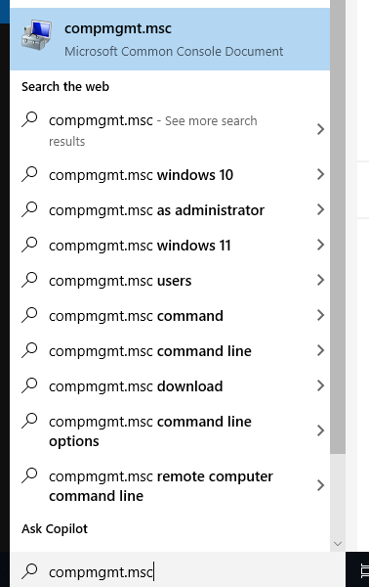
2. In the Computer Management dialog box, navigate to ”Users”.   
   **Path**: System Tools **→** Local Users and Groups **→** Users  
   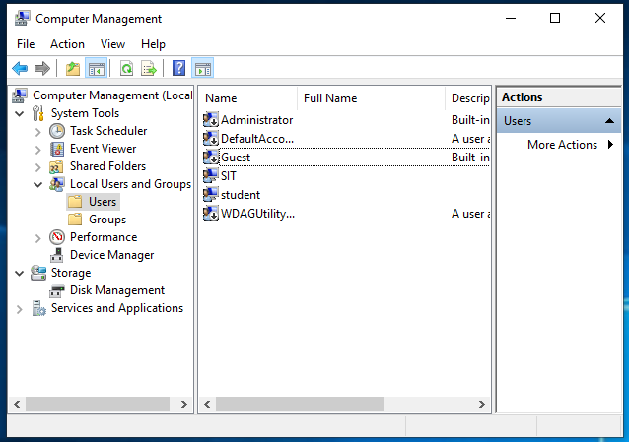
3. Right-click on “Guest” and click on Properties  
   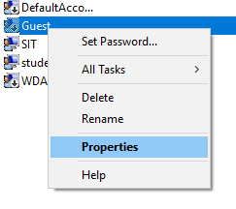
4. Ensure that “Account is disabled” is checked (“Apply” to save changes).

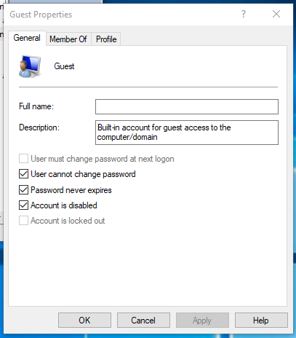

### (3) Disable or Delete Unnecessary Accounts

1. In the Windows search bar at the bottom left, type compmgmt.msc to run the Computer Management  
   
2. In the Computer Management dialog box, navigate to ”Users”.   
   **Path**: System Tools **→** Local Users and Groups **→** Users  
   
3. Right-click on any unnecessary user accounts and click Delete  
   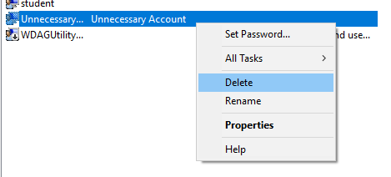
4. Click yes to confirm deletion  
   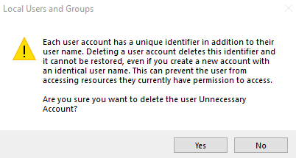

### (4) Use Account Password

1. In the Windows search bar at the bottom left, type compmgmt.msc to run the Computer Management  
   
2. In the Computer Management dialog box, navigate to ”Users”.   
   **Path**: System Tools **→** Local Users and Groups **→** Users  
   
3. Right click on an account that you want to set a password for and click set password:  
   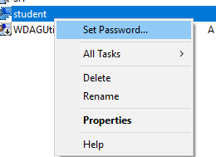
4. Click proceed  
   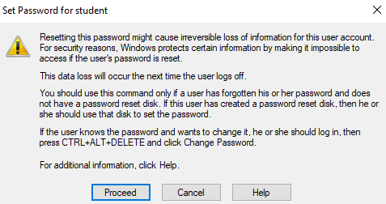
5. Set the password for the user and click ok.  
   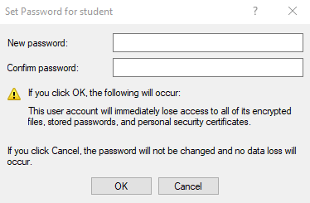

### (5) Set Stronger Password Policies

1. In the Windows search bar at the bottom left, type Local Group Policy Editor to run the Computer Management  
   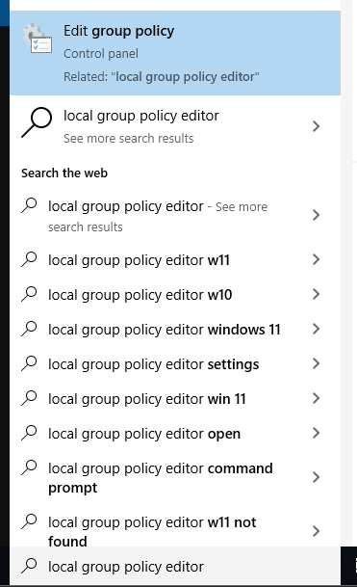
2. In the Local Group Policy Editor, go to *Password Policy*.  
   **Path**: Computer Configuration **→** Windows Settings **→**Security Settings **→** Account Policy **→** Password Policy  
   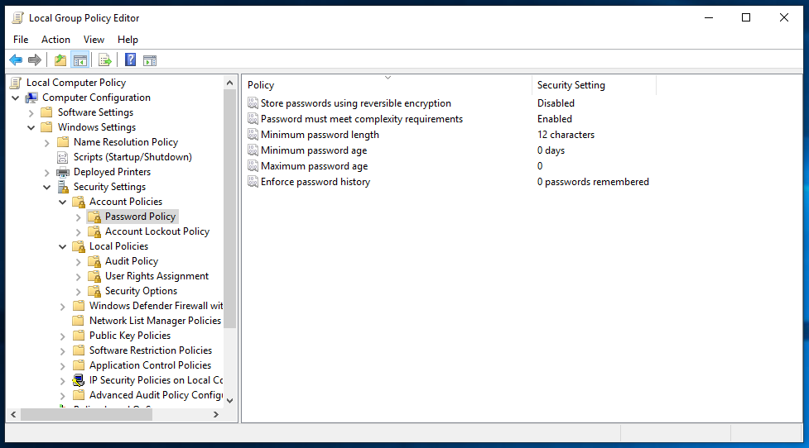
3. Set “*Minimum password length”* to 12
4. Set “*Password must meet complexity requirements”* to enabled
5. Set “Store passwords using reversible encryption” to enabled.

### (6) Set Account Lockout Policy

1. In the Windows search bar at the bottom left, type Local Group Policy Editor to run the Computer Management  
   
2. Inside of Local Group Policy Editor, go to *Account Lockout Policy* **Path**: Computer Configuration **→** Windows Settings **→**Security Settings **→** Account Policy **→** Account Lockout Policy  
   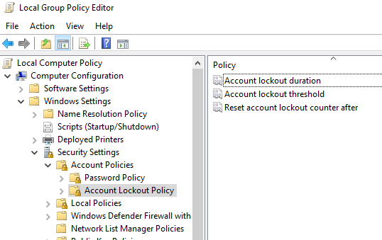
3. Change “Account lockout threshold” from 0 to 5 and click apply.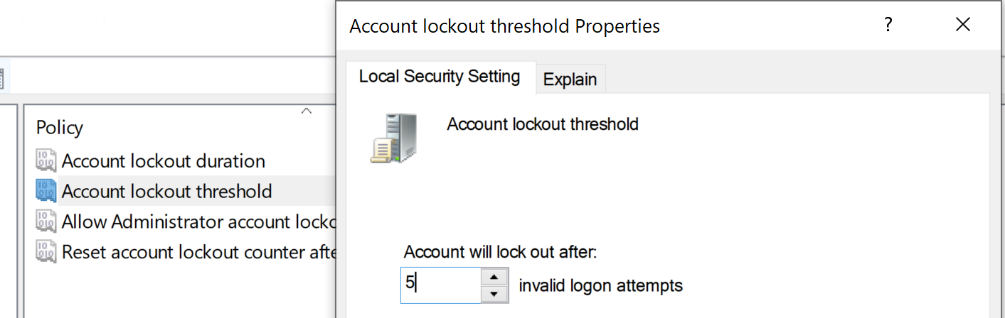
4. Click ok to the prompt that pops up.  
   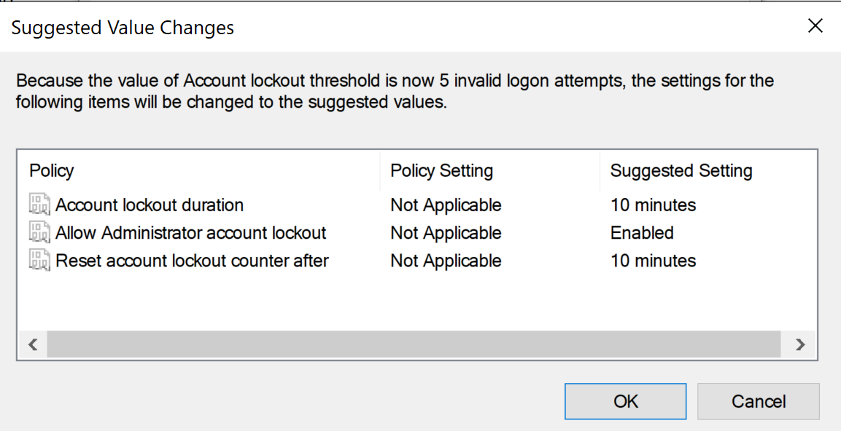

### (16) Secure System from PowerShell Exploits

1. In the Windows search bar at the bottom left, type Local Group Policy Editor to run the Computer Management  
   
2. Inside of Local Group Policy Editor, go to *Account Lockout Policy* **Path**: Computer Configuration **→** Administrative Templates **→** Windows Components **→** Windows PowerShell  
   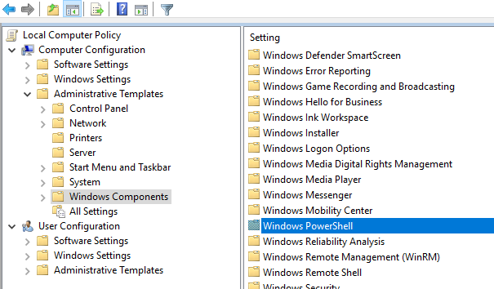
3. All settings inside should be “Not configured”  
   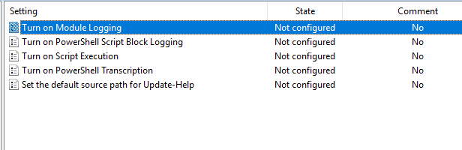
4. Set “Turn on Module Logging” to Enabled  
   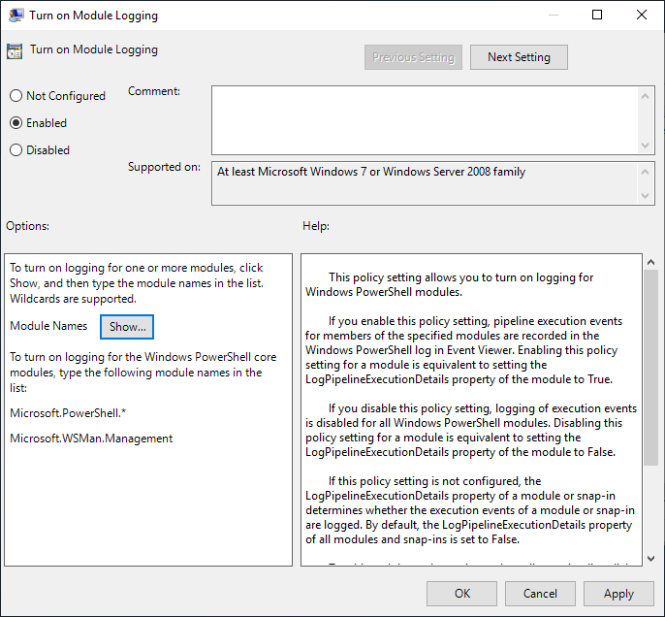
5. Click on show and enter “*” inside of the value column  
   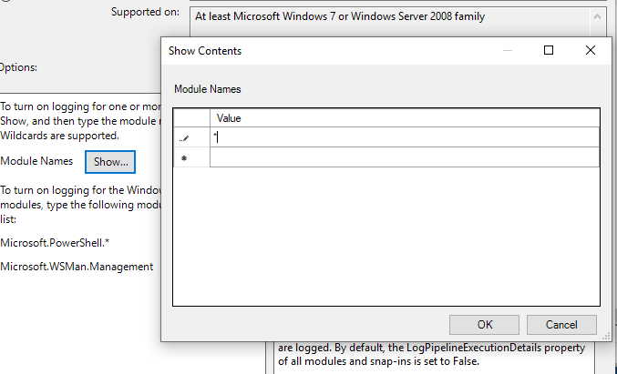
6. Click Ok then click Apply  
   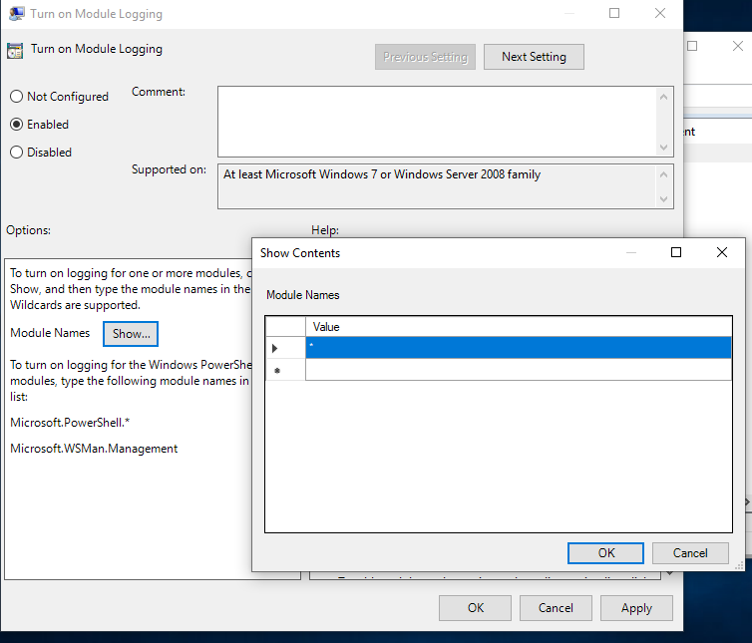
7. Set “Turn on PowerShell Script Block Logging” to Enabled  
   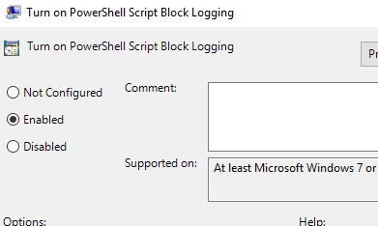
8. Check “Log script Block invocation start / stop events:”  
   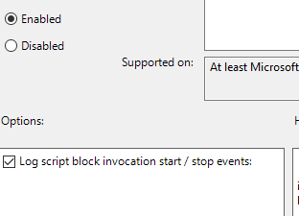
9. Click Apply  
   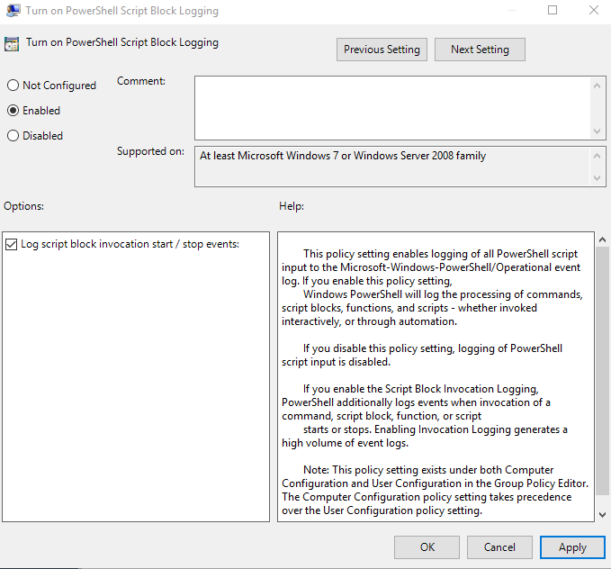
10. Set “Turn on Script Execution” to Enabled  
    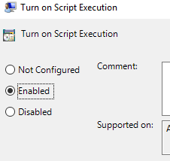
11. Set Execution Policy to only “Allow local scripts and remote signed scripts”  
    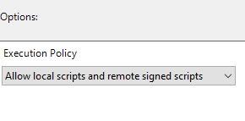
12. Click Apply  
    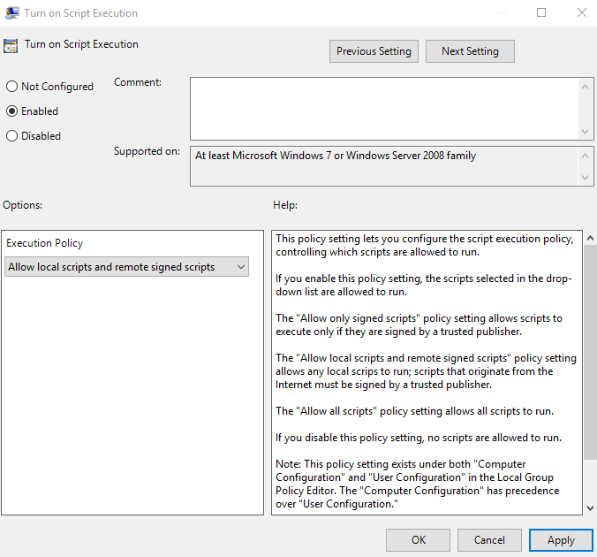
13. Set “Turn on PowerShell Transcription” to Enabled  
    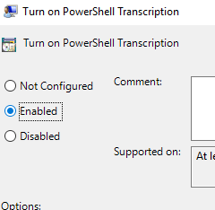
14. Click Apply  
    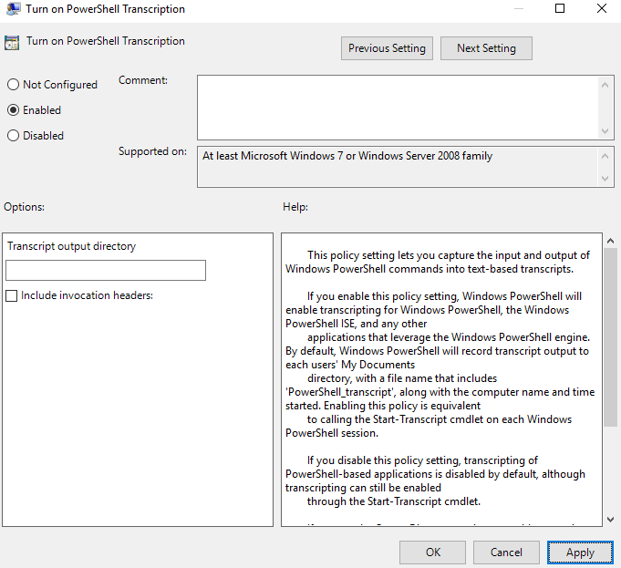

## _Network stuff and access control (Dhiraj)

Tasks:

* ~~(7) Disable Internet Connection Sharing~~
* ~~(8) Protect file sharing and shared folders~~
* ~~(9) Enable Internet Connection Firewall~~
* ~~(10) Use software restriction policies~~
* ~~(15) Disable Remote Access~~
* ~~(11) Disable unnecessary services~~
* ~~(28) Install Host-Based Intrusion Prevention System~~

Documentation:

### (7) Disable Internet Connection Sharing

1. Press Win + R, and type services.msc > press OK.

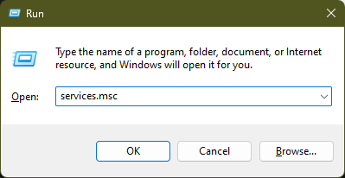

2. Scroll down to find Internet Connection Sharing (ICS), Right-click on ICS and select Properties.

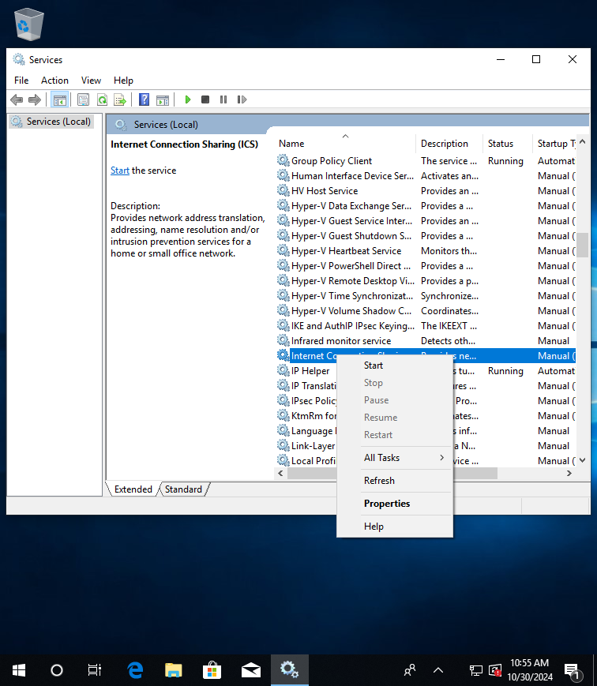

3. Change the Startup Type from ‘Manual’ to ‘Disable’, Click Apply, and OK.

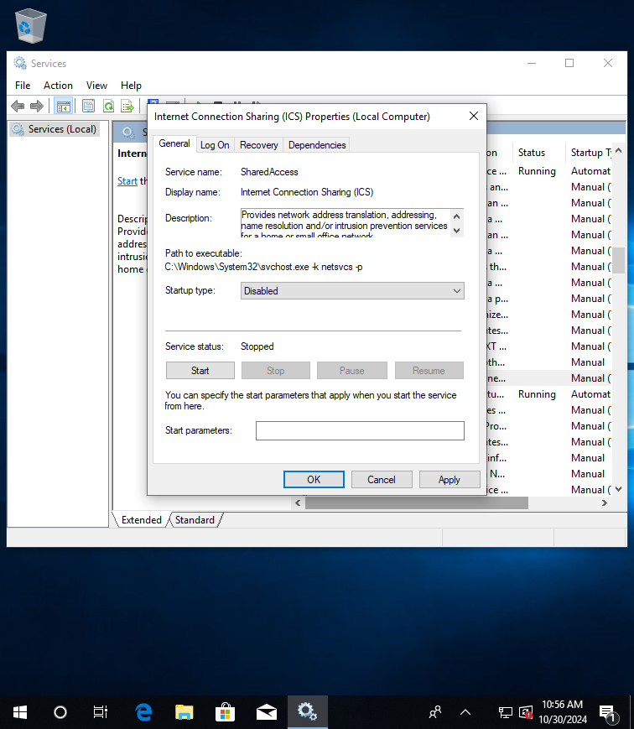

### (8) Protect Files And Shared Folders

1. Open ‘Control Panel’ and click on ‘Network and Internet’.

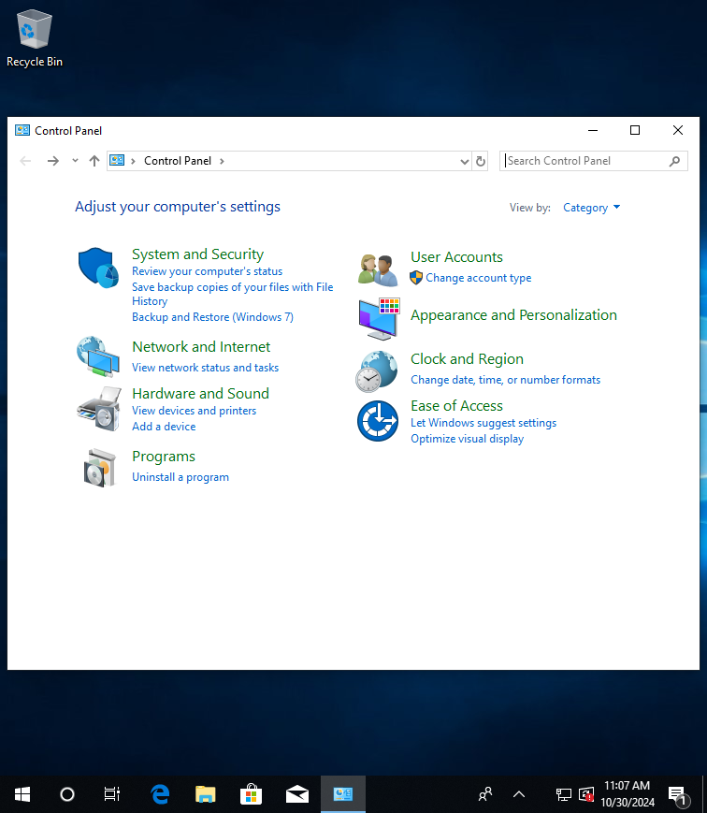

2. Click on ‘Network and Sharing Centre’.

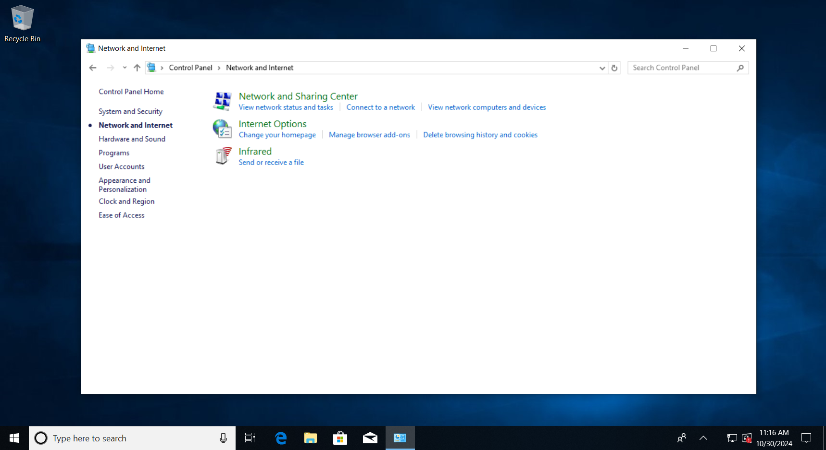

3. Click on ‘Change advanced sharing settings’.

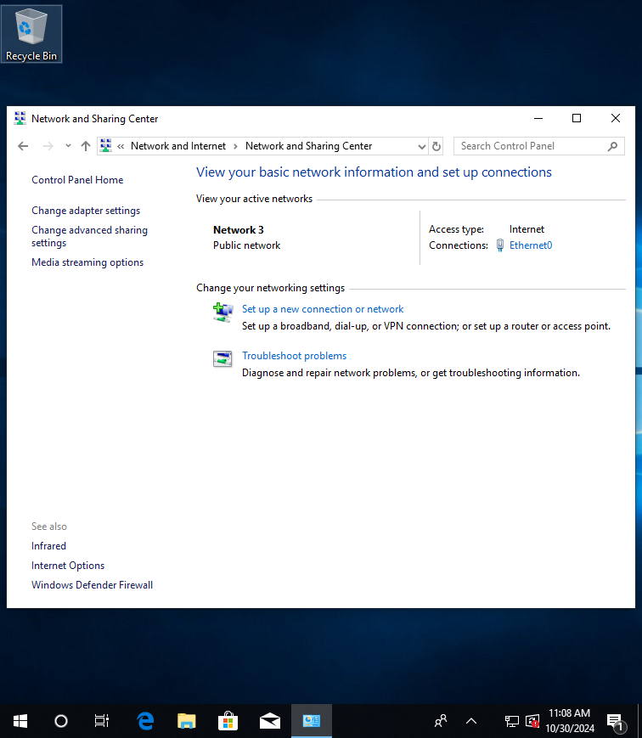

4. Turn off File And Printer sharing for your network profile (private, guest, or public). Click on Save changes.

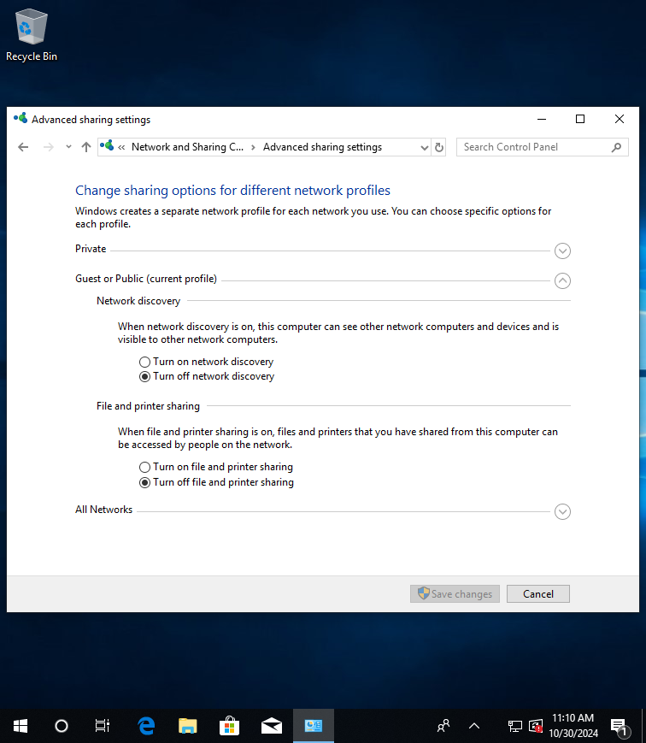

### 

### (9) Enable Internet Connection Firewall

1. Go to Control Panel, click on ‘System and Security’.



1. Click on ‘Windows Defender Firewall’.

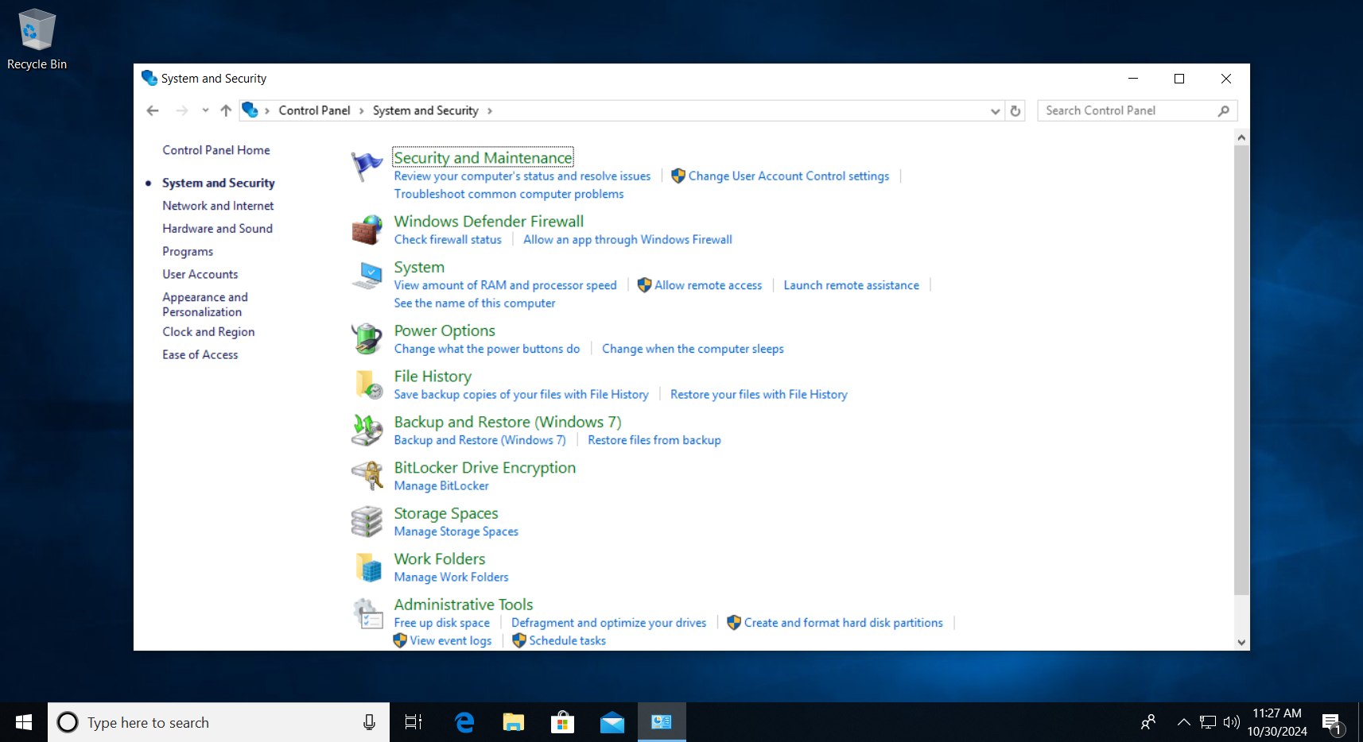

1. Click on ‘Turn Windows Defender Firewall on or off’.

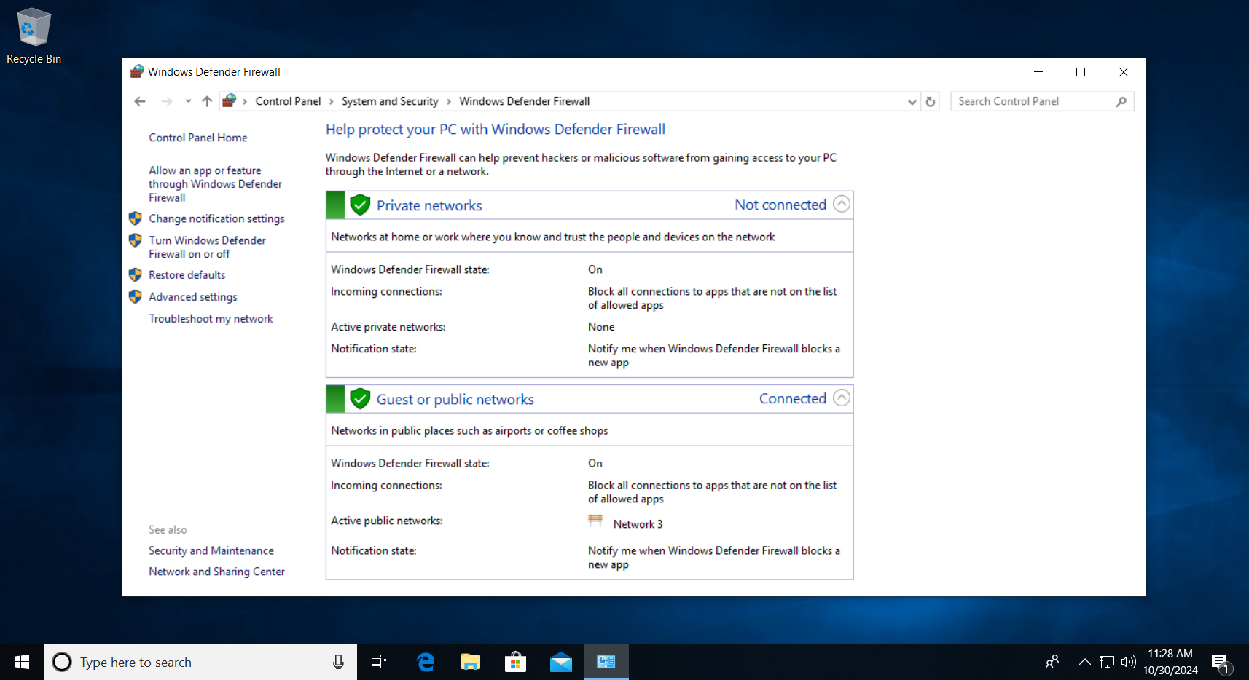

1. Ensure the firewall is enabled for both public and private networks. Click ‘OK’.

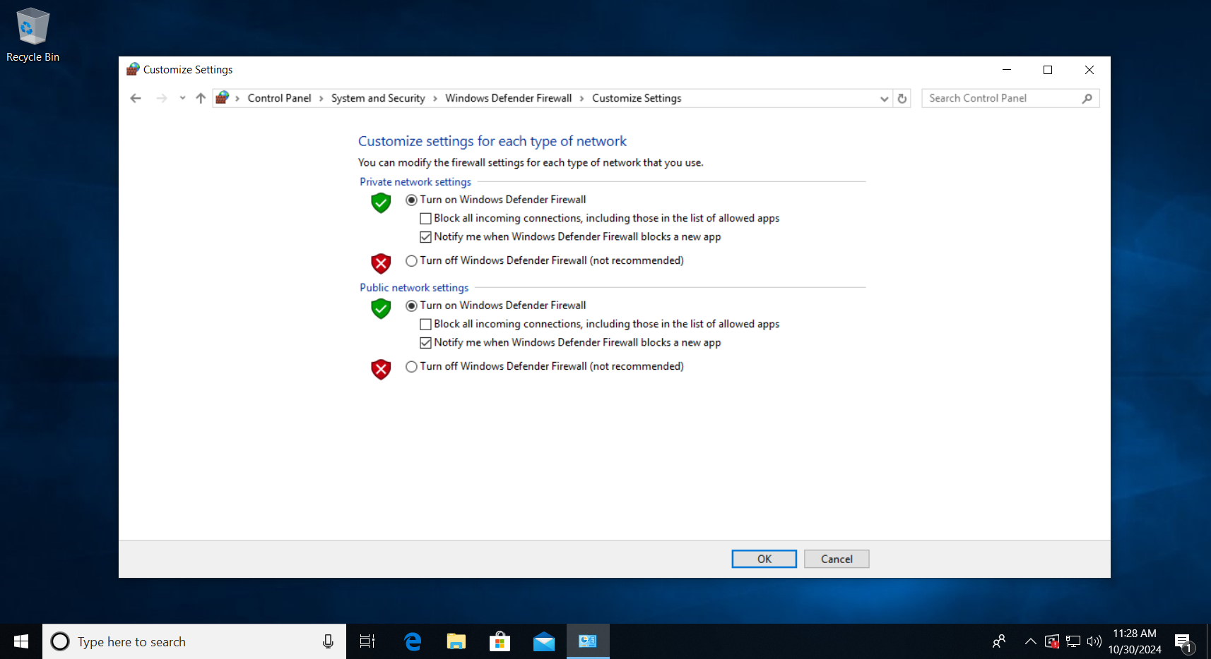

### (10) Use software restriction policies

1. Press Win + R and type, ’gpedit.msc’ to open the Group Policy Editor.

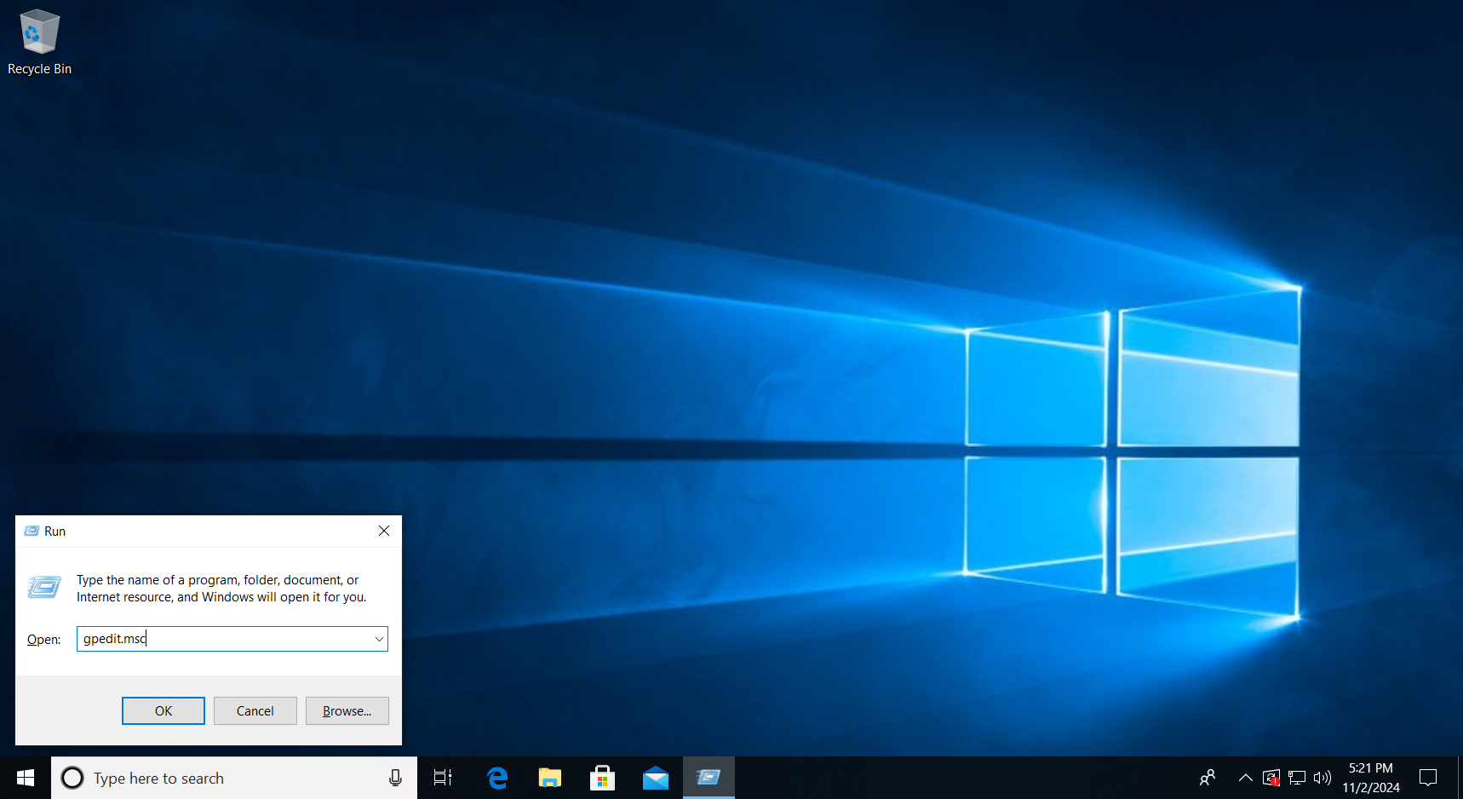

1. Click on Computer Configuration > Windows Settings > Security Settings > Software Restriction Policies > Security Levels

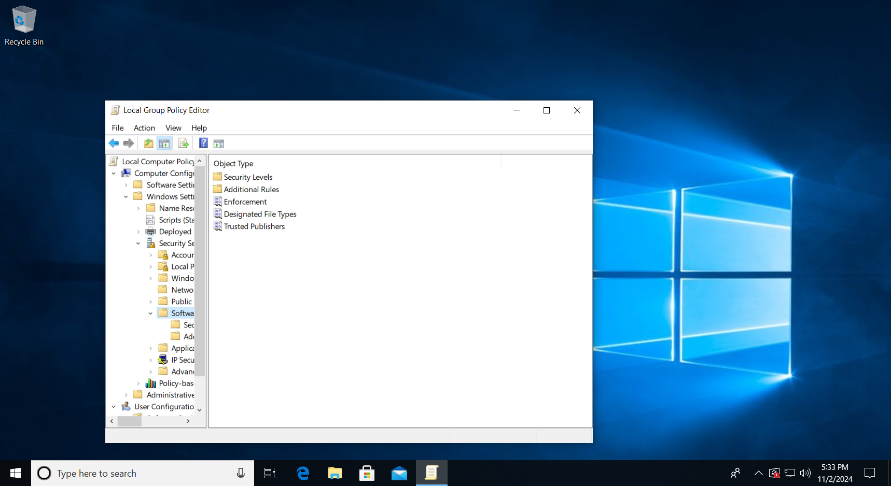

1. Choose one of the following depending on your use case:

* Disallowed: Blocks all applications unless explicitly allowed (recommended for a secure setup).
* Basic User: Allows applications to run but without administrator privileges.
* Unrestricted: Allows all applications to run unless there’s a specific restriction rule.

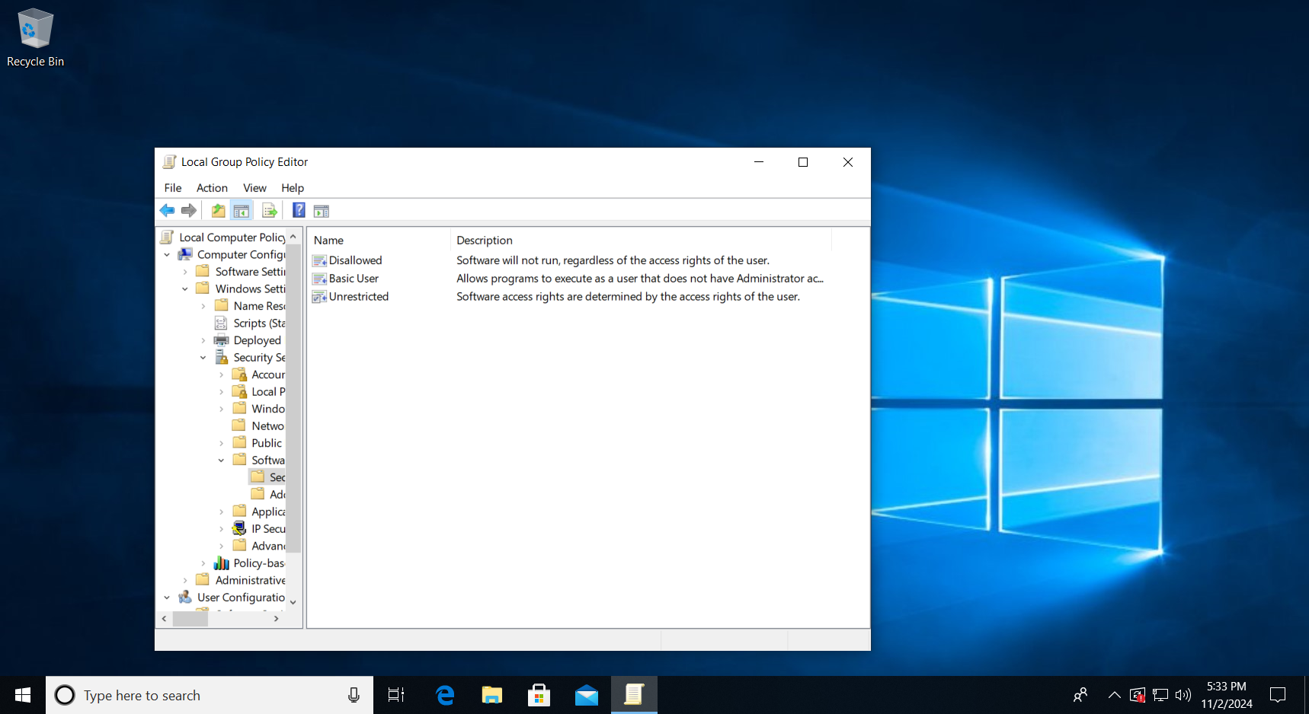

1. Choose your preferred level of security then Apply > OK.

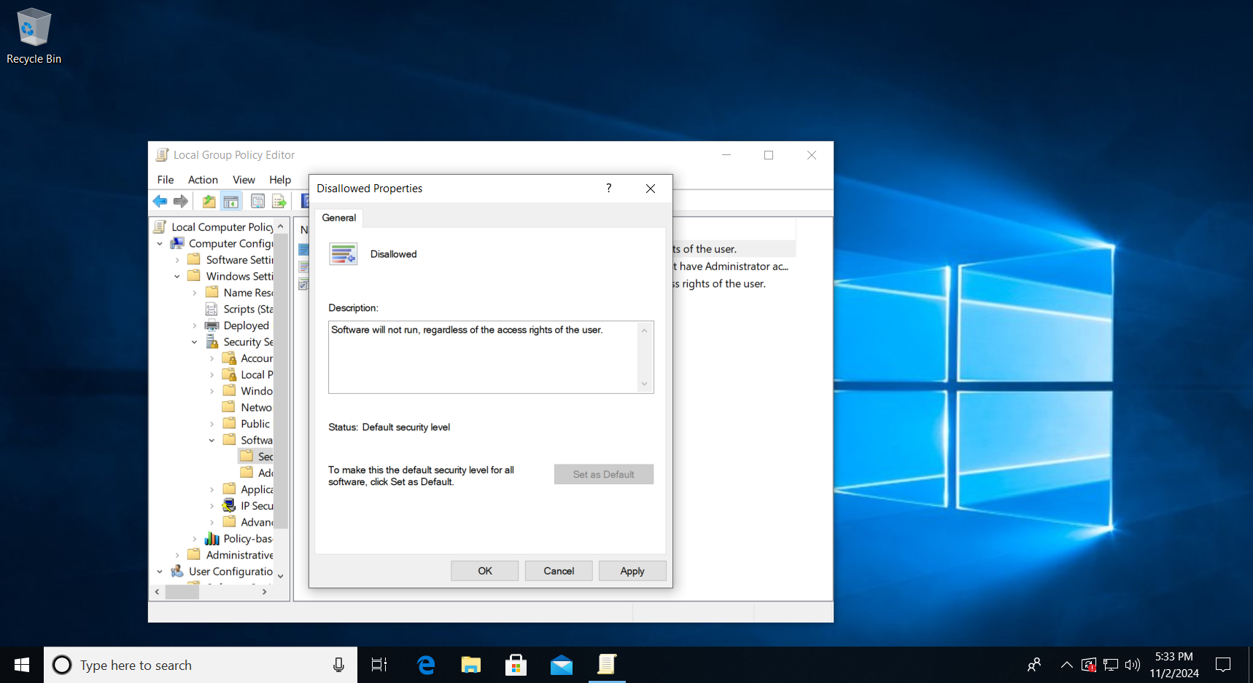

**Additional way to use software policy**

1. Right Click on additional rules and click on New Hash Rules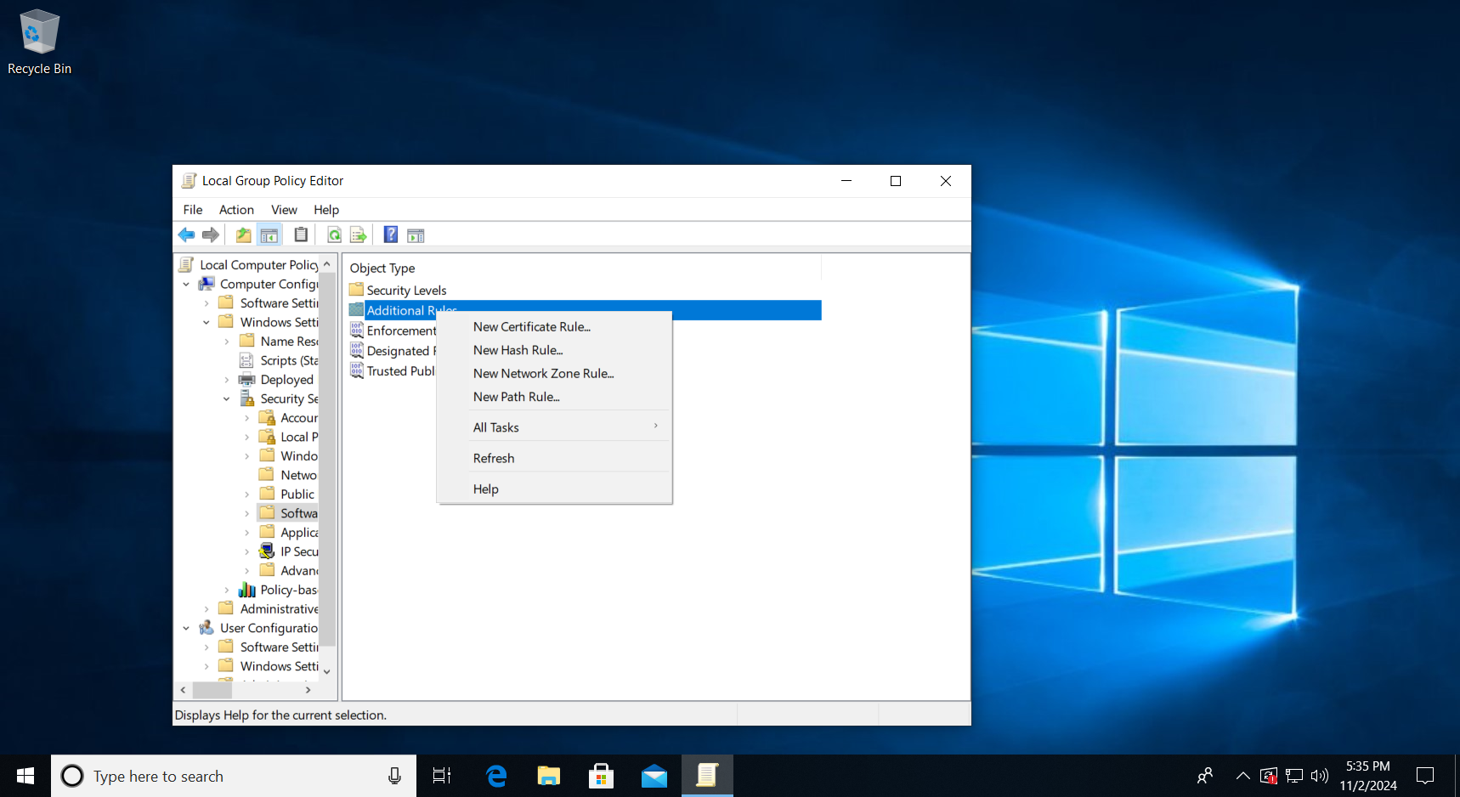
2. Browse for the file to for the hash rule to be executed on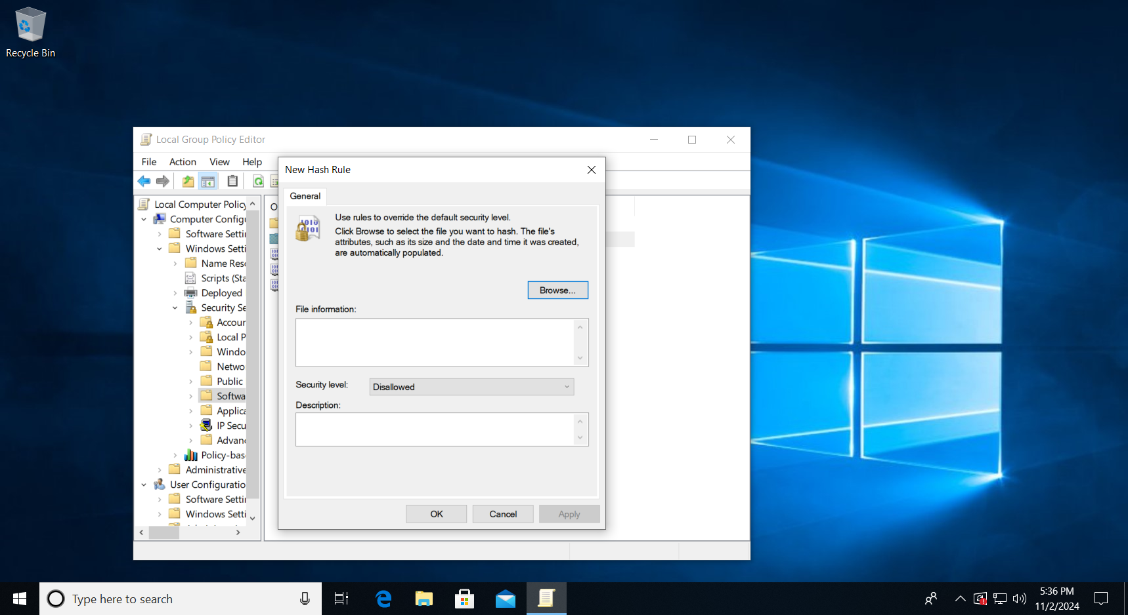
3. After searching for the file, choose your level of security, click apply, and OK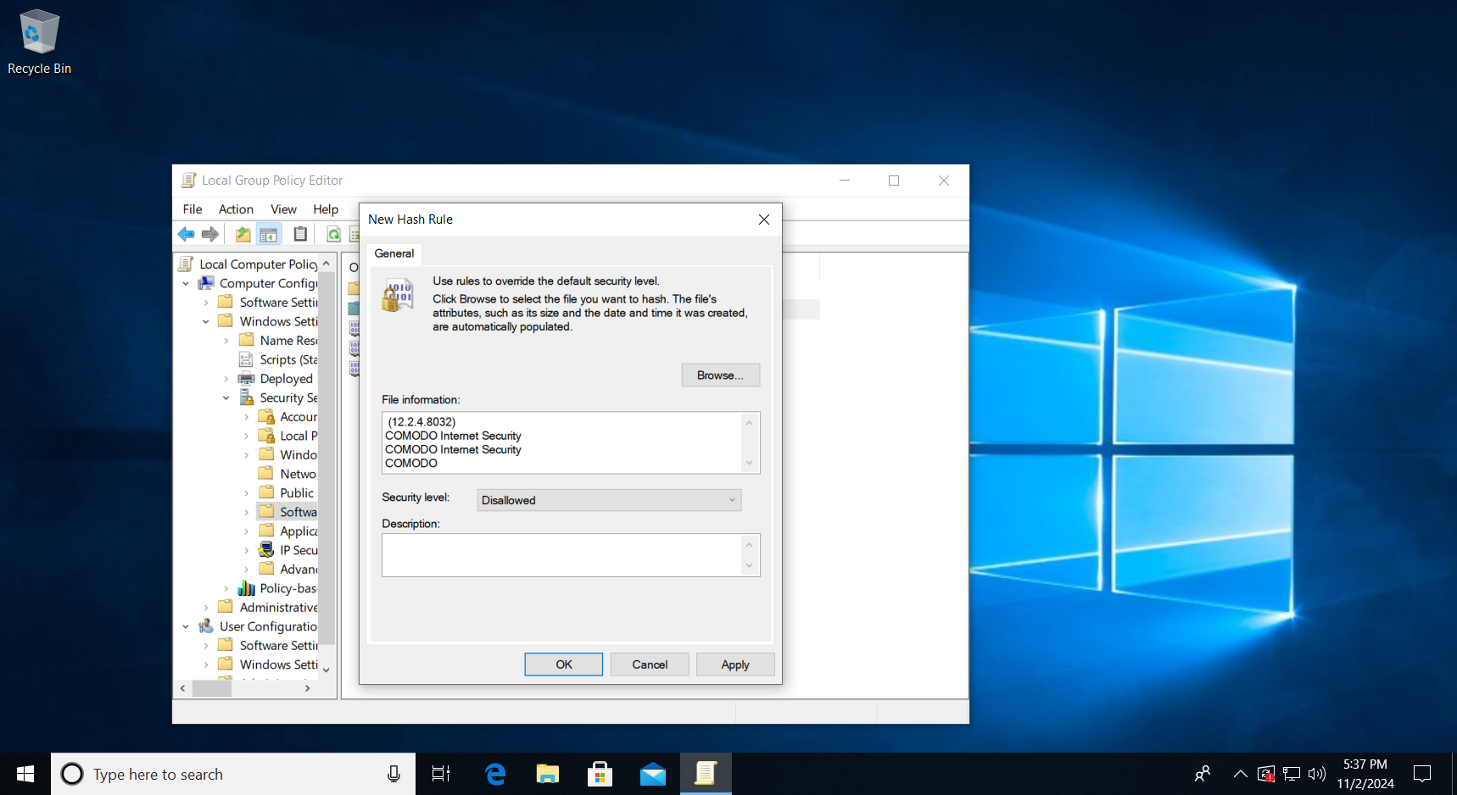

### (11) Disable unnecessary services

1. Press Win + R, and type services.msc > press OK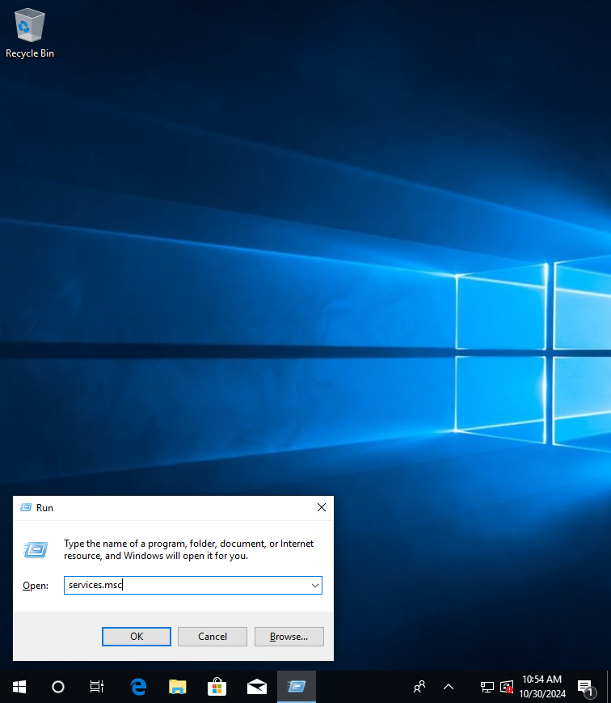
2. Review the list and identify services that aren’t required (like Windows Error Reporting Service, Remote Registry, Telnet, etc.). Right-click on one and select properties.

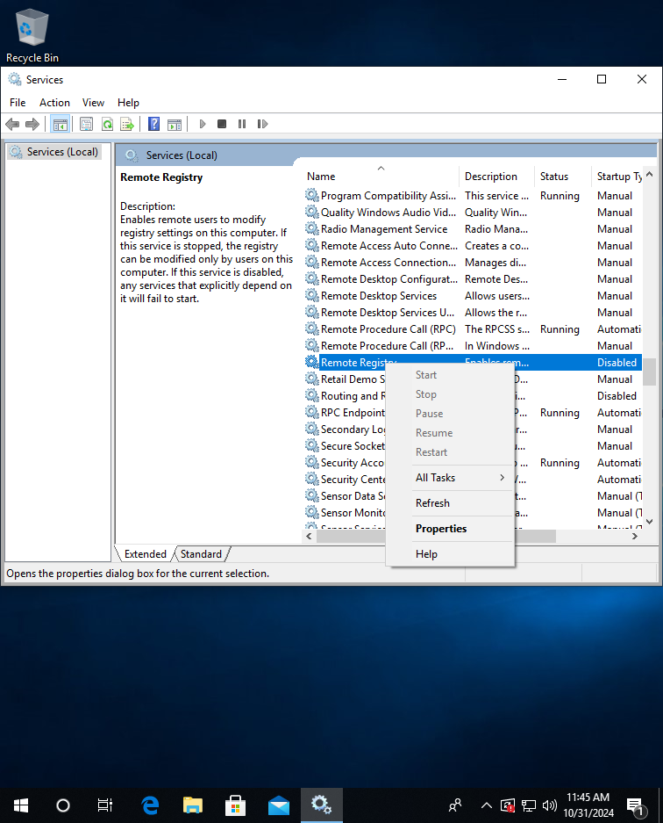

1. Change the startup type from ‘manual’ to disable your unnecessary service. Click apply and ok 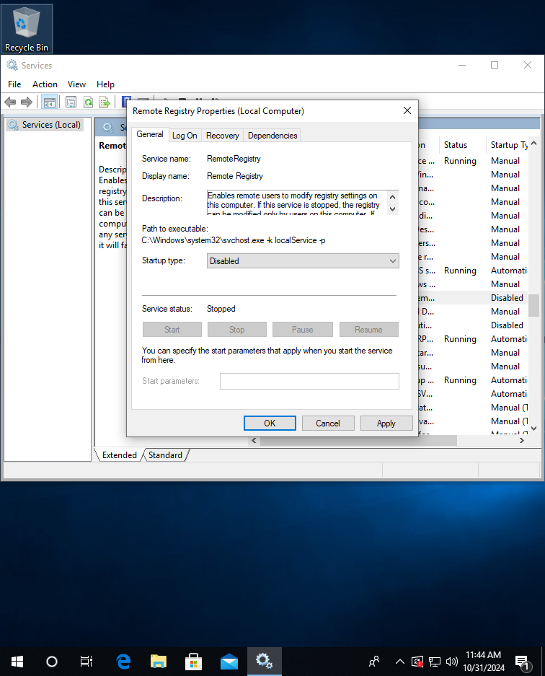
2. You can also disable fax if you do not have a fax machine.

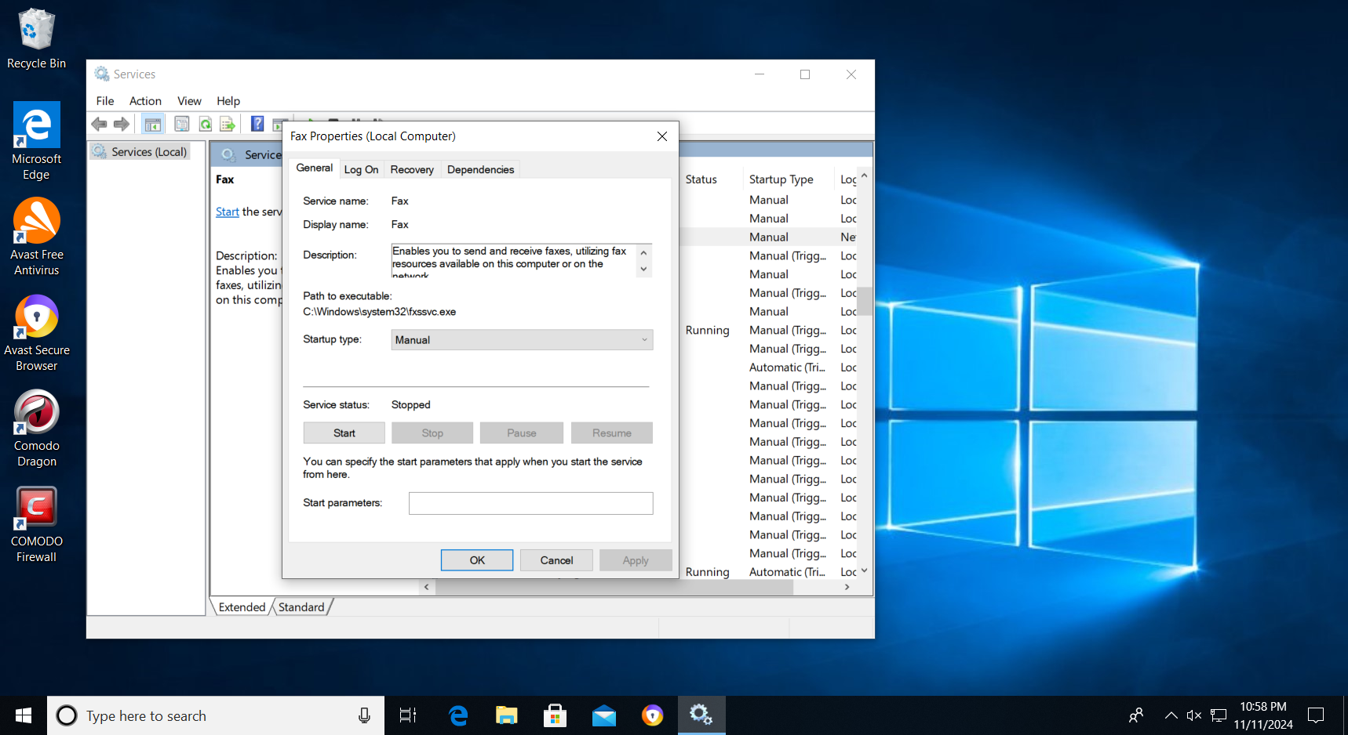

### (15) Disable Remote Access

1. Go to Control Panel, click on ‘System and Security’
2. Click on ‘System’



1. Click on ‘Remote Settings’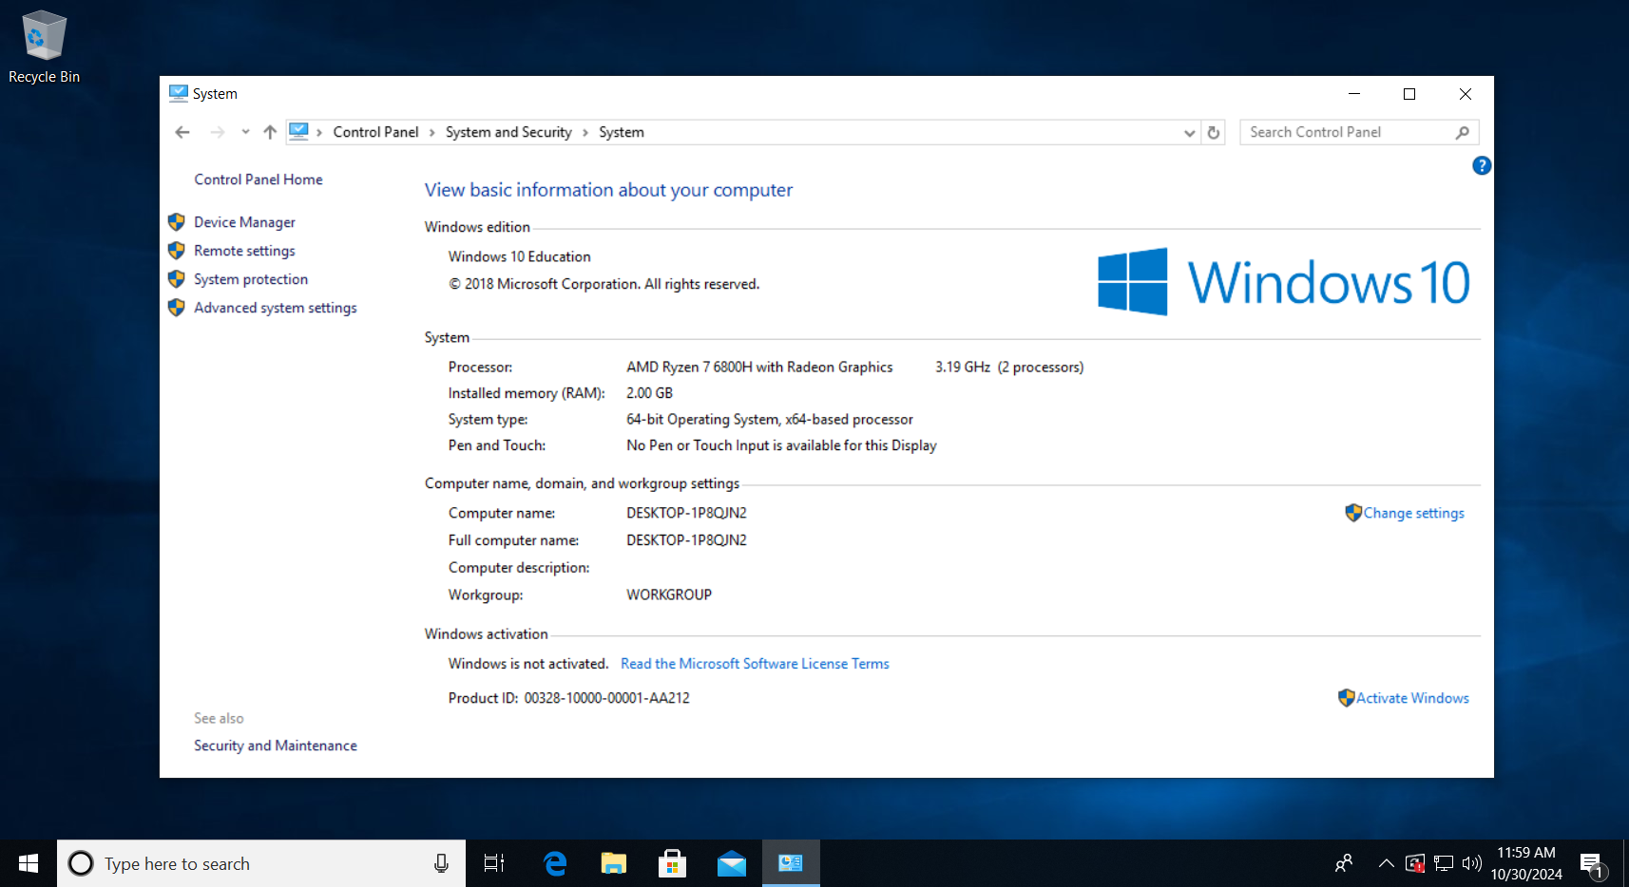
2. Under Remote Desktop, select Don’t allow remote connections to this computer. Apply > OK.

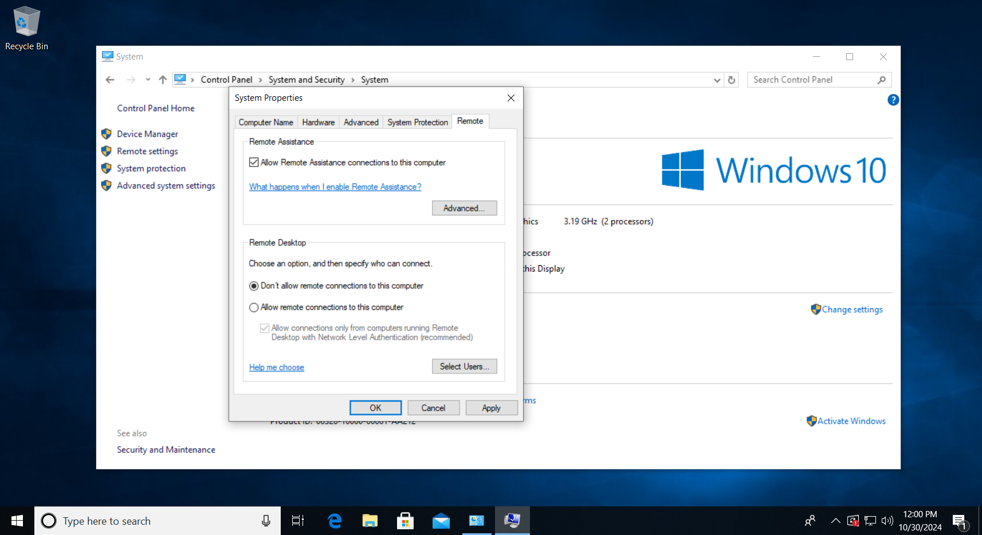

### (28) Install Host-Based Intrusion Prevention System

1. Visit [Comodo Internet Security Download - 12.2.2.8012](https://www.techspot.com/downloads/4758-comodo-internet-security.html)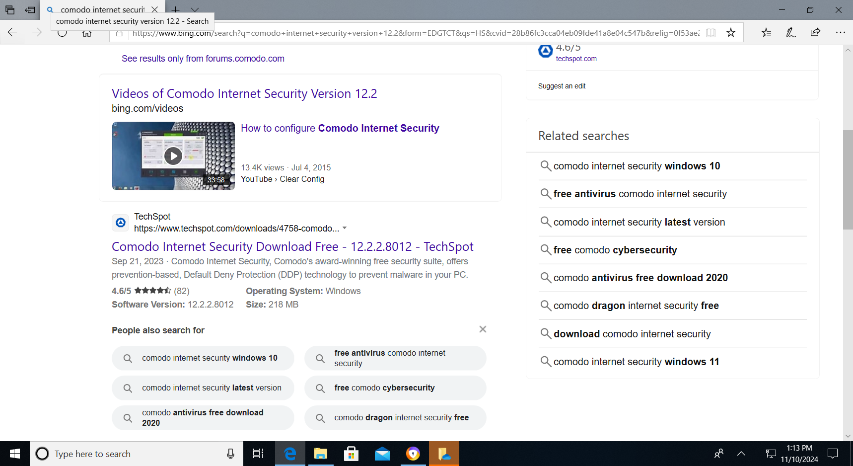
2. Scroll down and click on ‘Download Now’.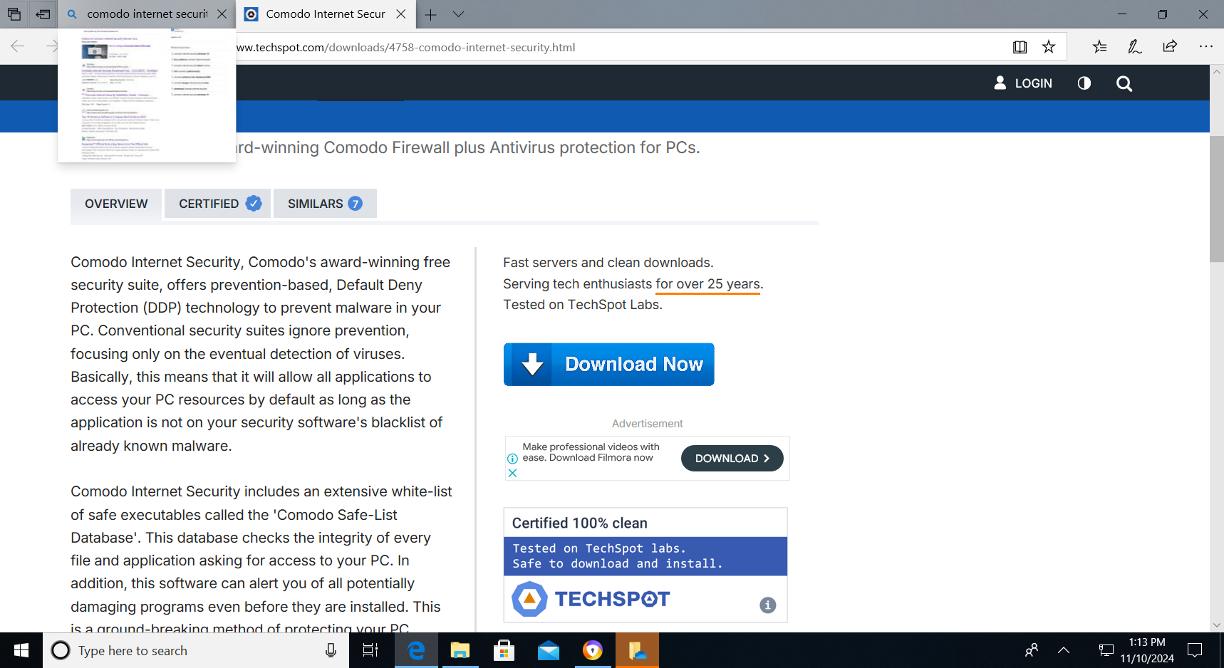
3. When this pop up shows, click Yes.

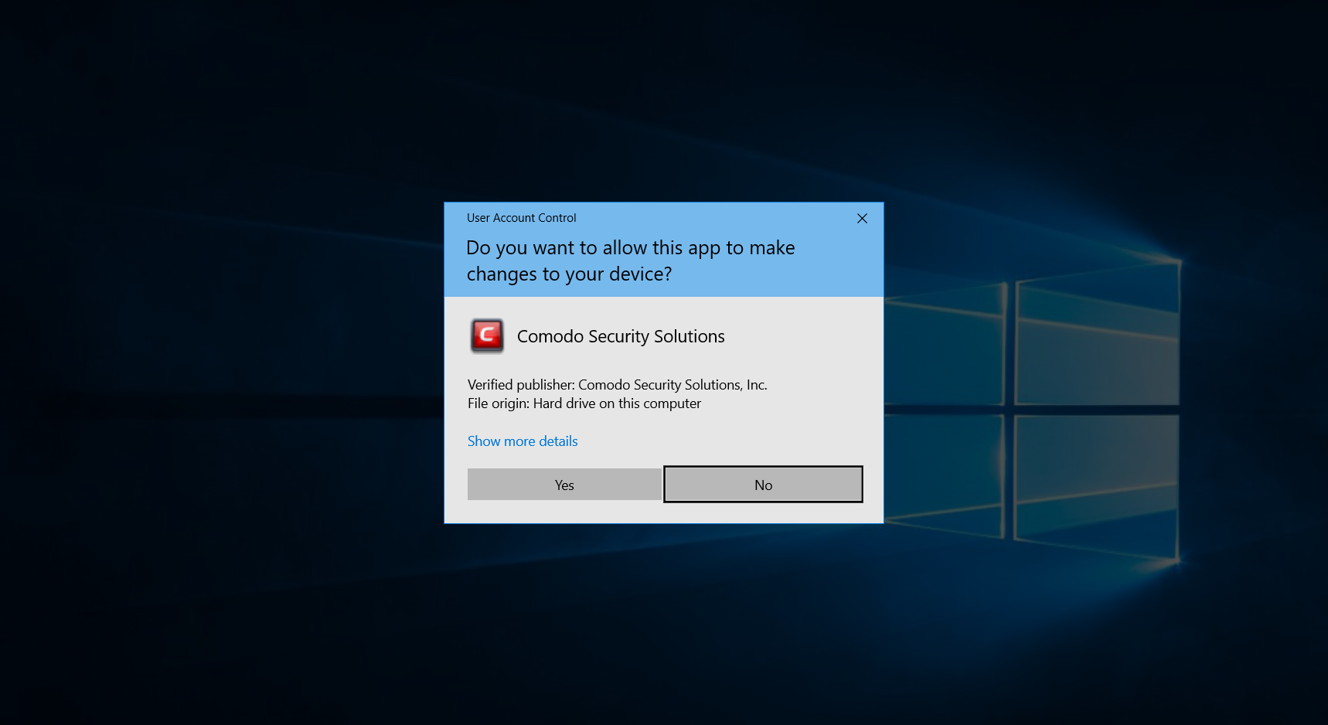

1. Choose your preferred language and click accept and install,after downloading click restart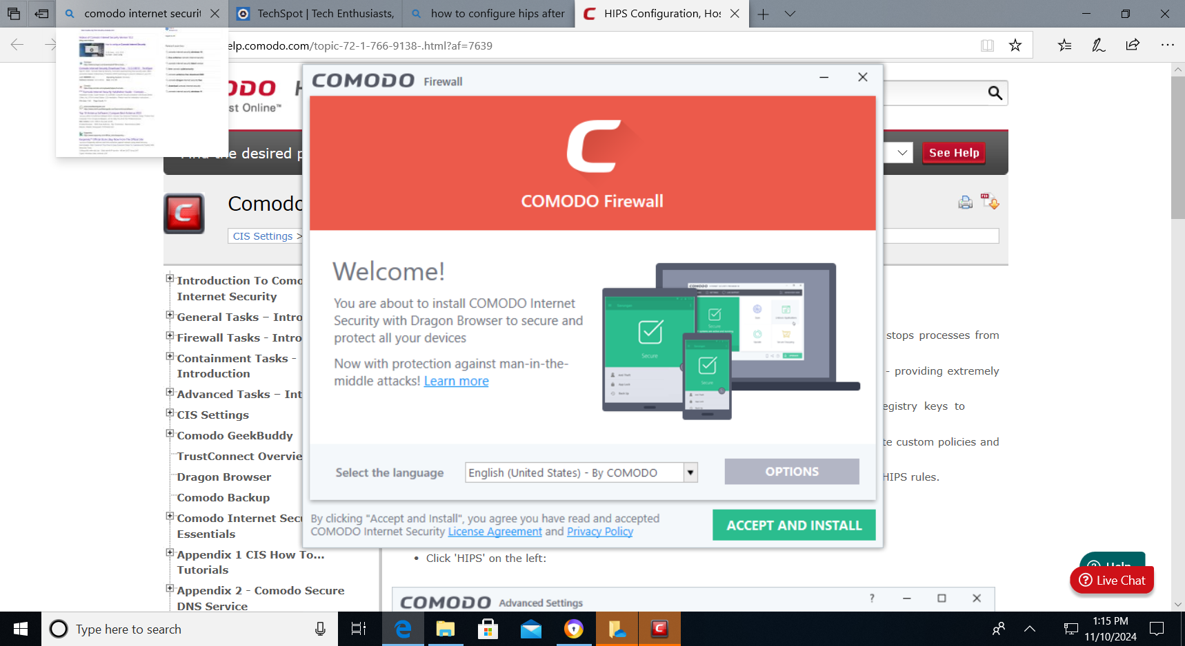
2. After Restarting,Open up the Comodo Firewall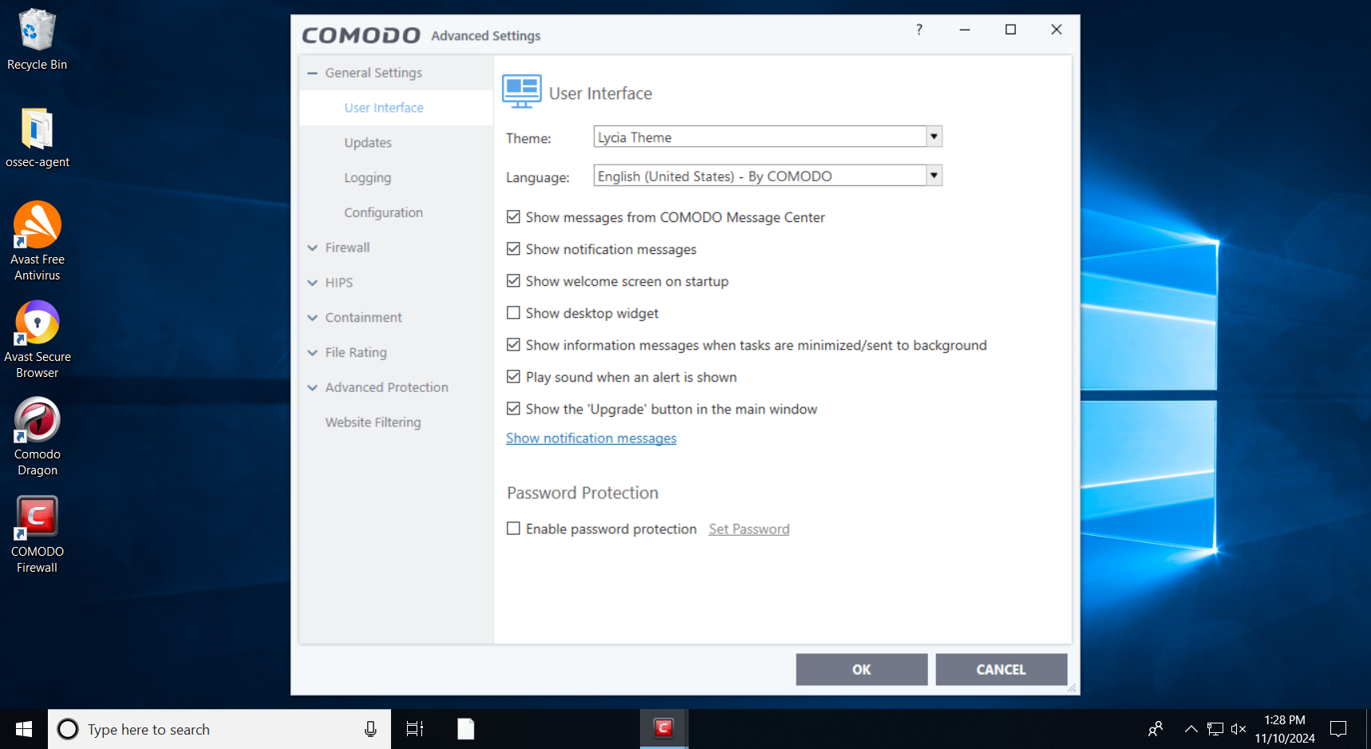
3. Scroll to HIPS settings and click on ‘Enable HIPS’ and click on ‘Safe Mode’.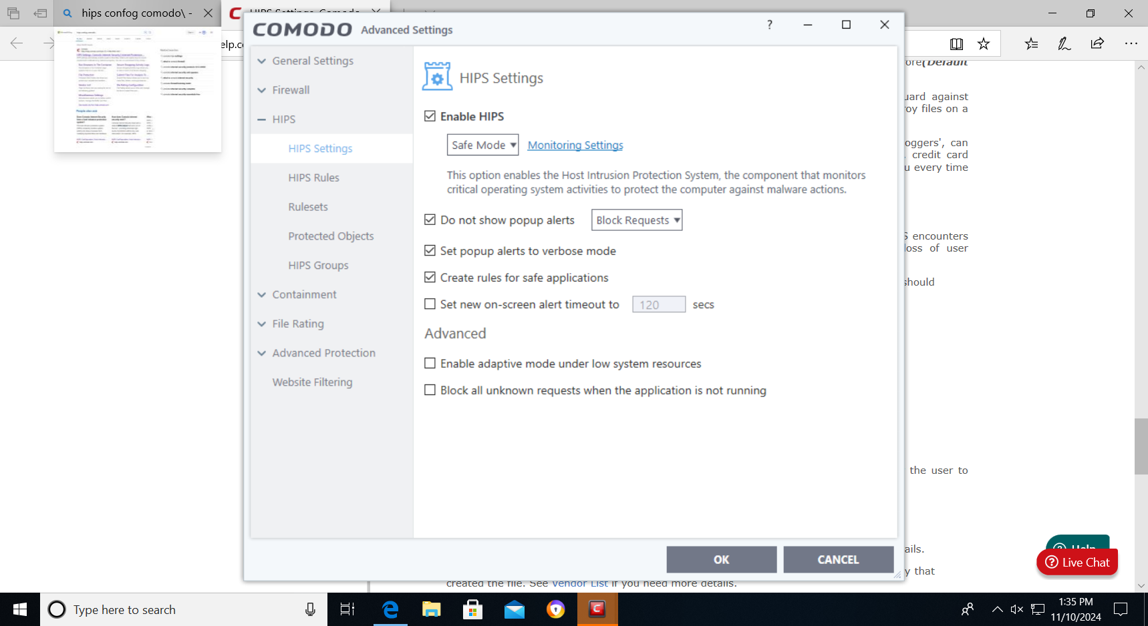
4. Click on Monitoring settings to choose the devices you want it to be monitored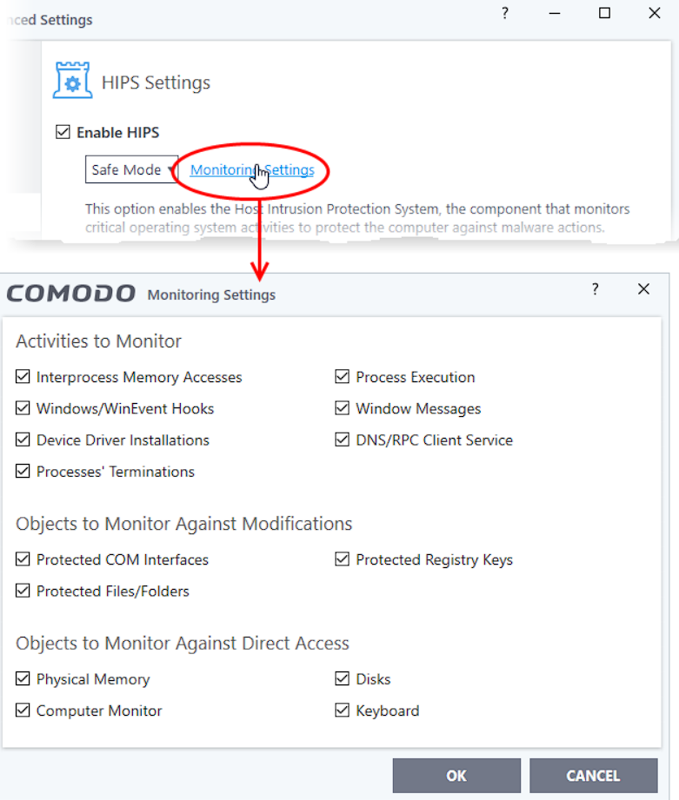
5. Click on the selected boxes,e.g. Block requests from pop-up alerts.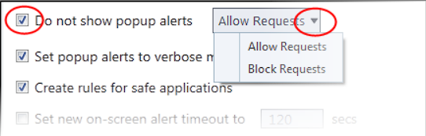

## _Device protection and malware stuff (Jun Lin)

Tasks:

* ~~(12) Disable USB, or Disable Autorun and Boot from USB (preferred)~~
* ~~(13) Install antivirus software and updates~~
* ~~(20) Maximize or Enhance Windows Defender Features~~
  + ~~(a) Antivirus~~
  + ~~(b) Exploit Guard~~
  + ~~(c) Device Guard~~
  + ~~(d) Application Guard (Not completed)~~
  + ~~(e) Credential Guard~~
* ~~(14) Keep up-to-date on the latest security updates~~
* ~~(17) Enable Auto Updates~~
* ~~(21) Enable Microsoft SmartScreen~~

Documentation:

### (12) Disable Disable Autorun and Boot from USB

1. Search for "AutoPlay settings," and press Enter.

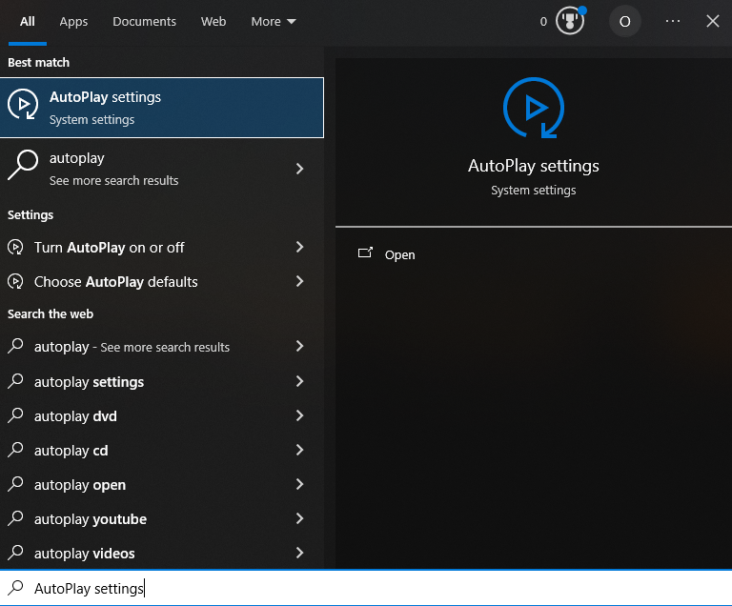

1. Click the toggle switch to turn AutoPlay Off.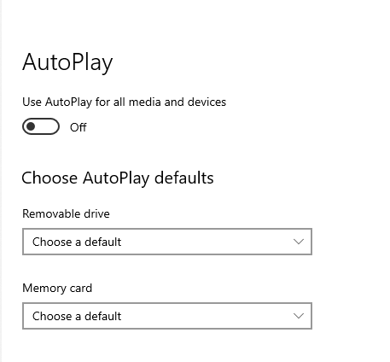
2. Select ‘Take No Action’ in the drop-down menu below ‘Removable drive’ and below ‘Memory card’

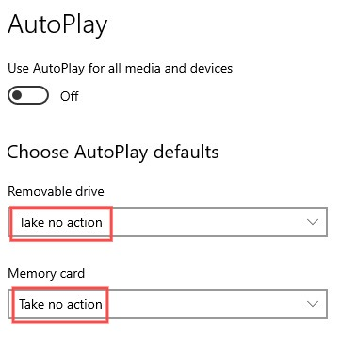

1. Go to BIOS > Boot Tab and move ‘Removable Devices’ to the bottom by pressing the “ - “ key

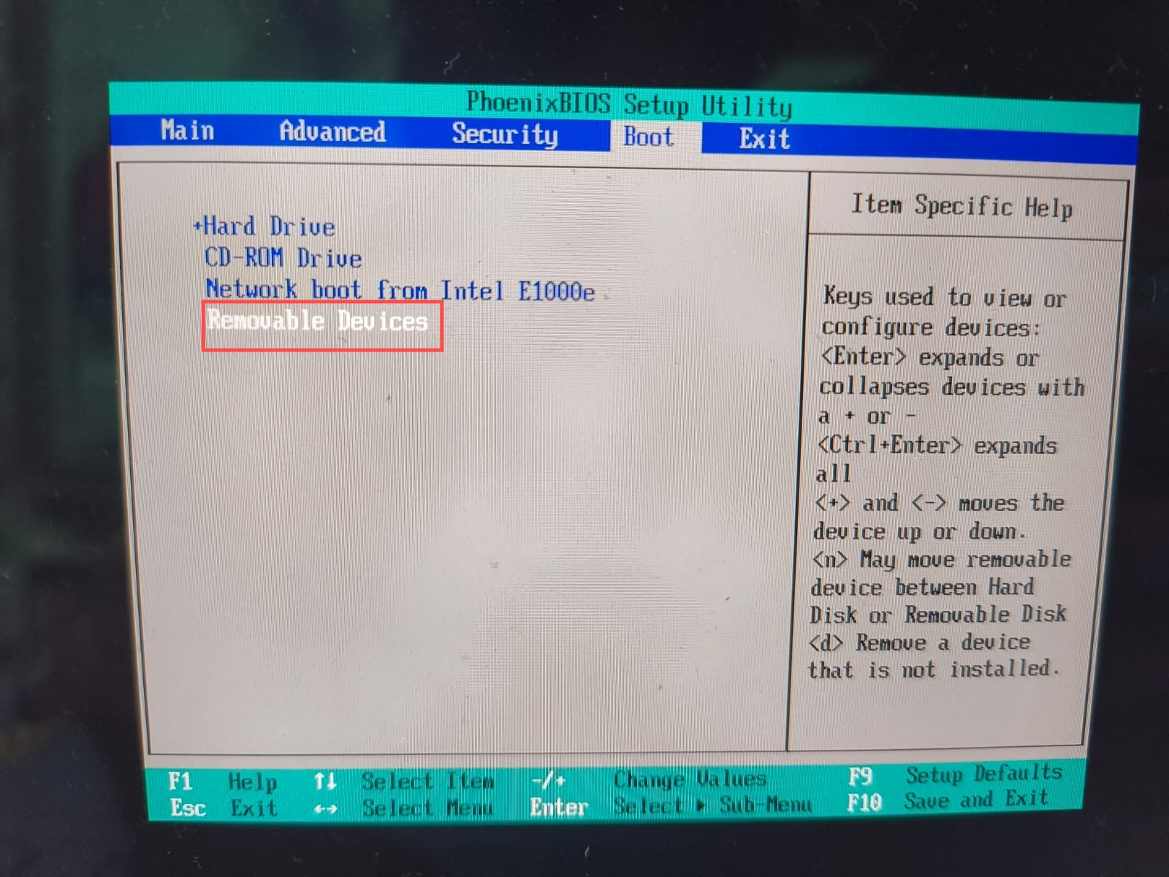

1. Proceed to the Exit tab and Exit Saving Changes  
   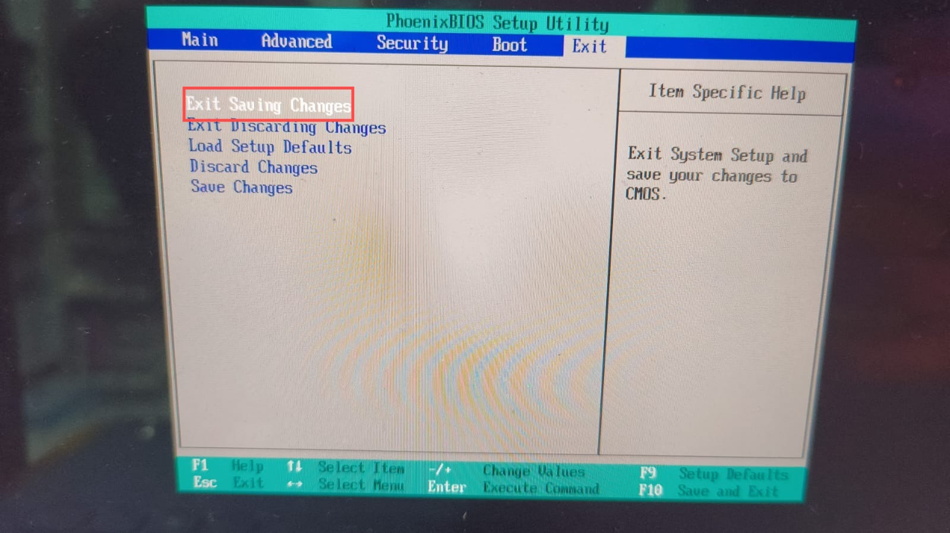

### (13) Install antivirus software and updates

1. Visit the Microsoft Store > search for AVG AntiVirus Free > Install

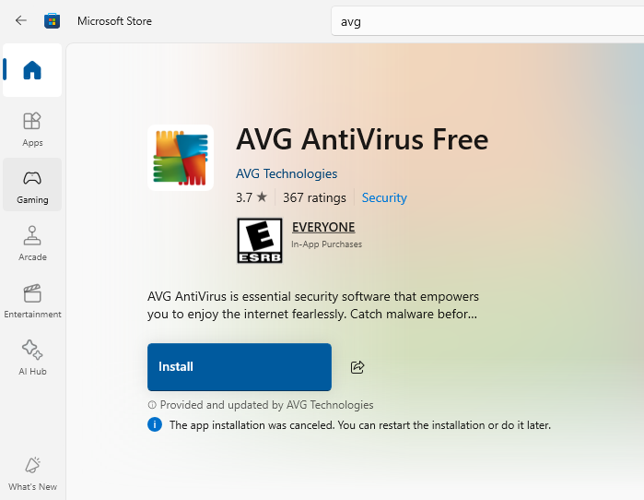

1. Launch AVG > follow through with the initial setup > Run a Smart Scan

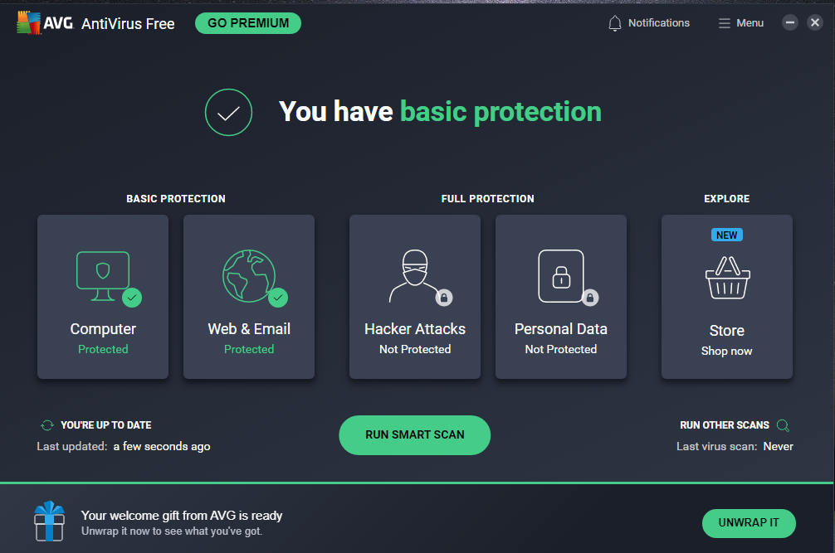

1. If there are issues found with your system > Review them to check if needed.

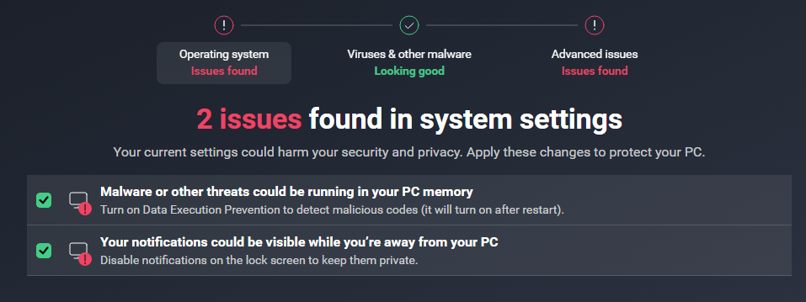

Resolve All to fix the detected issues.



Once okay, you will see the following message:

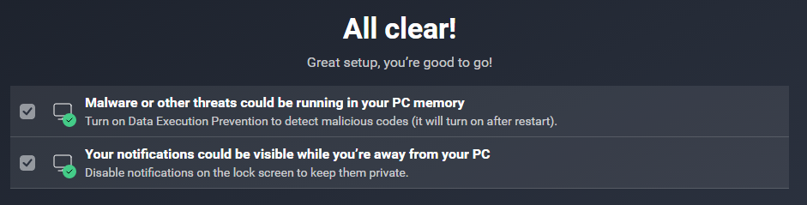

You may wish to enable the following if automation is preferred:

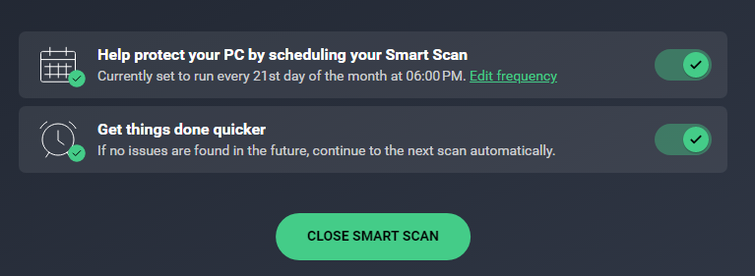

1. AVG Antivirus is now detected under Windows Security. Lastly, turn on Periodic scanning for automation.

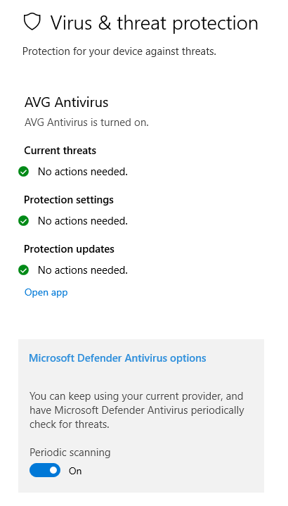

### (20) Maximize or Enhance Windows Defender Features

1. **Antivirus**

1. Launch Windows Security > “Virus & threat protection” > “Manage settings”

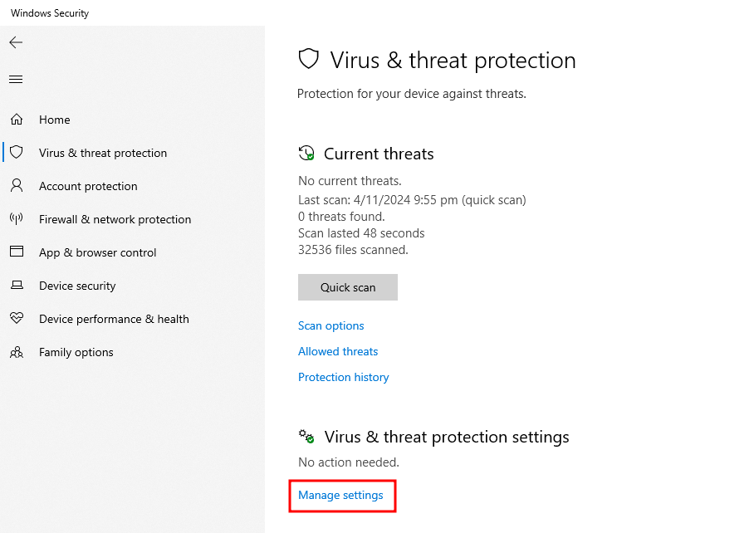

2. Turn on “Cloud-delivered protection”, “Automatic sample submission”, and “Tamper Protection”.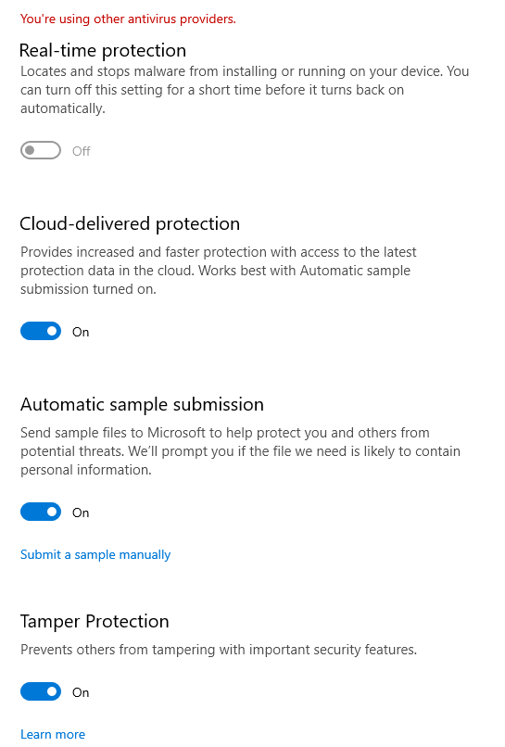

1. **Exploit Guard**
2. Open “Windows Security” > App & browser control > Exploit protection settings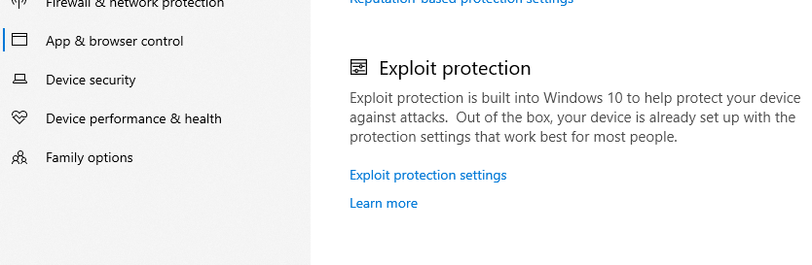

2. Turn on these settings:

* Control Flow Guard (CFG)
* Data Execution Prevention (DEP)
* Randomize memory allocations (ASLR)
* Validate heap integrity

3. Go to Windows Security > Virus and threat protection > Manage ransomware protection

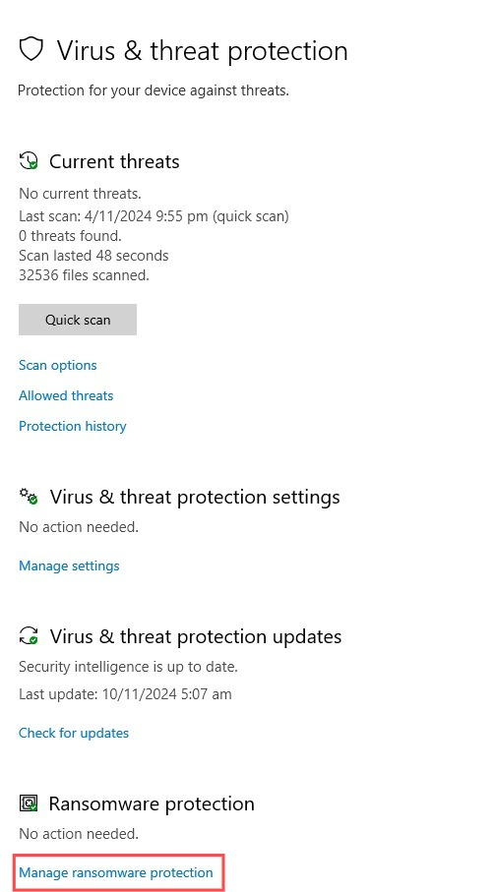

4. Turn on ‘Controlled folder access’

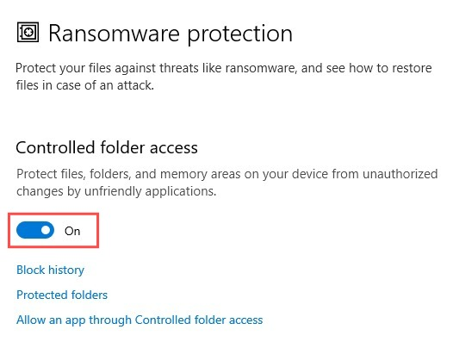

1. **Device Guard**
2. Search ‘Turn Windows features on or off’ and press Enter

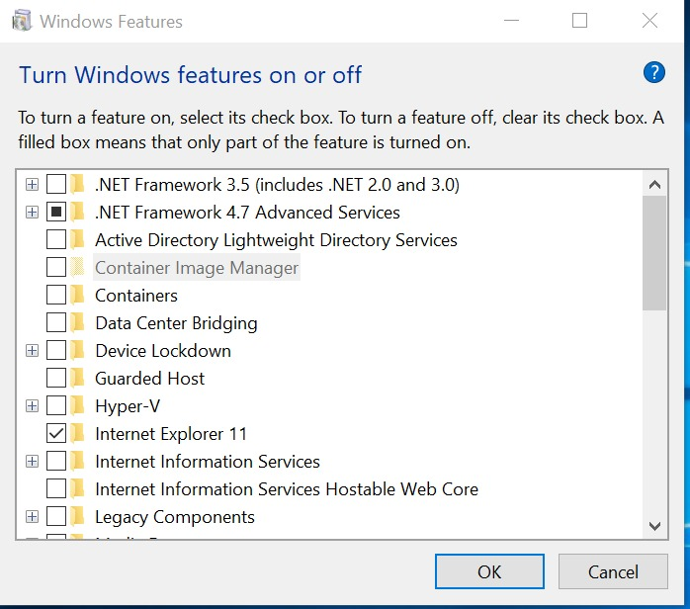

1. Check the checkbox next to Hyper-V and press OK

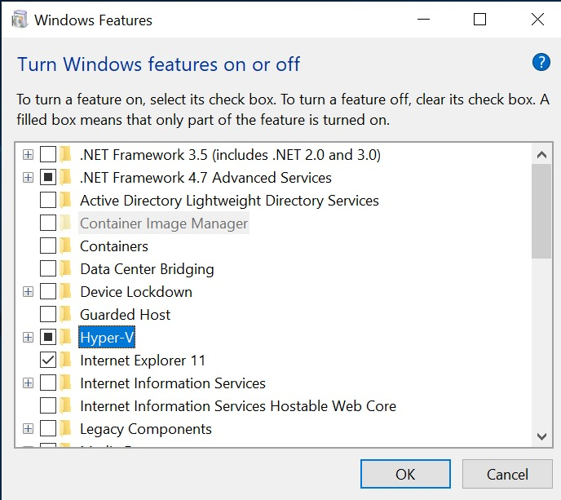

1. **Application Guard**

Not completed.

1. **Credential Guard**
2. Open Group Policy Editor > Computer Configuration > Administrative Templates > System > Device Guard

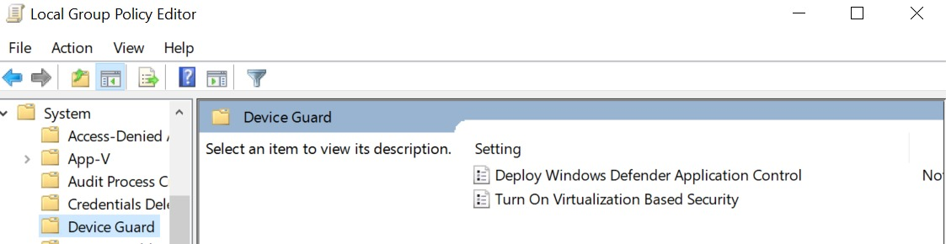

1. Double Click ‘Turn On Virtualization Based Security’ and set it to enabled.

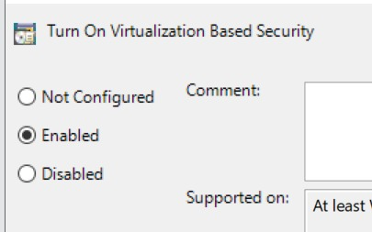

1. Under Virtualization Based Protection of Code Integrity, select Enabled with UEFI lock

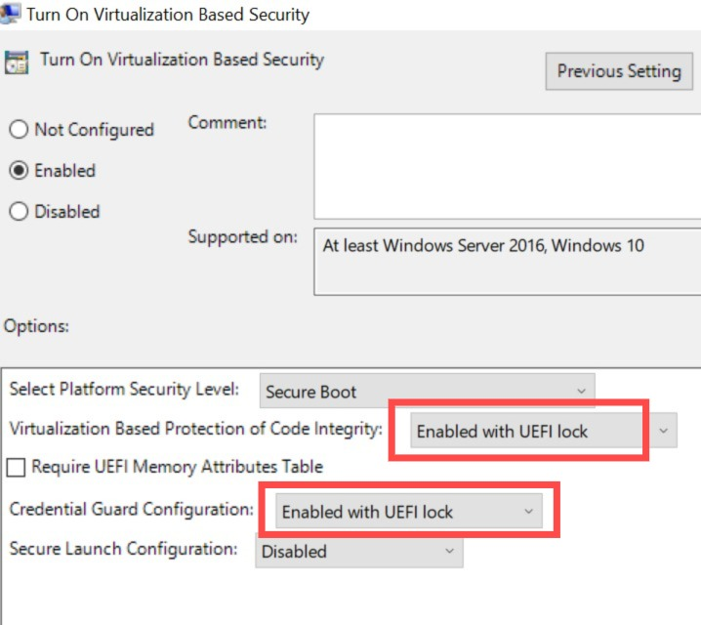

1. Press Apply then OK

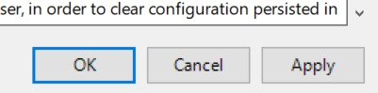

1. Restart your computer for it to take action.

### (17) Enable Auto Updates

1. Open Settings > Update & Security > Advanced Options  
   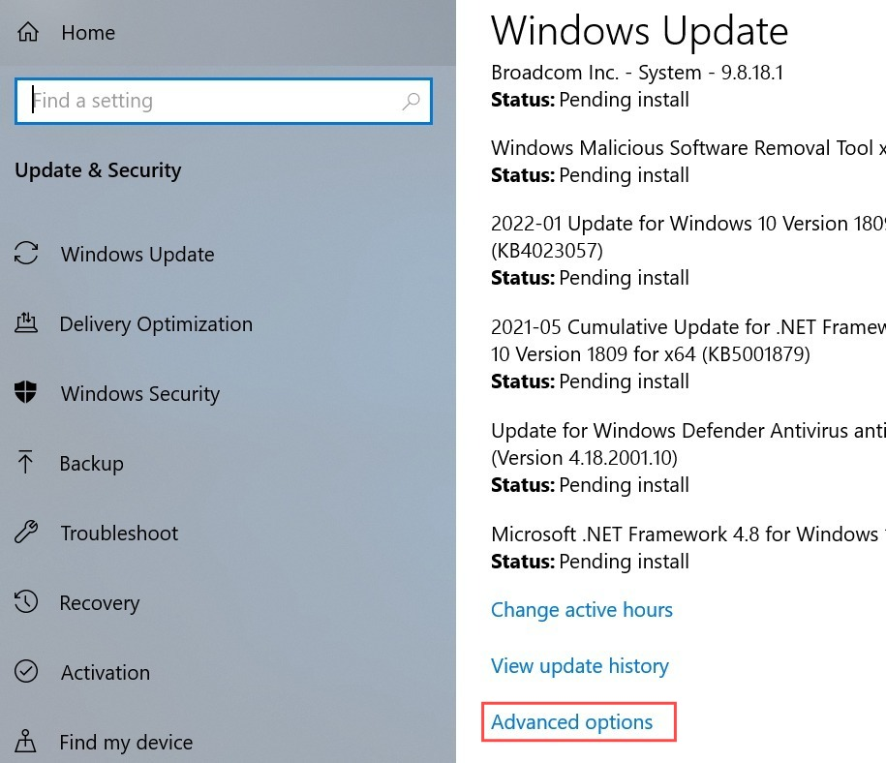
2. Toggle on ‘Give me updates’ and ‘Automatically download updates’

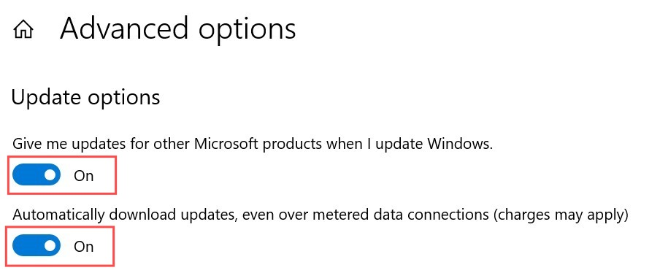

### (14) Keep up-to-date on the latest security updates

1. Visit Settings > Update & Security > Windows Update

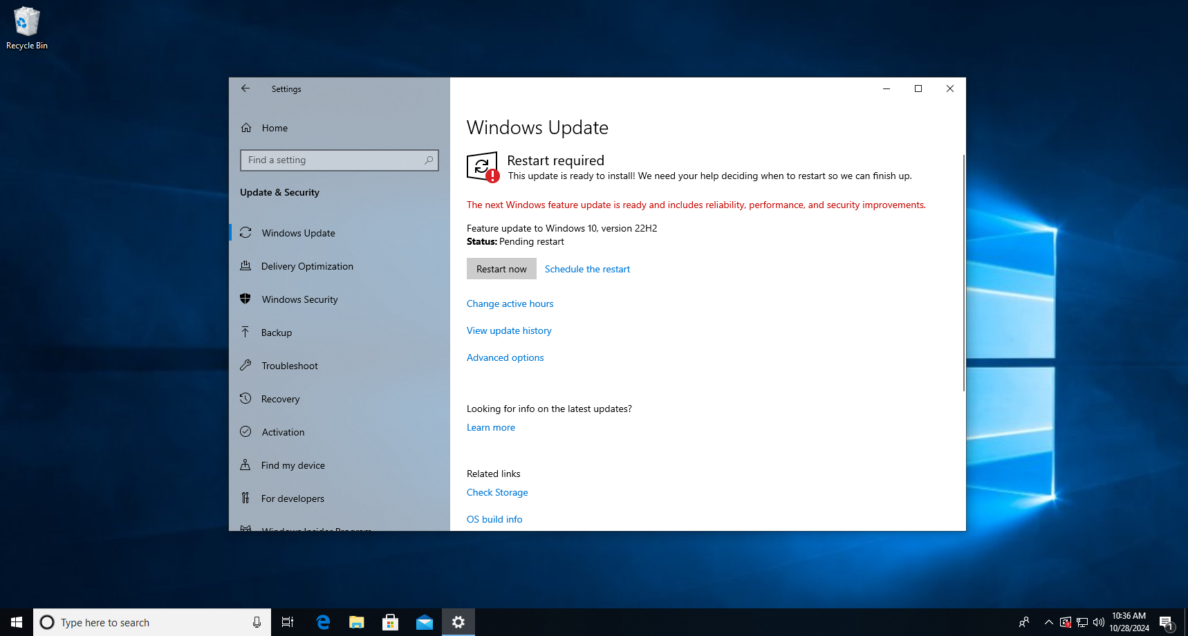

After installing and a reboot, you’re all set.

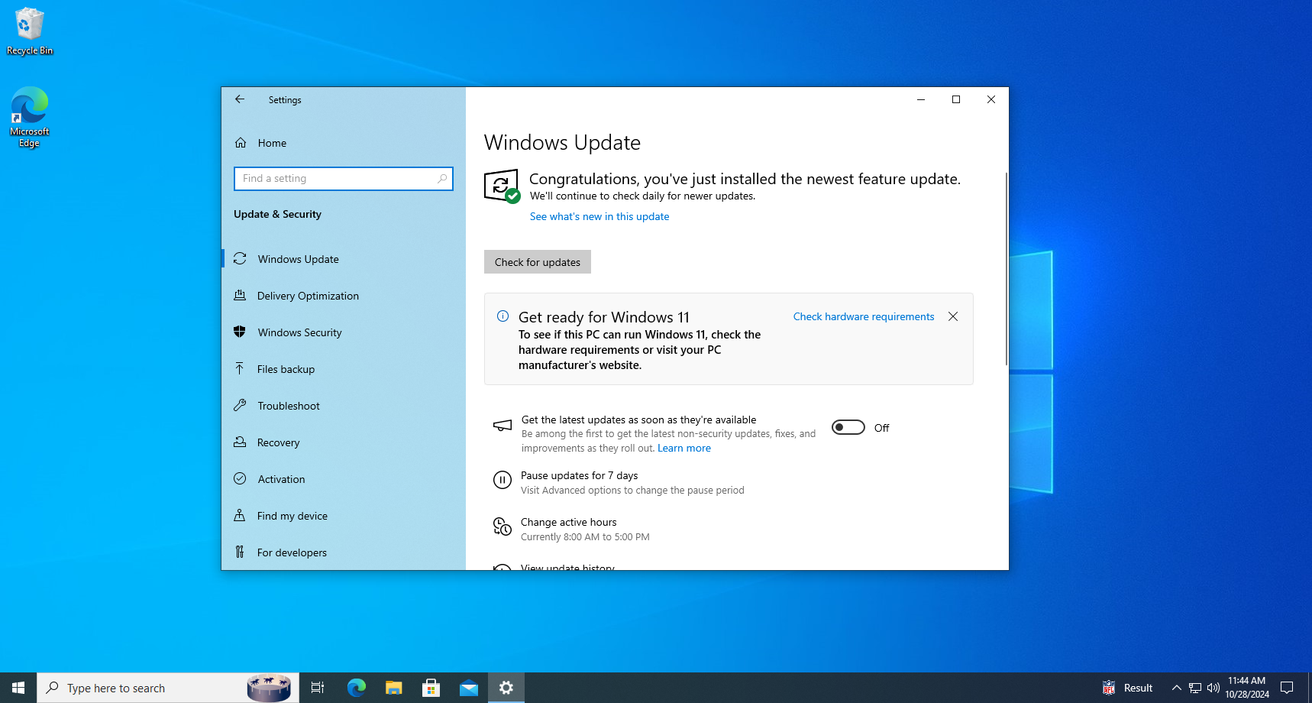

### (21) Enable Microsoft SmartScreen

1. Visit Windows Security > App & browser control



1. Click on Reputation-based protection settings

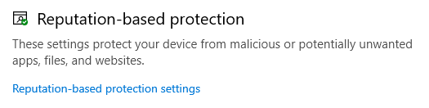

1. Make sure SmartScreen for Microsoft Edge is enabled

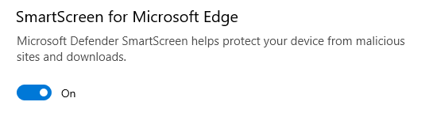

## _Protection & backups (Kriston)

Tasks:

* ~~(18) App Management - Only allow the installation of approved applications from controlled software repositories or application marketplaces~~
* ~~(19) Application Control - Whitelisting and blacklisting of executables or apps~~
* ~~(22) Enable Windows Hello~~
* ~~(23) Enable Windows Sandbox (Not completed)~~
* ~~(24) Enable Windows Secure Boot~~
  + ~~(a) Enable TPM if available~~
  + ~~(b) Create personal security certificates if necessary (Not completed: Redundant)~~
* ~~(25) Enable Windows BitLocker Encryption~~
* ~~(26) Enable File Backups~~
* ~~(27) Enable Restore Points~~

Documentation:

### (18) App Management - Only allow the installation of approved applications from controlled software repositories or application marketplaces

1. In Windows Security, under the App & browser control tab, select Reputation-based protection settings.

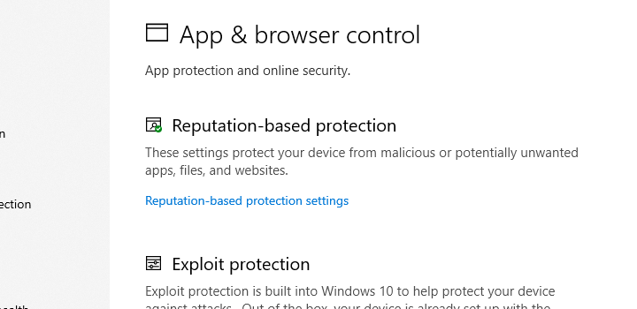

Scroll to find Potentially unwanted app-blocking.

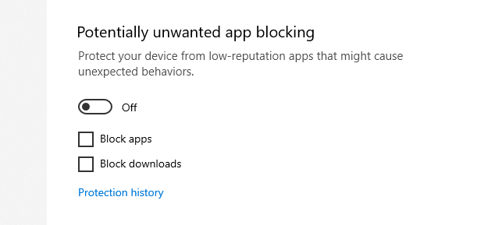

Toggle the setting on, and you’re set after.

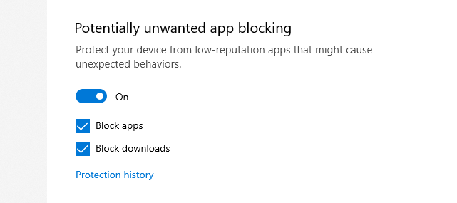

1. Visit Settings > Apps > Apps & features

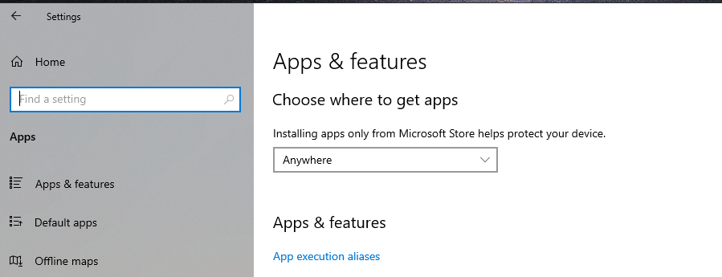

Under “Choose where to get apps”, choose “The Microsoft Store only (recommended)”.

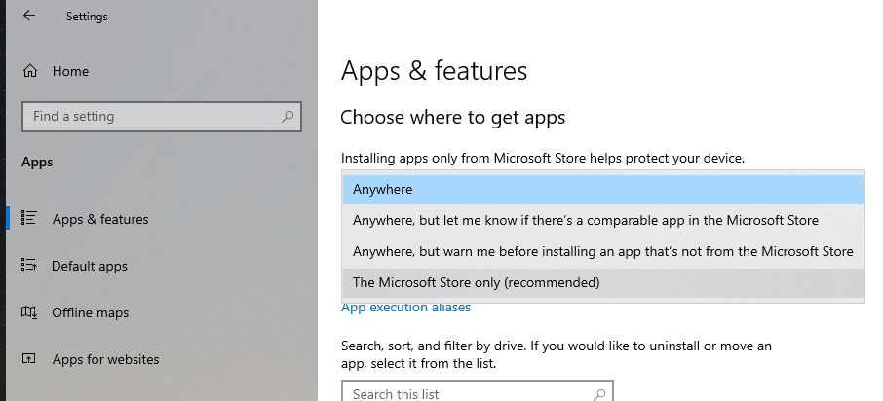

After that, you are all set.

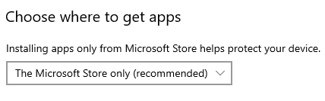

1. Restrict App Sources Using Group Policy

Win + R > gpedit.msc > OK

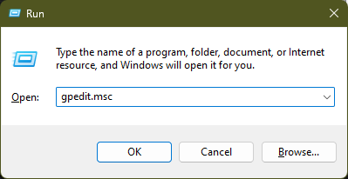

Navigate to Computer Configuration > Administrative Templates > Windows Components > Store

Find the setting "Only display the private store within the Microsoft Store app".

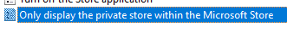

Double-click the setting, set it to Enabled, > OK. This restricts access to only approved applications from a designated private Microsoft Store.

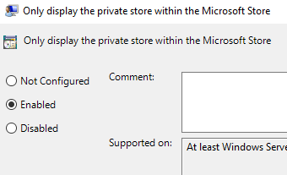

1. Configure AppLocker for Whitelisting

Go to Local Security Policy.> Application Control Policies > select AppLocker.

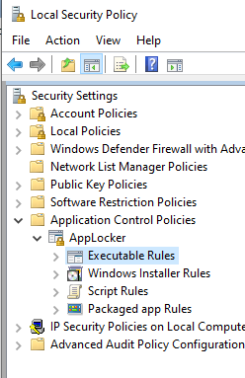

Right-click on Executable Rules and choose Automatically Generate Rules.

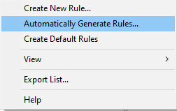

Follow the wizard > Next > Follow the defaults

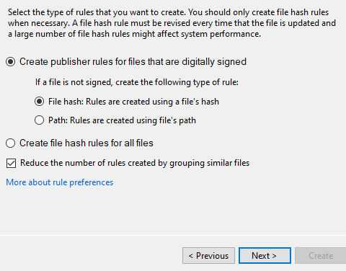

Review the list of generated rules. You’ll see file paths or hash rules created based on the applications in the selected directory. 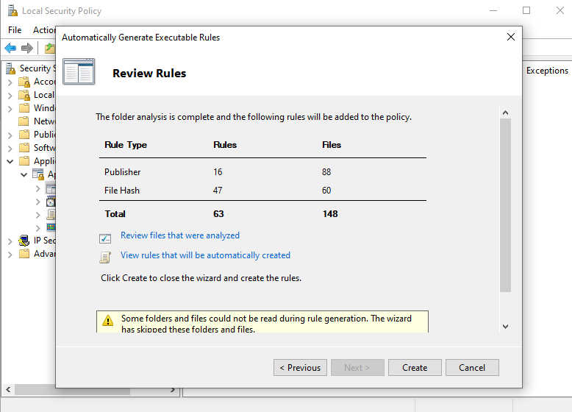

Now, we have our Executable Rules. You may wish to specify which is allowed and not as per use case scenario.

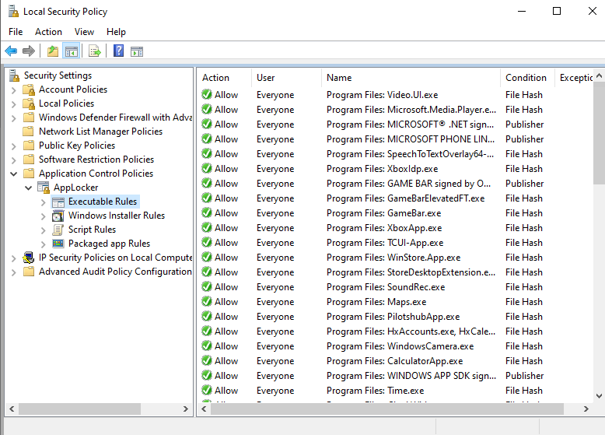

### (19) Application Control - Whitelisting and blacklisting of executables or apps

1. In Windows Security, visit the Virus & threat protection tab, visit Ransomware protection settings.

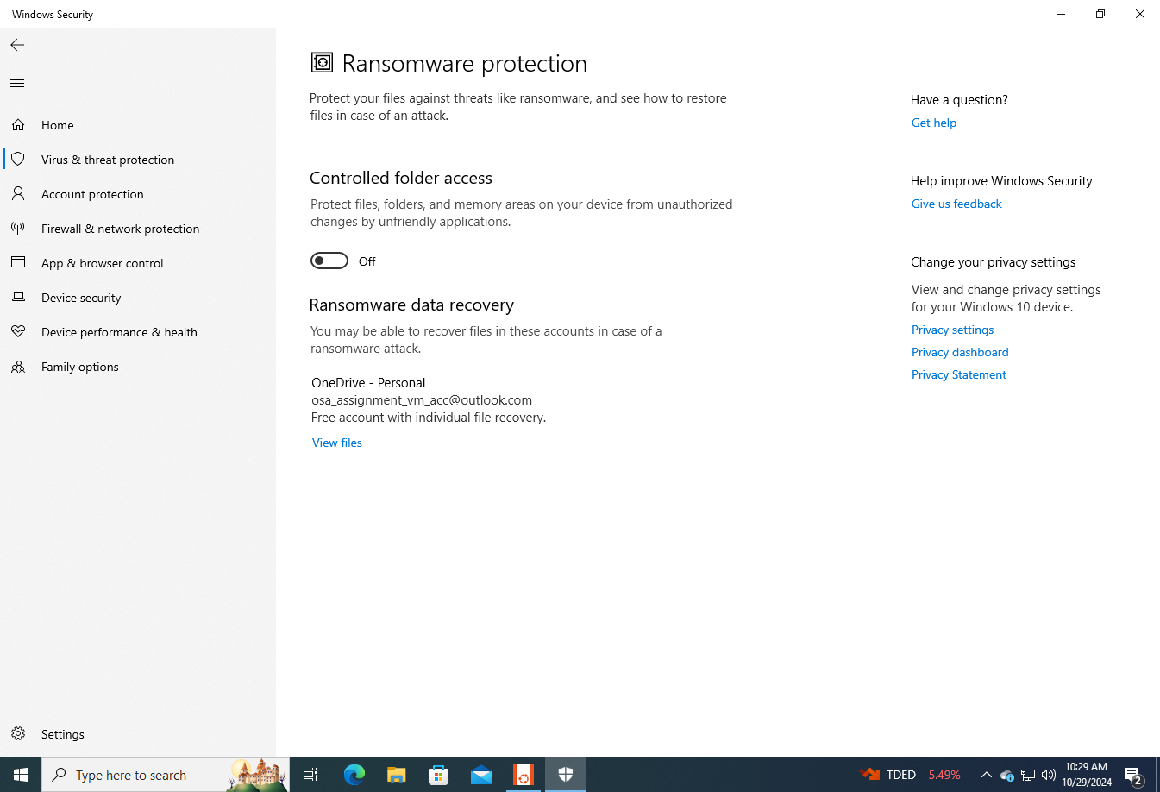

1. Simply enable the Controlled folder access.

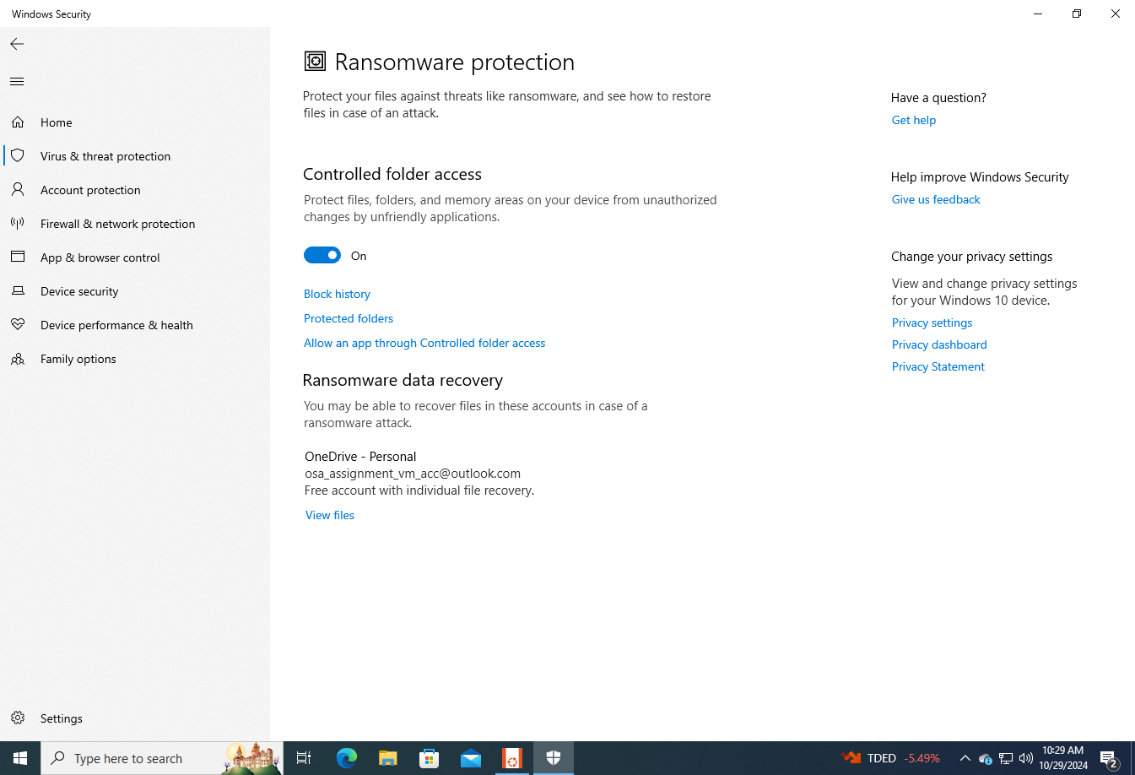

1. Visit Local Security Policy, Win + R > secpoll.msc > OK

Application Control Policies > AppLocker > Right-click Executable Rules

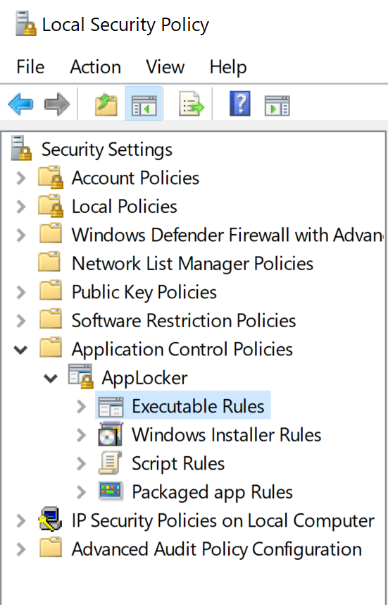

Create New Rule

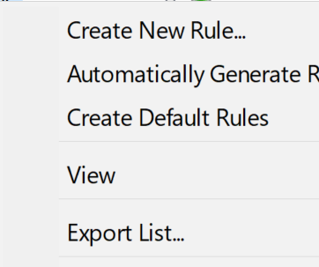

Choose Allow as the action and specify everyone > Next.

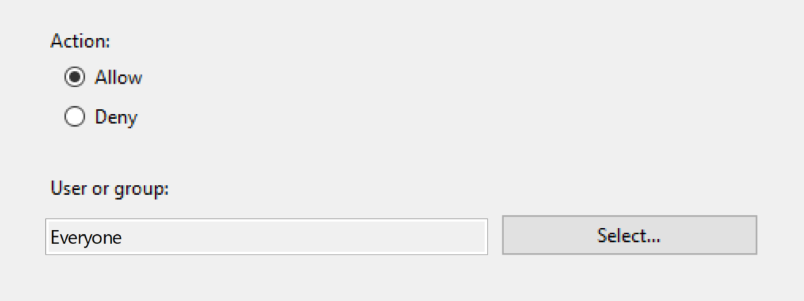

Choose to specify the Path > Next.

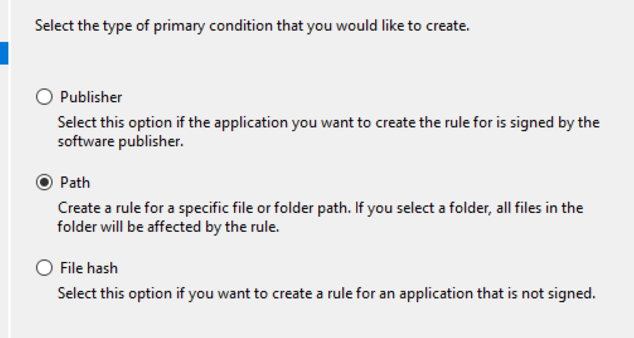

Specify the following > Create:

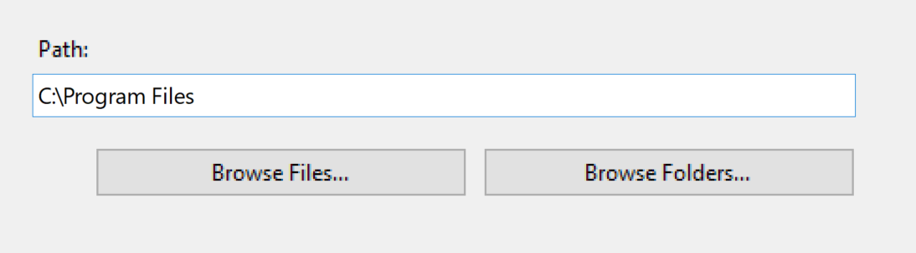

1. Blacklisting: Create another Executable Rule > Deny > Everyone

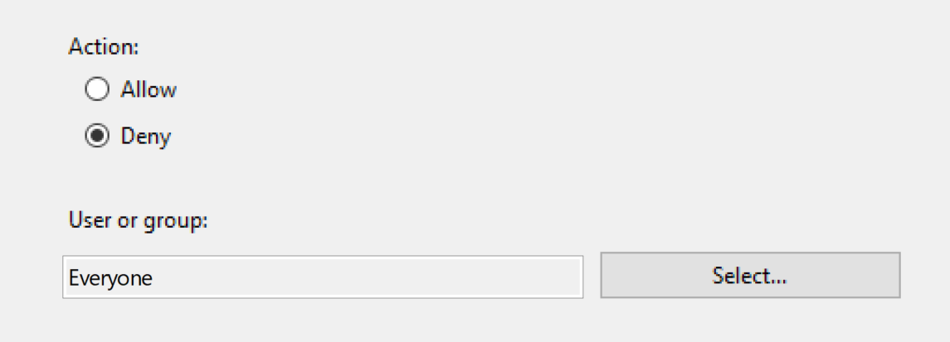

Select Path.

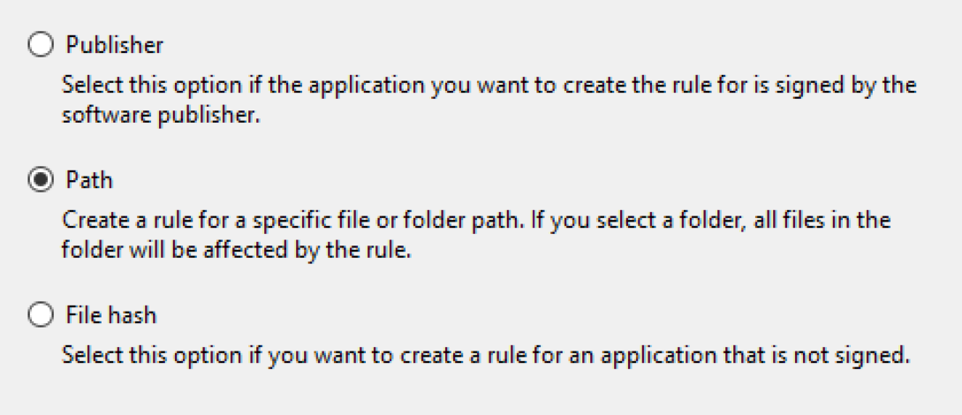

Browse Path > select the Downloads folder > OK.

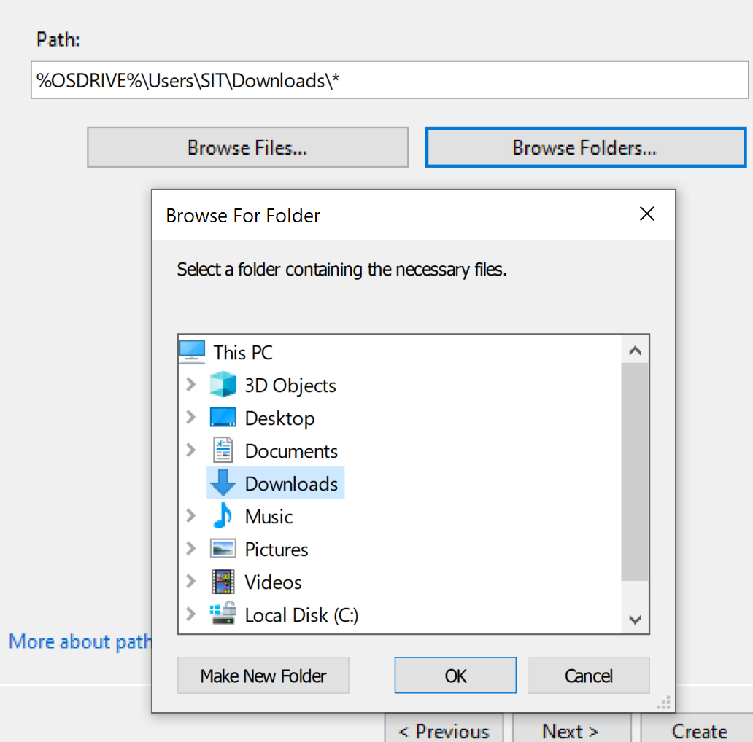

Include .exe at the end.

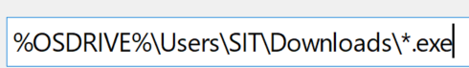

### (22) Enable Windows Hello

1. On Windows Security, under the Account Protection tab, Windows Hello is currently disabled, and we are required to sign in to use the feature.

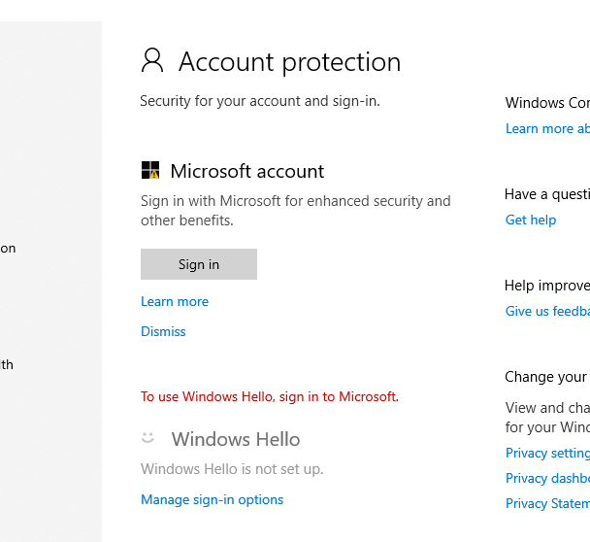

1. After signing in and toggling to setup Windows Hello, we are required to create a new PIN.

The PIN used is: Th1s1sMYp@ssw0rd$

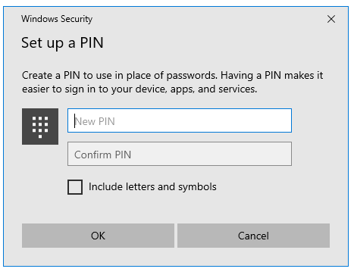

1. Windows Hello setup confirmation.

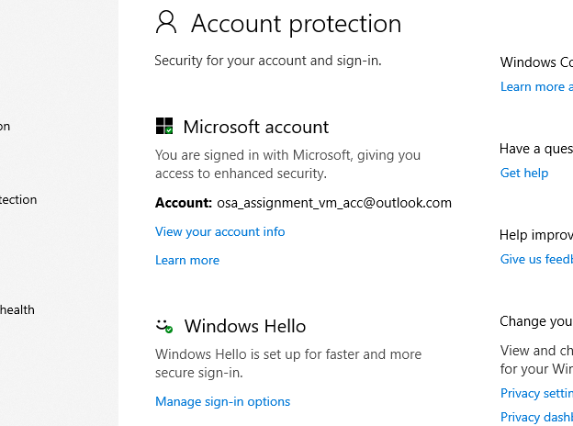

1. Unfortunately, we do not have access to sign-in options like Hello Face or Fingerprint; hence, PIN is our next best option. For enhanced security, we also enabled Windows Hello sign-in for all Microsoft accounts on this device.

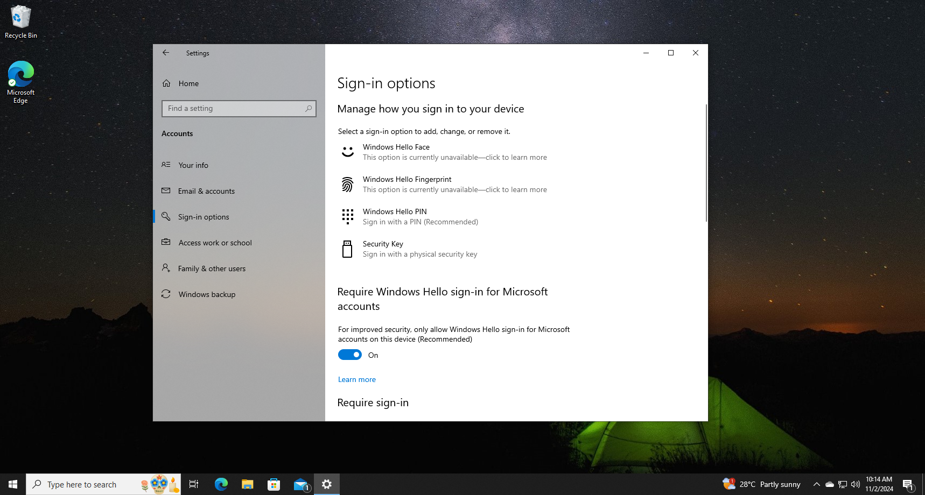

### (23) Enable Windows Sandbox

1. Not completed.

### (24) Enable Windows Secure Boot

1. Launch Powershell as Administrator > Run get-disk to check the partition style > In our case, it’s MBR > We need to convert it into GPT > We do so by running MBR2GPT.EXE /convert /allowfullOS (You may have to run the command twice.) > Power down the VM after.

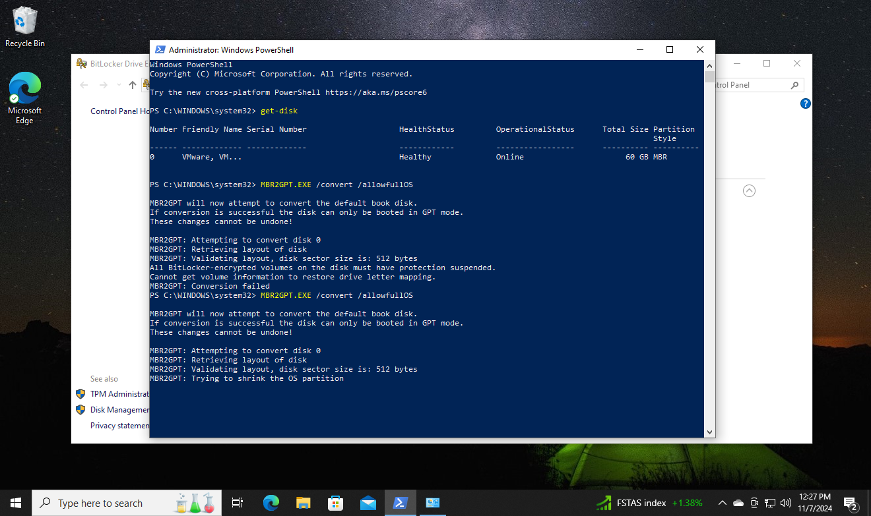

1. On VMware, access the VM’s Settings > Options > Access Control > Encrypt the VM > Fill in a strong password.

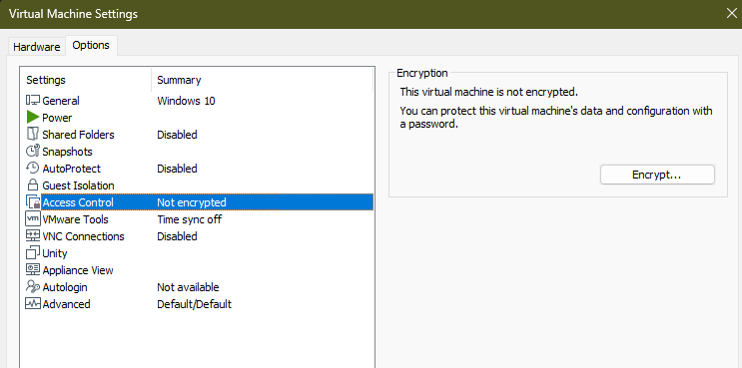

For example: Th1s1sMYp@ssw0rd$

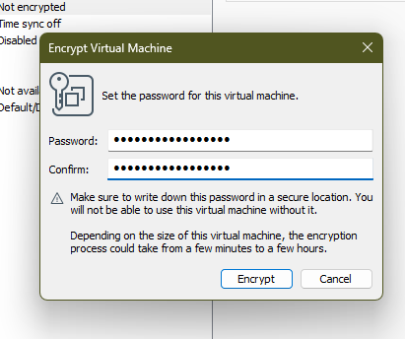

Confirmation that it is now encrypted.

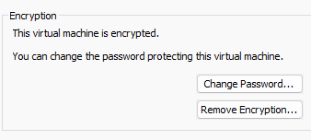

1. On the same Options tab > Advanced > Firmware type >Swirtch from BIOS to UEFI with secure boot enabled.

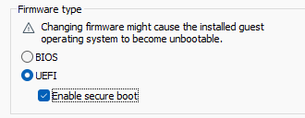

1. On the Hardware tab > Add... > Trusted Platform Module > Finish.

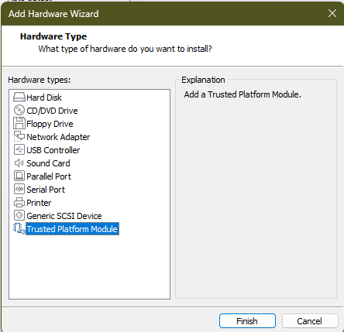

You will now be able to boot with UEFI + Secure Boot + have a TPM (more security).

### (25) Enable Windows BitLocker Encryption

1. Visit Control Panel, then “System and Security” > “BitLocker Drive Encryption” > Turn on BitLocker

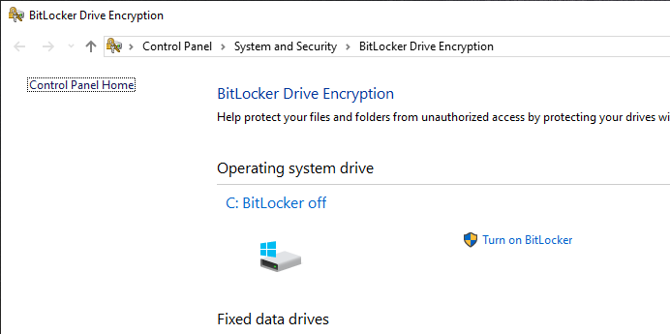

1. Press Next > Next > Restart > Next

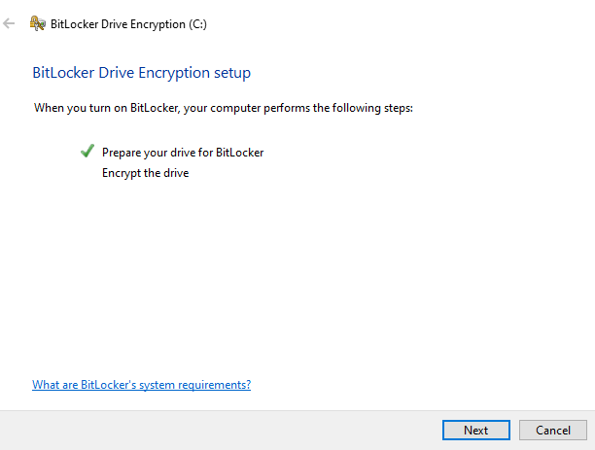

Choose the “Enter a password” option, use the password: Th1s1sMYp@ssw0rd$

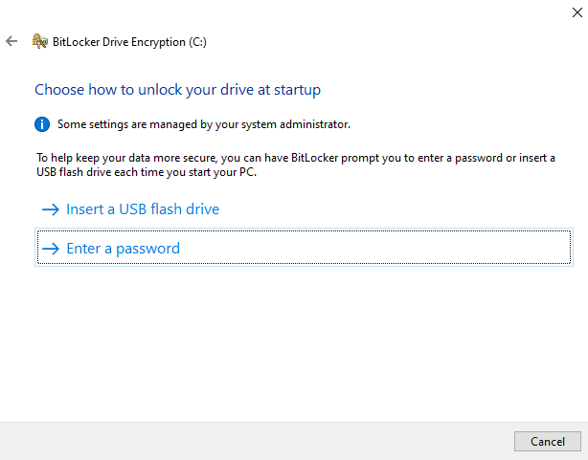

Back up the recovery key to your Microsoft account

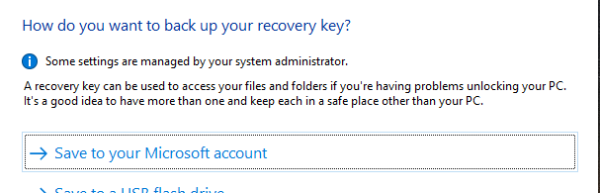

Additionally, choose the option to “Print the recovery key” as a secondary backup.

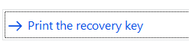

Print it to a PDF file > name the file bitlocker_recovery_key > save it locally or on your OneDrive

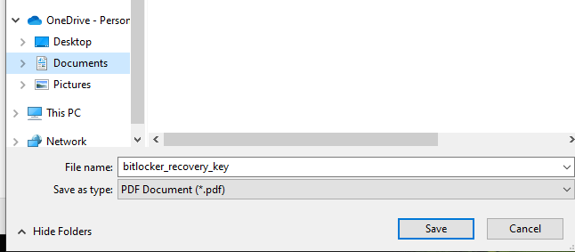

Next > choose “Encrypt entire drive” > Next

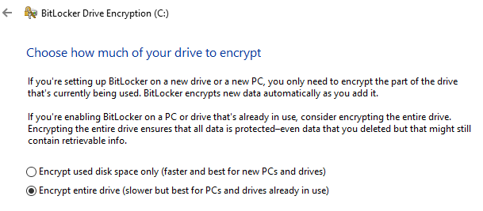

Choose “New encryption mode”

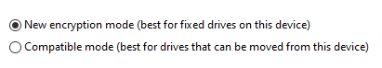

Leave the option ticked > Continue > Reboot your PC

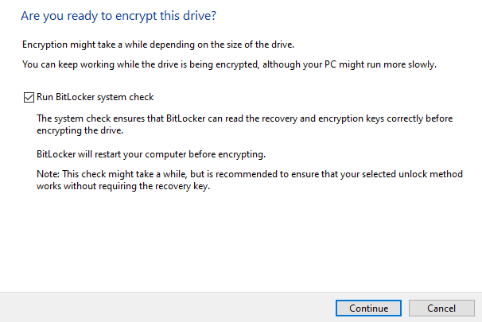

Enter the password.



Wait for a while then after, BitLocker will show that it is “on”, and you’re set.

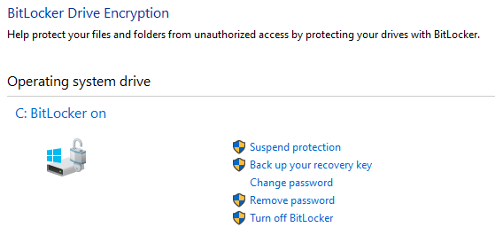

### (26) Enable File Backups

1. Sign in with a Microsoft Account (done prior)
2. Visit Settings > System > Storage > More storage settings > View backup options

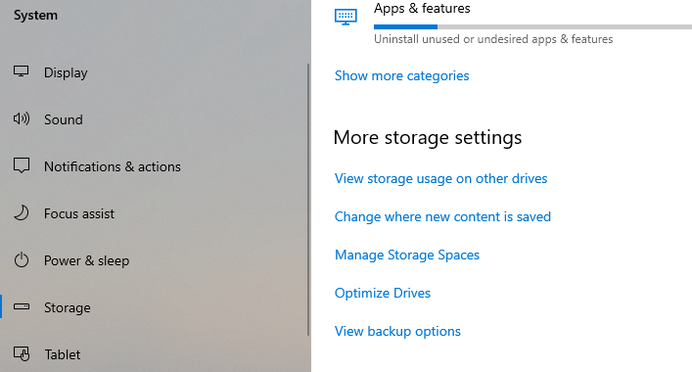

1. Choose to backup your files on OneDrive and once done, you should see the following:

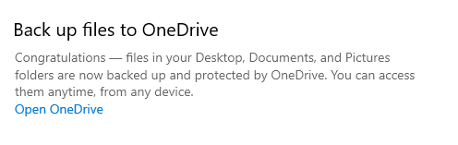

### (27) Enable Restore Points

1. Visit Settings > System > About > Related settings > System protection

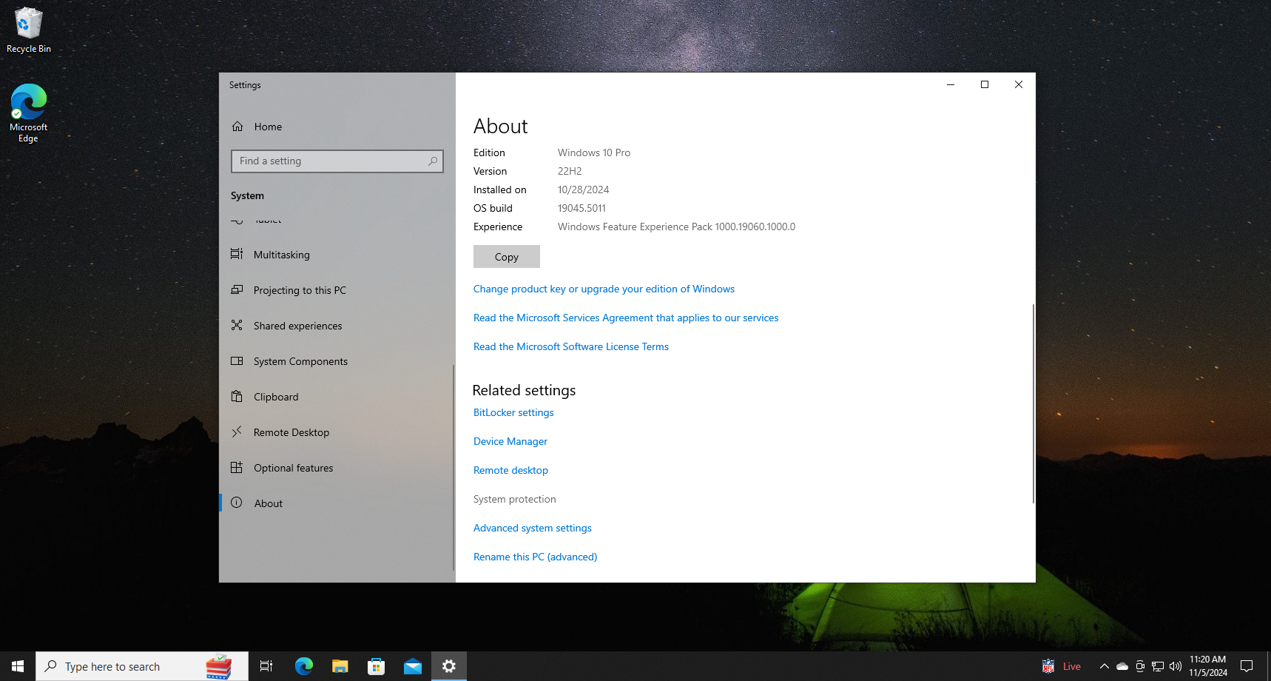

1. In the tab, press “Configure”

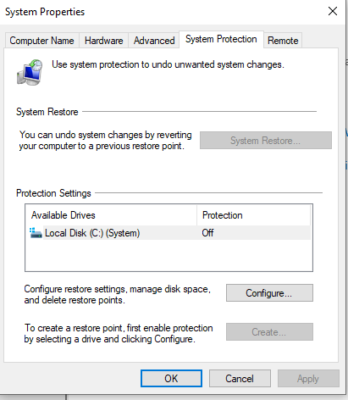

1. Turn on system protection (Disable system protection by default)

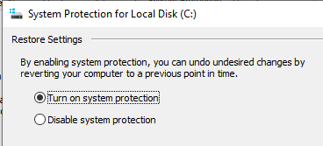

Apply to save changes.

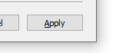

1. Back on the System Protection tab, create a restore point

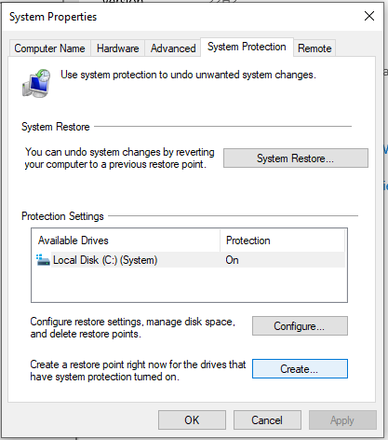

Any name is fine, we went with restore_point_1 > press Create

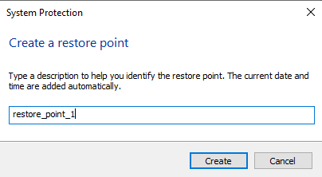

Your newly created restore point should be under “System Restore…”

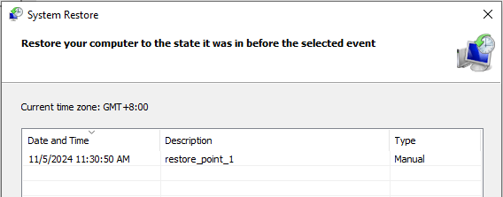

## _task29

Tasks (add on as you go):

* ~~(29) Activating && Switching to Windows 10 Pro~~
* ~~(30) Create groups for easier account management~~
* ~~(31) Implementing Role-Based Access Control (RBAC)~~
* ~~(32) Blocking Specific Ports: Port 445 (SMB) on TCP~~
* ~~(33) DNS-over-HTTPS (DoH) for Encrypted DNS Queries~~
* ~~(34) Network Level Authentication (NLA) for RDP~~
* ~~(35) Disable SMBv1 Protocol~~
* ~~(36) Configure Audit Policies for Sensitive Data Access~~
* ~~(37 )Memory Integrity~~
* ~~(38) Disabling Auto login~~

Documentation:

### (29) Activating && Switching to Windows 10 Pro (Kriston)

1. Proof of unactivated Windows 10 Education.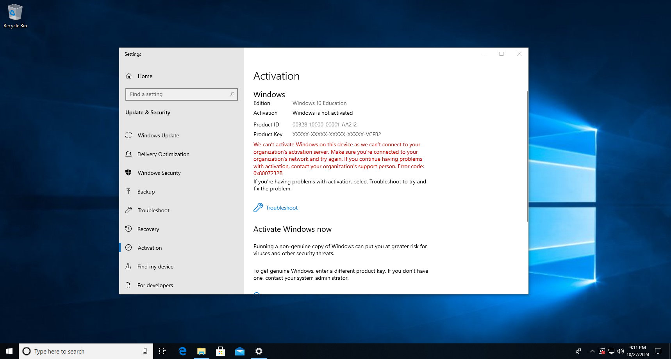
2. Microsoft Activation Scripts (MAS) by massgravel ([GitHub Repo](https://github.com/massgravel/Microsoft-Activation-Scripts))

Using Powershell in Administrator Mode, we ran the following:

irm https://get.activated.win | iex

After doing so, you’ll be greeted by the following menu:

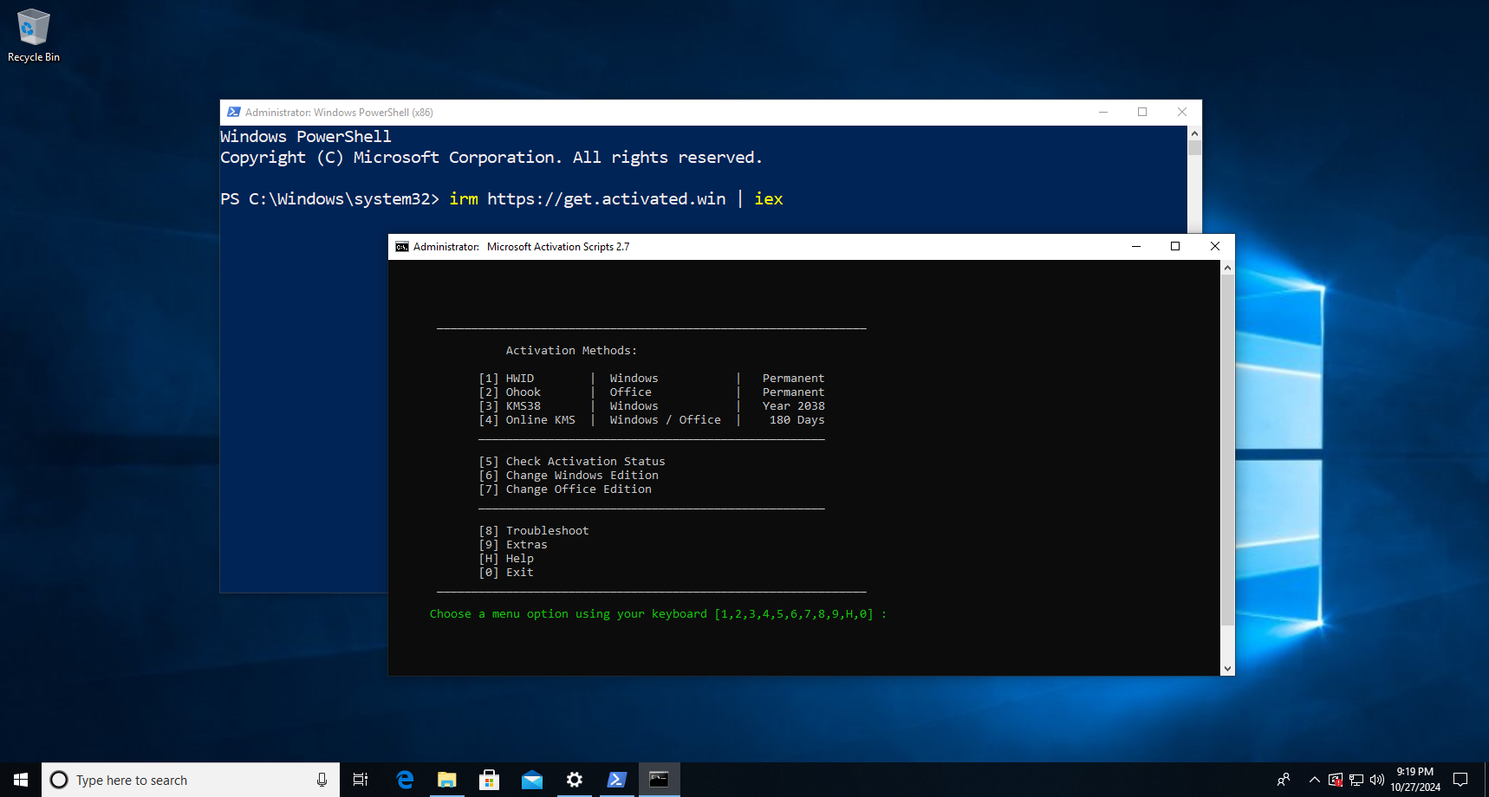

6 to change Windows Editions, then press 1 for the regular Windows 10 Pro version.

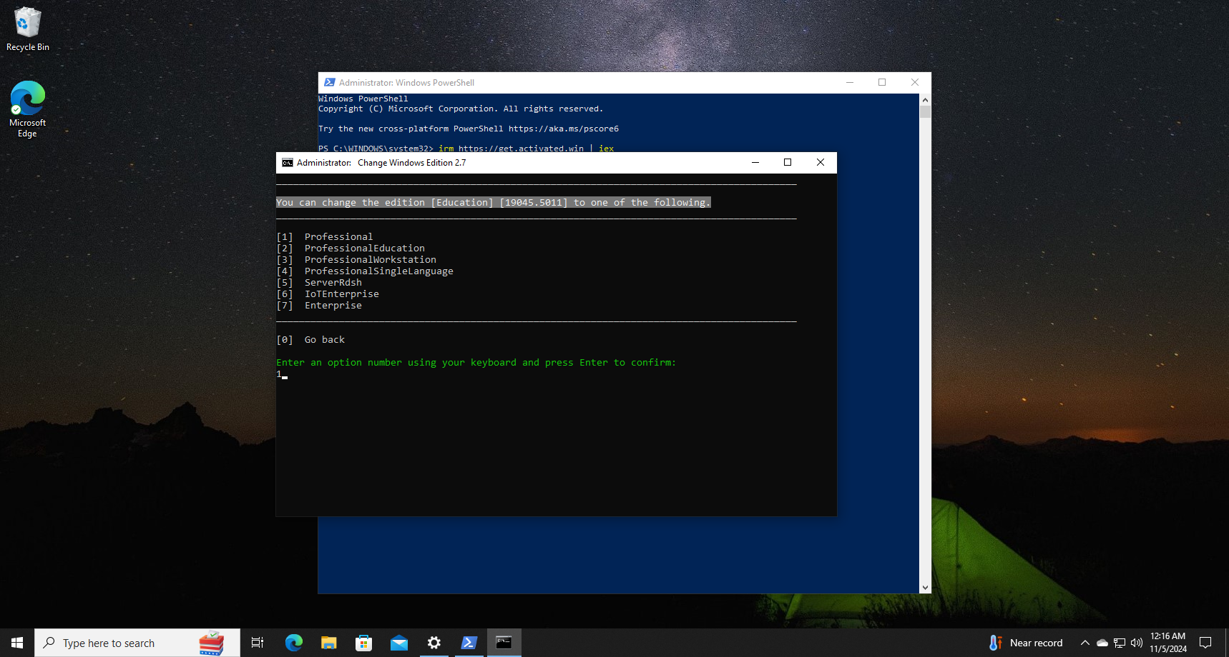

Successful confirmation. Press any key to Go back, but don’t exit yet.

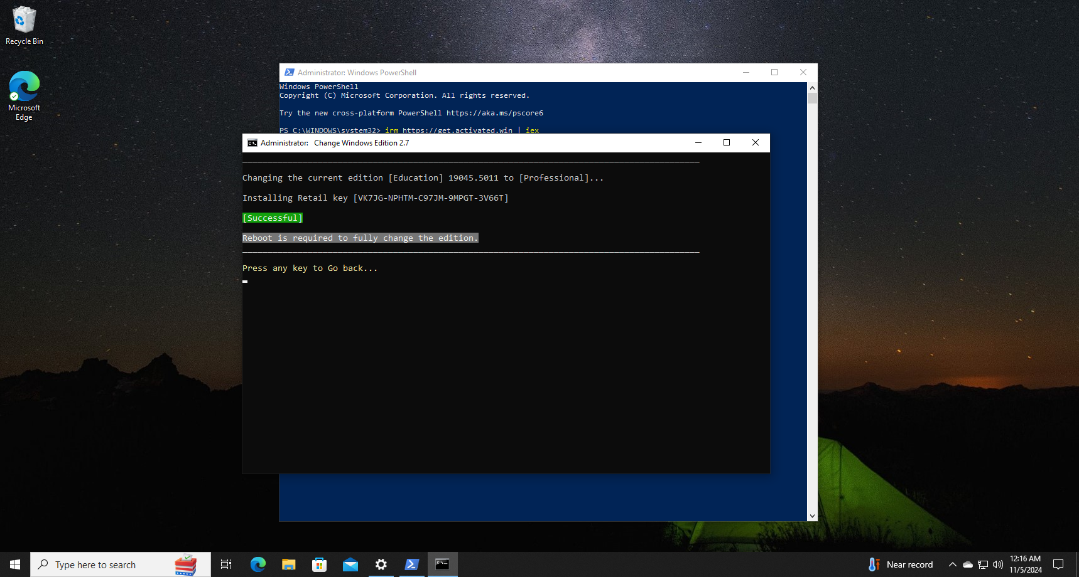

1. Activating Windows 10 Pro

You’ll see that the Windows 10 Edition is now set to Pro but it isn’t activated yet.

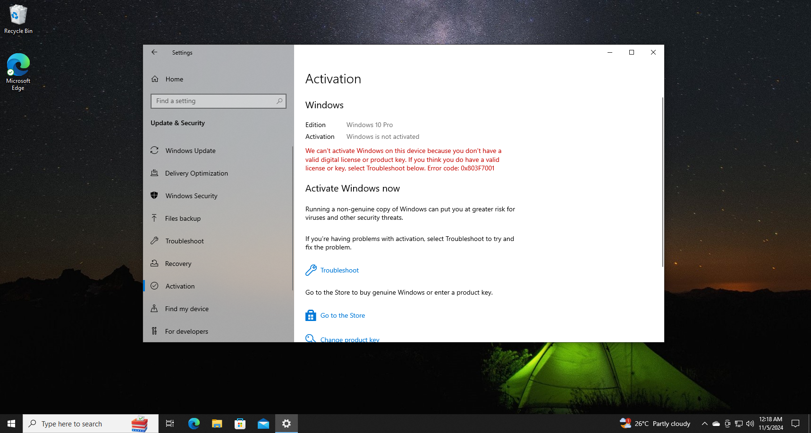

On the main menu of MAS, press 1 to activate via Hardware Identification (HWID).

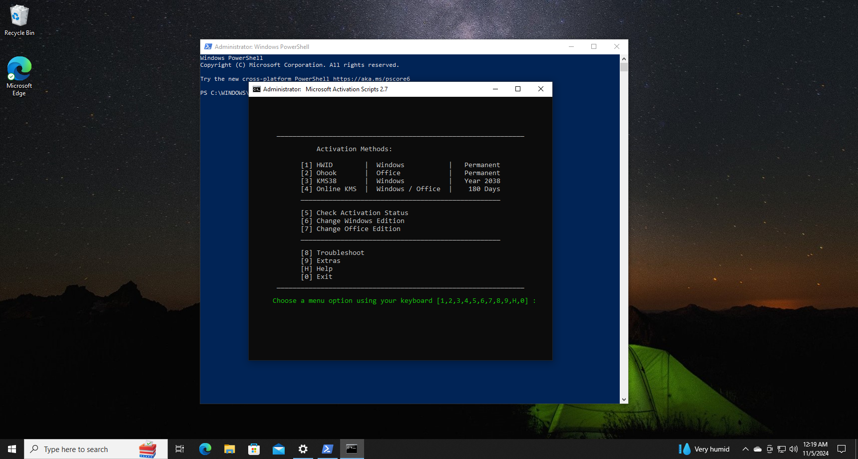

Successful confirmation.

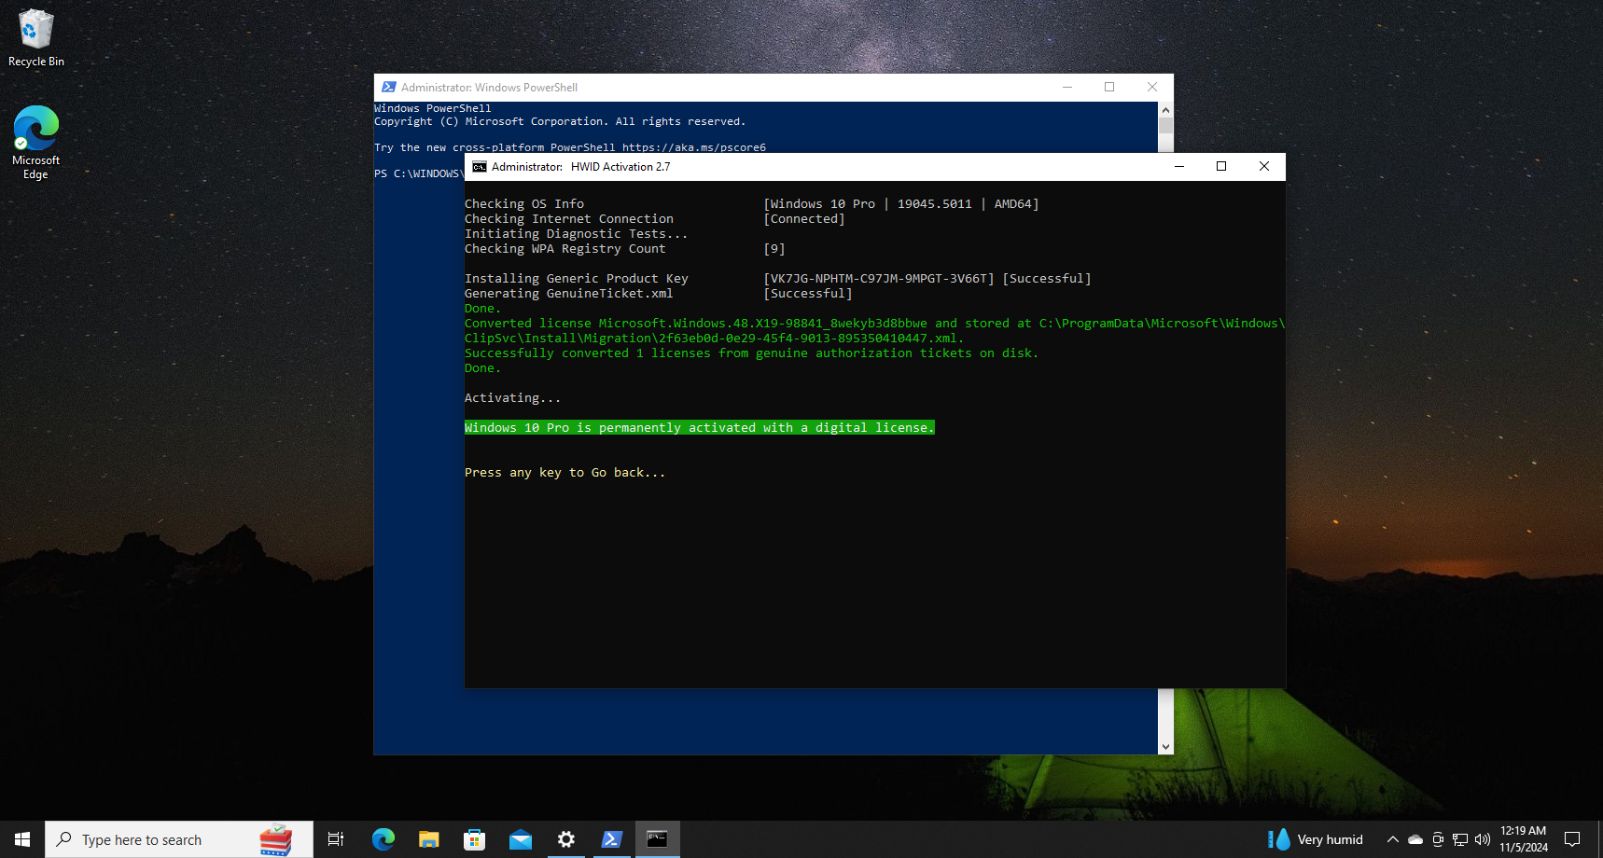

Reboot the VM, then visit Settings > Activation. We can see that it is activated now.

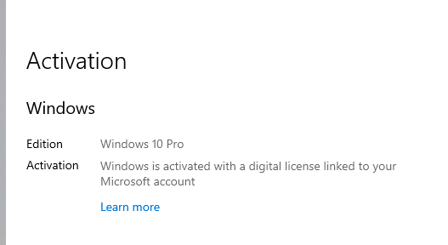

### (30) Create groups for easier account management (Jia Xiang)

1. In the Windows search bar at the bottom left, type compmgmt.msc to run the Computer Management  
   
2. In the Computer Management dialog box, navigate to ”Groups”.   
   **Path**: System Tools **→** Local Users and Groups **→** Groups  
   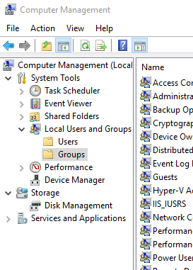
3. Click on Action  
   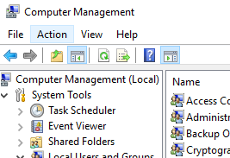  
     
   Click on “New Group…”  
   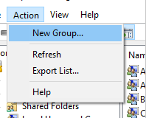
4. Enter group name and description > Click “Add”  
   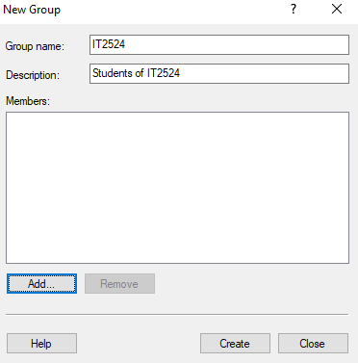  
     
   Enter name of user then click ok  
   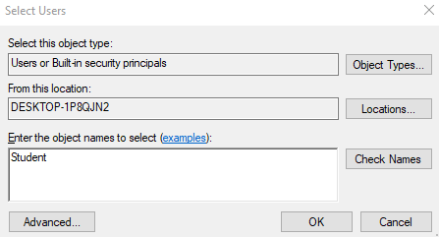
5. Click close  
   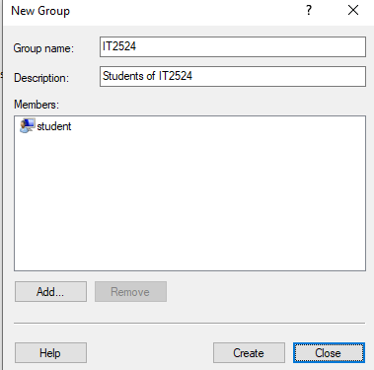
6. **Add users to groups from “Users”**  
   In the Computer Management dialog box, navigate to ”Users”.   
   **Path**: System Tools **→** Local Users and Groups **→** Users  
   
7. Right click on a user and click properties  
   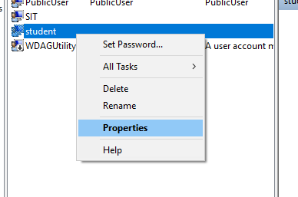  
     
   Go to the “Member Of” section and click “Add…”

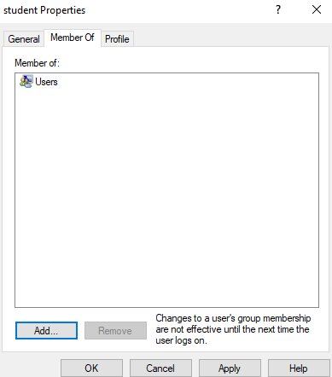  
  
Enter group name and click ok  
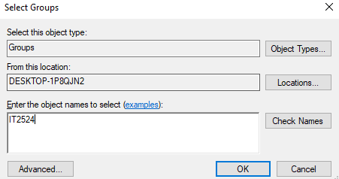  
  
Click apply  
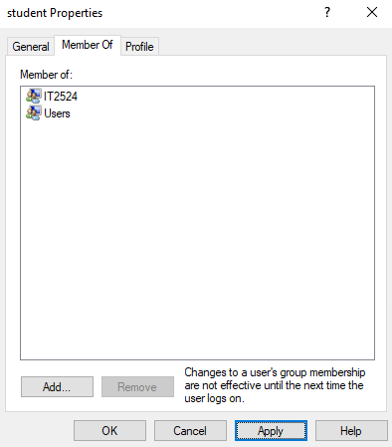

### (31) Implementing Role-Based Access control (Jia Xiang)

1. Open file Explorer and right-click “notepad.exe” in “system32”  
   **Path**: C: **→** Windows **→** System32   
   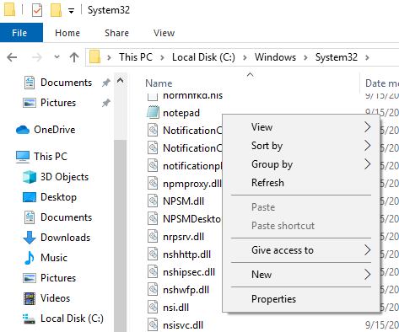  
     
   Click on properties  
   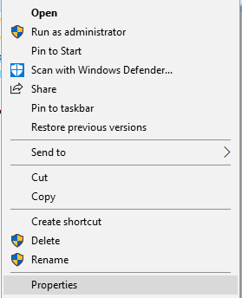
2. Go to Security section inside of properties  
   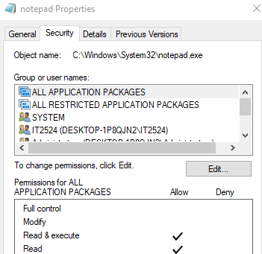  
     
   Click on advanced  
   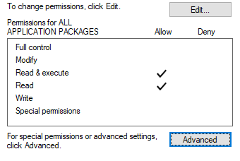  
   Check all the permissions of groups  
   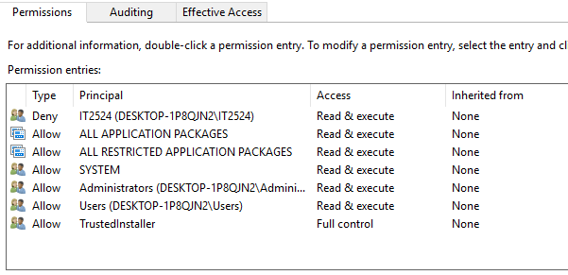  
     
   Notice how IT2524 has permission to read and execute and has a type of Deny.  
   Select IT2524 and click “Edit”  
   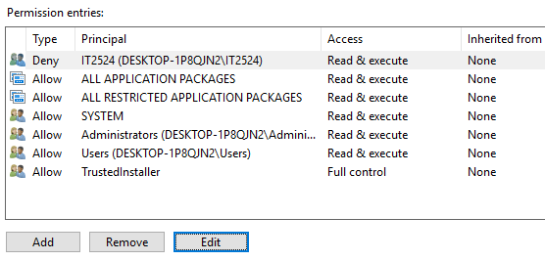
3. Unselect “Read & execute” and set the type to “Allow” then click OK  
   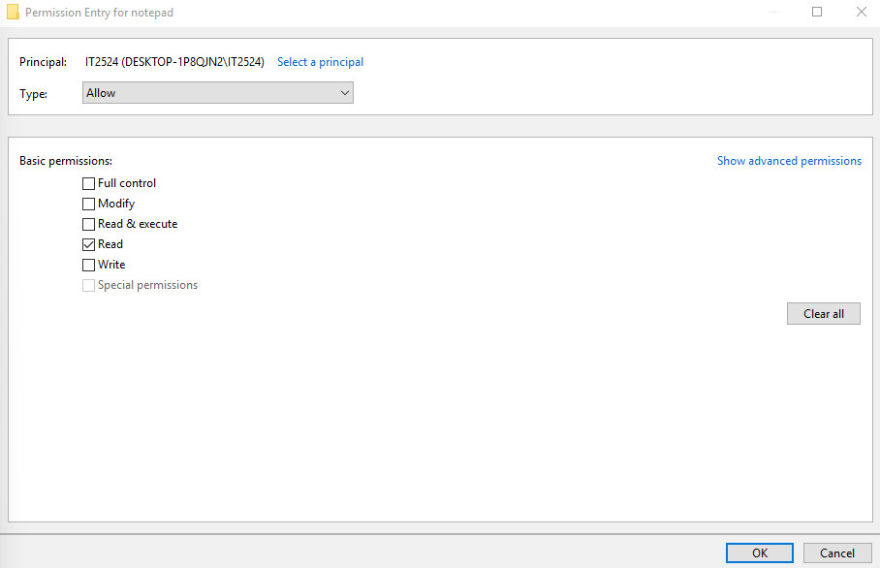
4. Click Apply  
   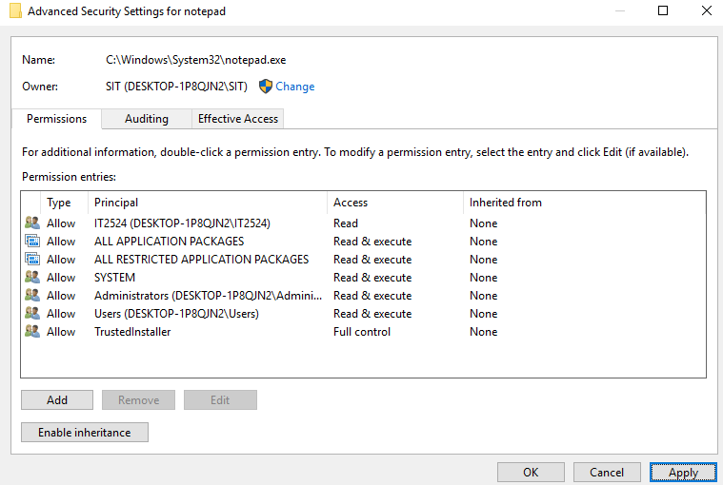  
     
   Click Yes  
   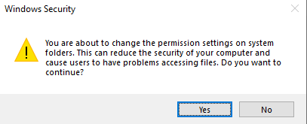

### (32) Blocking Specific Ports: Port 445 (SMB) on TCP (Kriston)

1. Open Windows Defender Firewall > Advanced Security

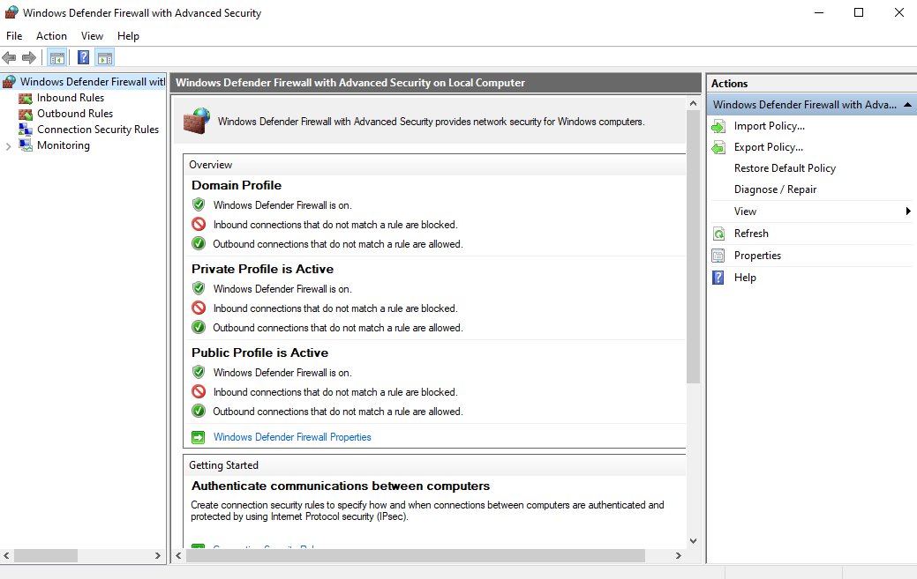

1. Create a New Rule for Blocking a Port:

Inbound Rules > New Rule… > Follow setup wizard

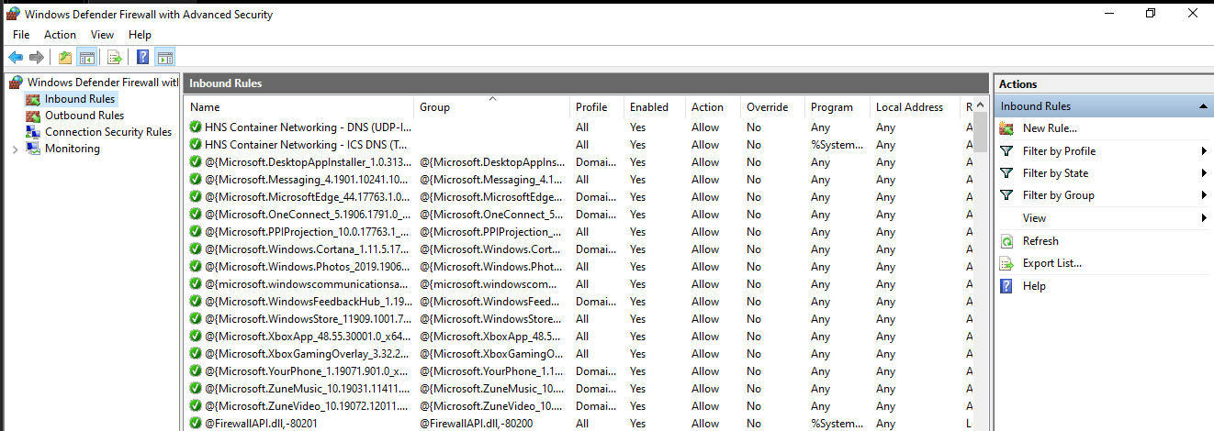

Port as Rule Type > Next.

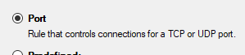

Apply to TCP and specify Port 445 to block SMB traffic on TCP. > Next

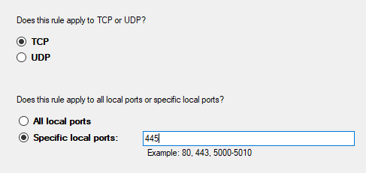

Block the connection.

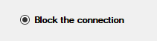

Generally safest to select all three options unless you have a specific reason not to > Next.

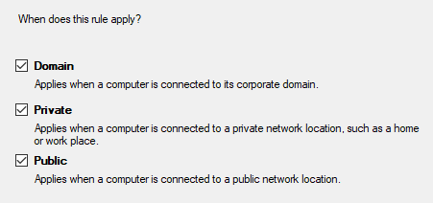

Add descriptive names > Finish.

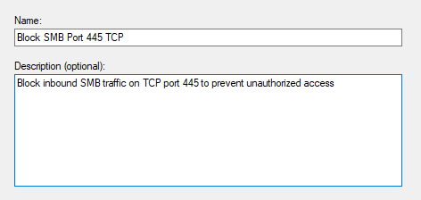

1. You should now see the newly created rule.

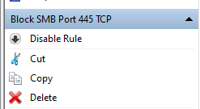

This prevents unauthorized access to file-sharing services, reducing the risk of malware and network attacks.

### (33) DNS-over-HTTPS (DoH) for Encrypted DNS Queries (Kriston)

1. Settings > Network & Internet > Advanced network settings > Network and Sharing Center

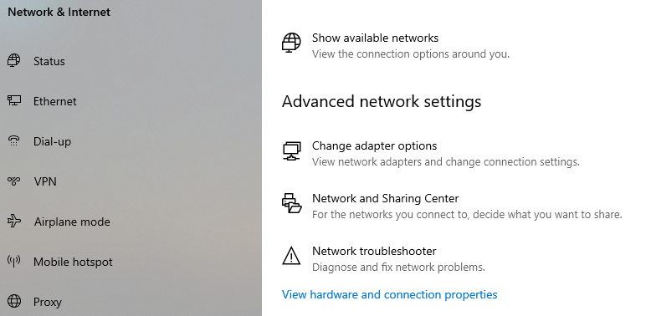

1. Click on your network (Ethernet0)

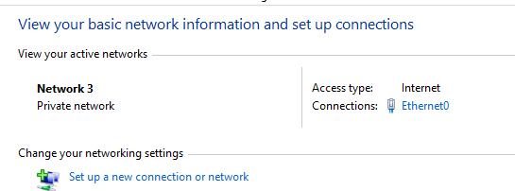

Choose Properties.

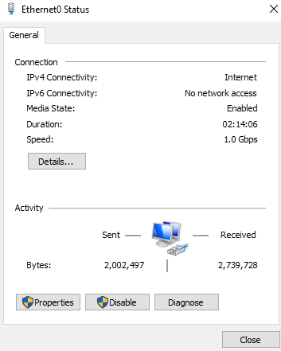

Now head to Internet Protocol 4 (TCP/IPv4) > Properties

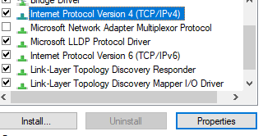

Enter the following DNS addresses (both are Cloudflare DNS-s) > OK.

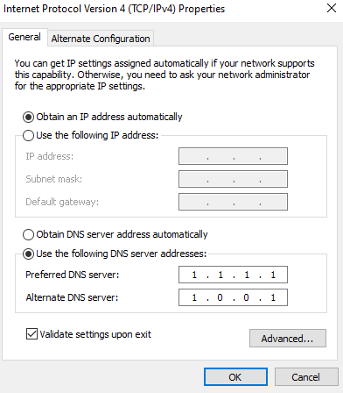

### 

### (34) Network Level Authentication (NLA) for RDP (Jun Lin)

1. Open System Properties, Win + R > sysdm.cpl > OK

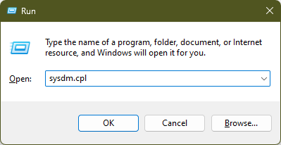

1. Visit Remote tab > Remote Desktop > Allow remote connections to this computer

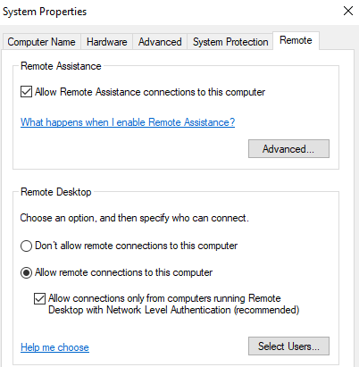

1. Apply to save changes.

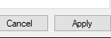

### (35) Disable SMBv1 Protocol (Kriston)

1. Under Windows Features > Disable the following (SMB 1.0 and SMB Direct):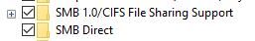  
   Disable SMBv1 and SMB Direct to reduce security vulnerabilities and minimize unnecessary network features in non-enterprise environments.  
   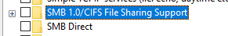
2. OK to save changes.  
   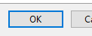

### 

### (36) Configure Audit Policies for Sensitive Data Access (Dhiraj Joshy)

1. Press win+r, type ‘secpol.msc’, this will open Local Security Policy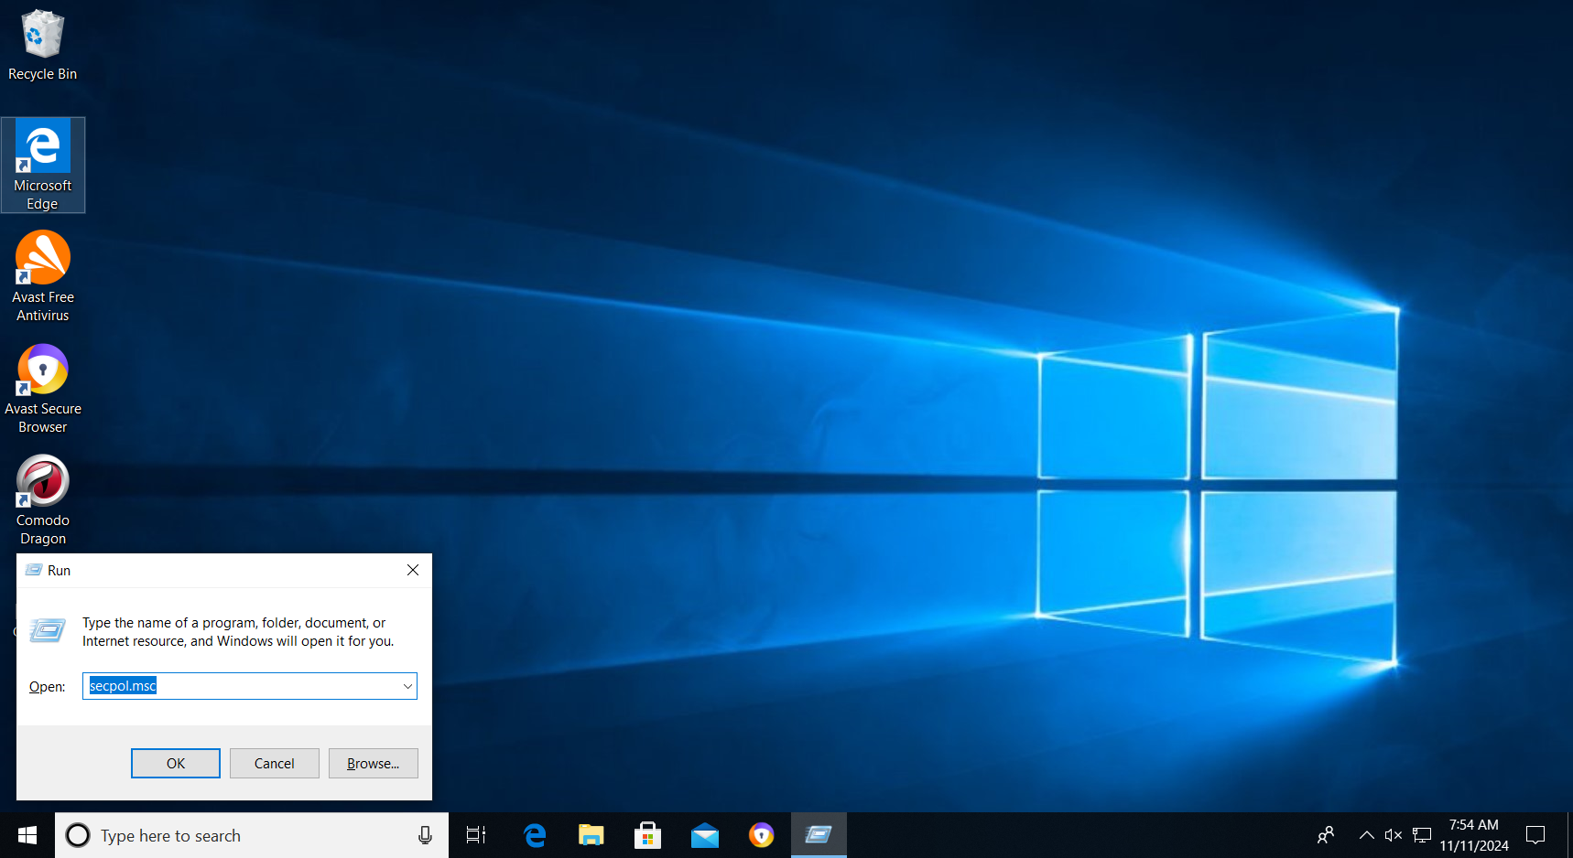
2. Go to Advanced Audit Policy Config > System Audit Policies > Object Access and click on Audit File System

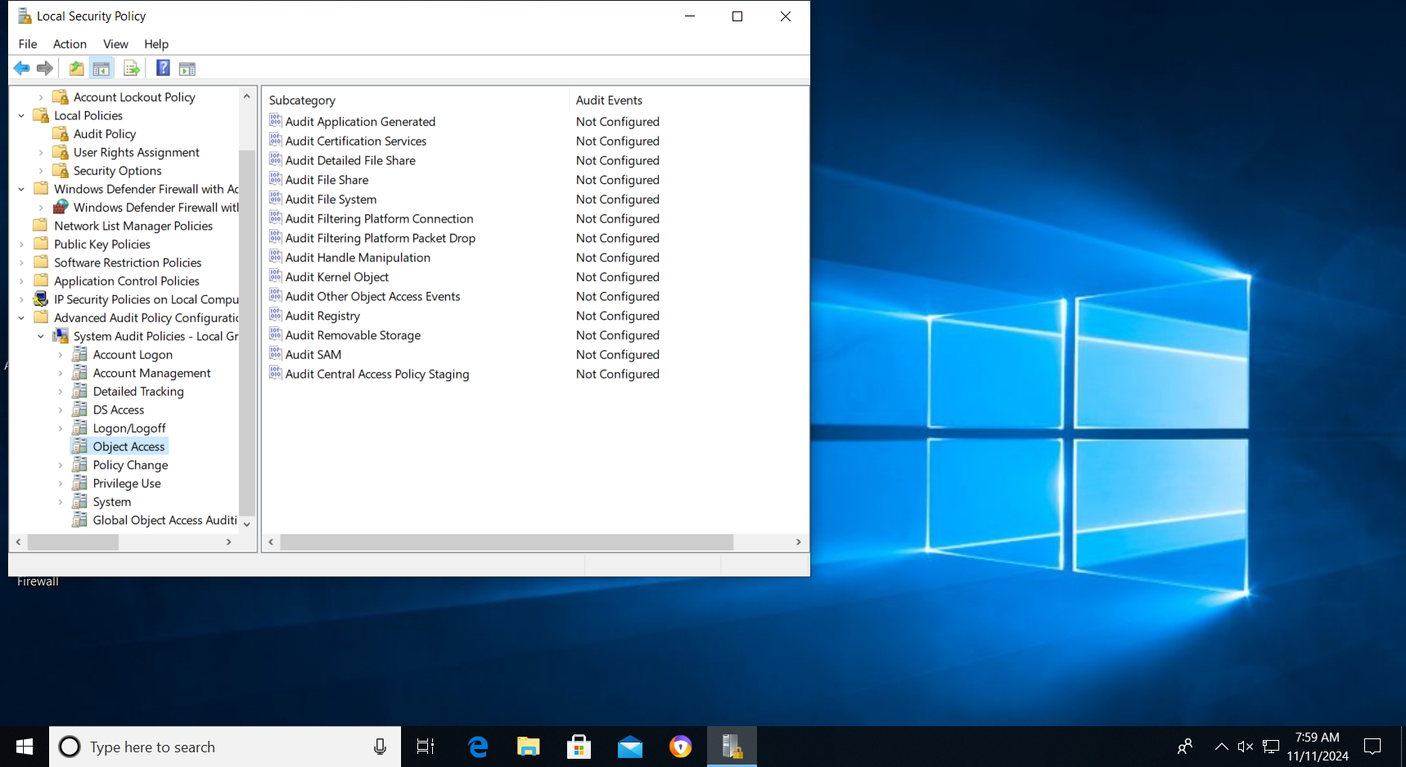

1. Click on the Success and Failure box,click apply and ok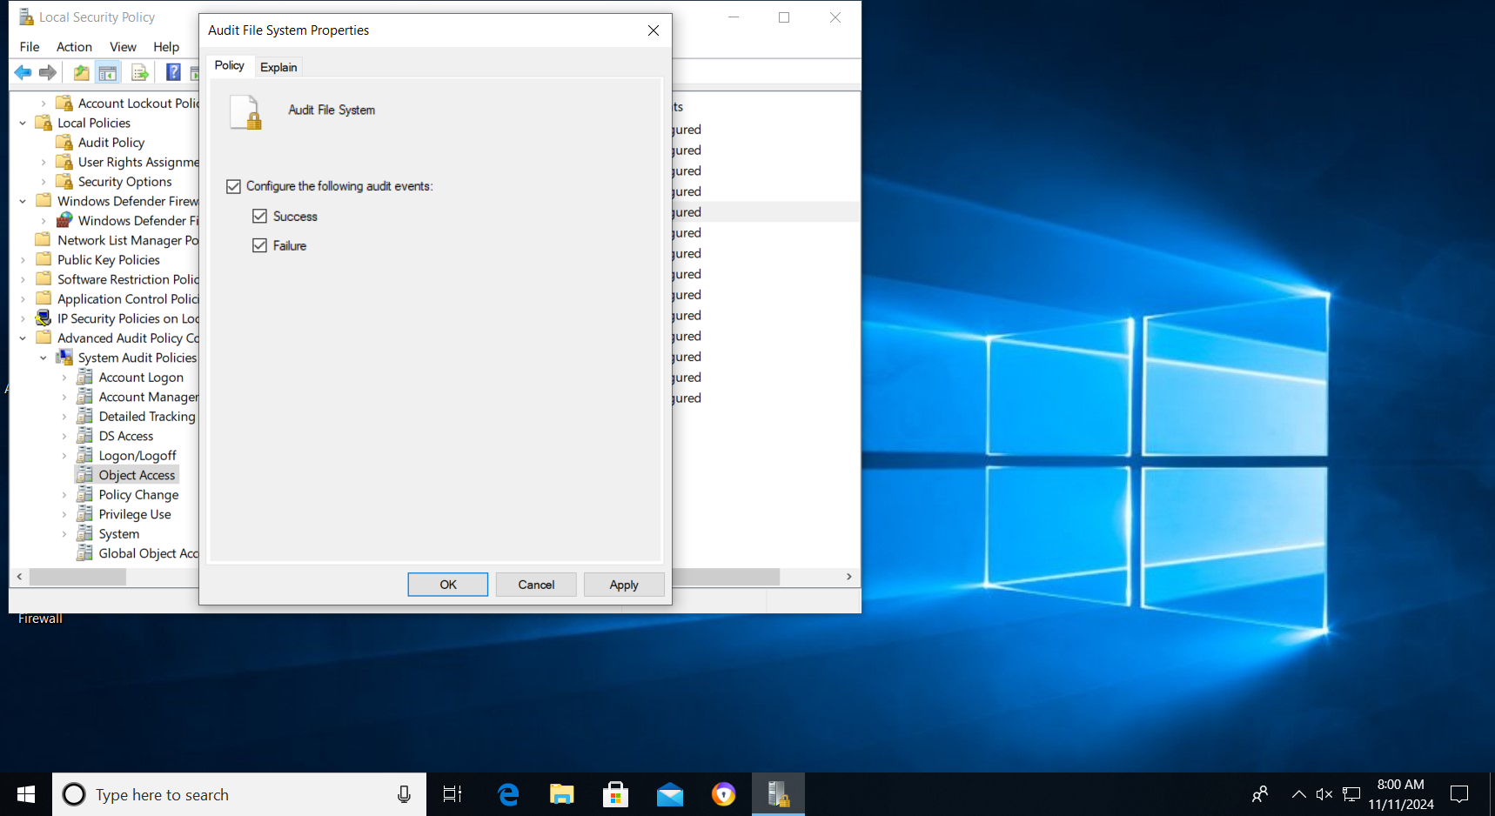
2. On the file you want to audit,right click and select ‘Properties’ e.g :’AUDIT EG’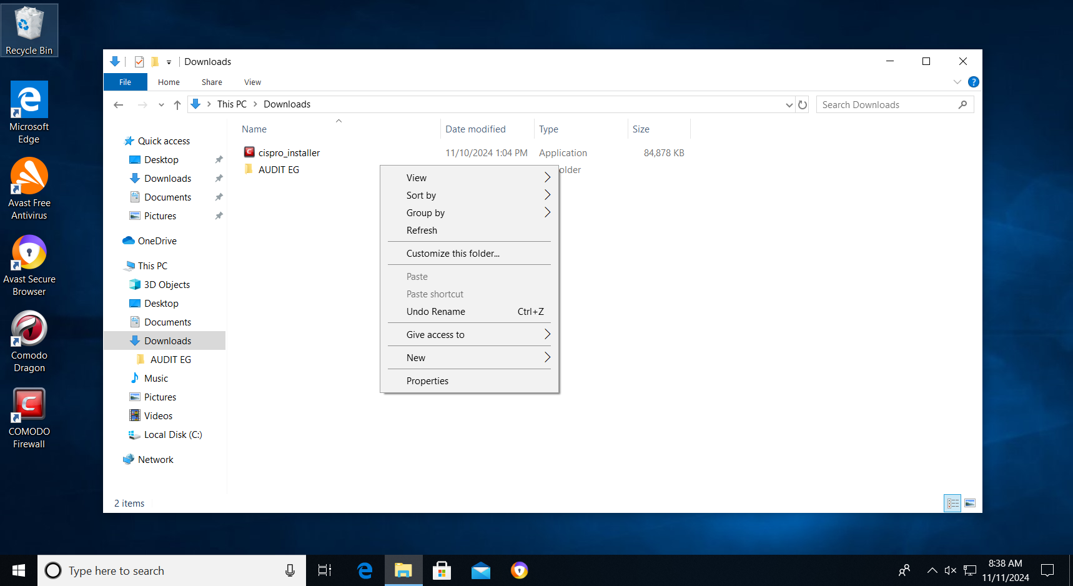
3. Go to the Security tab and click ‘Advanced’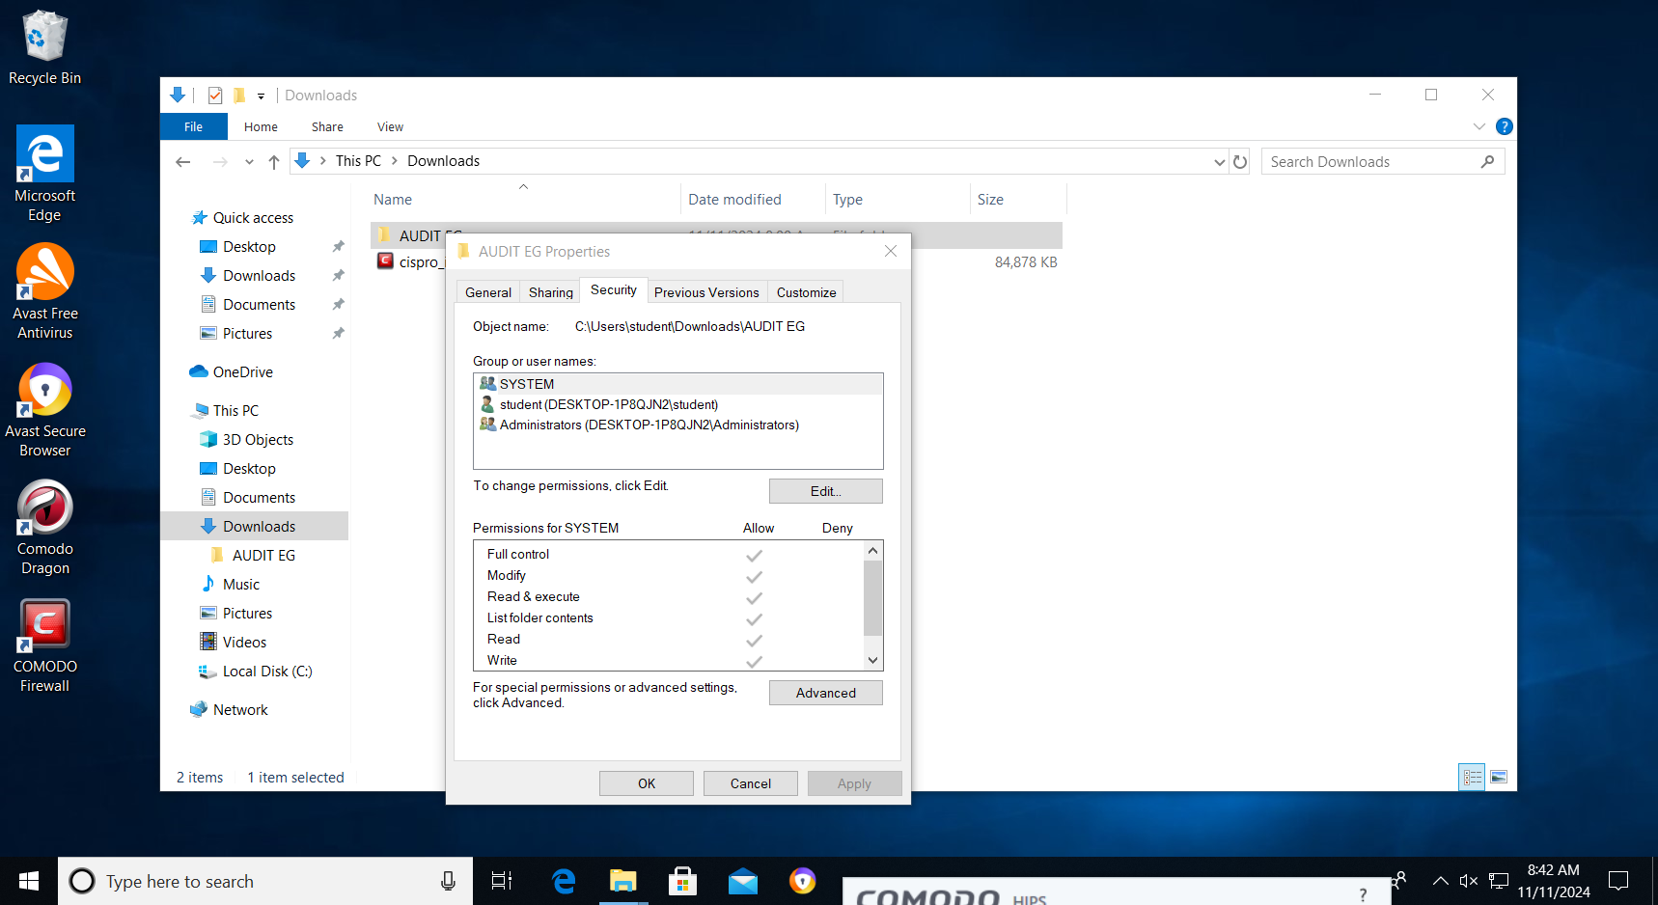
4. Click on Add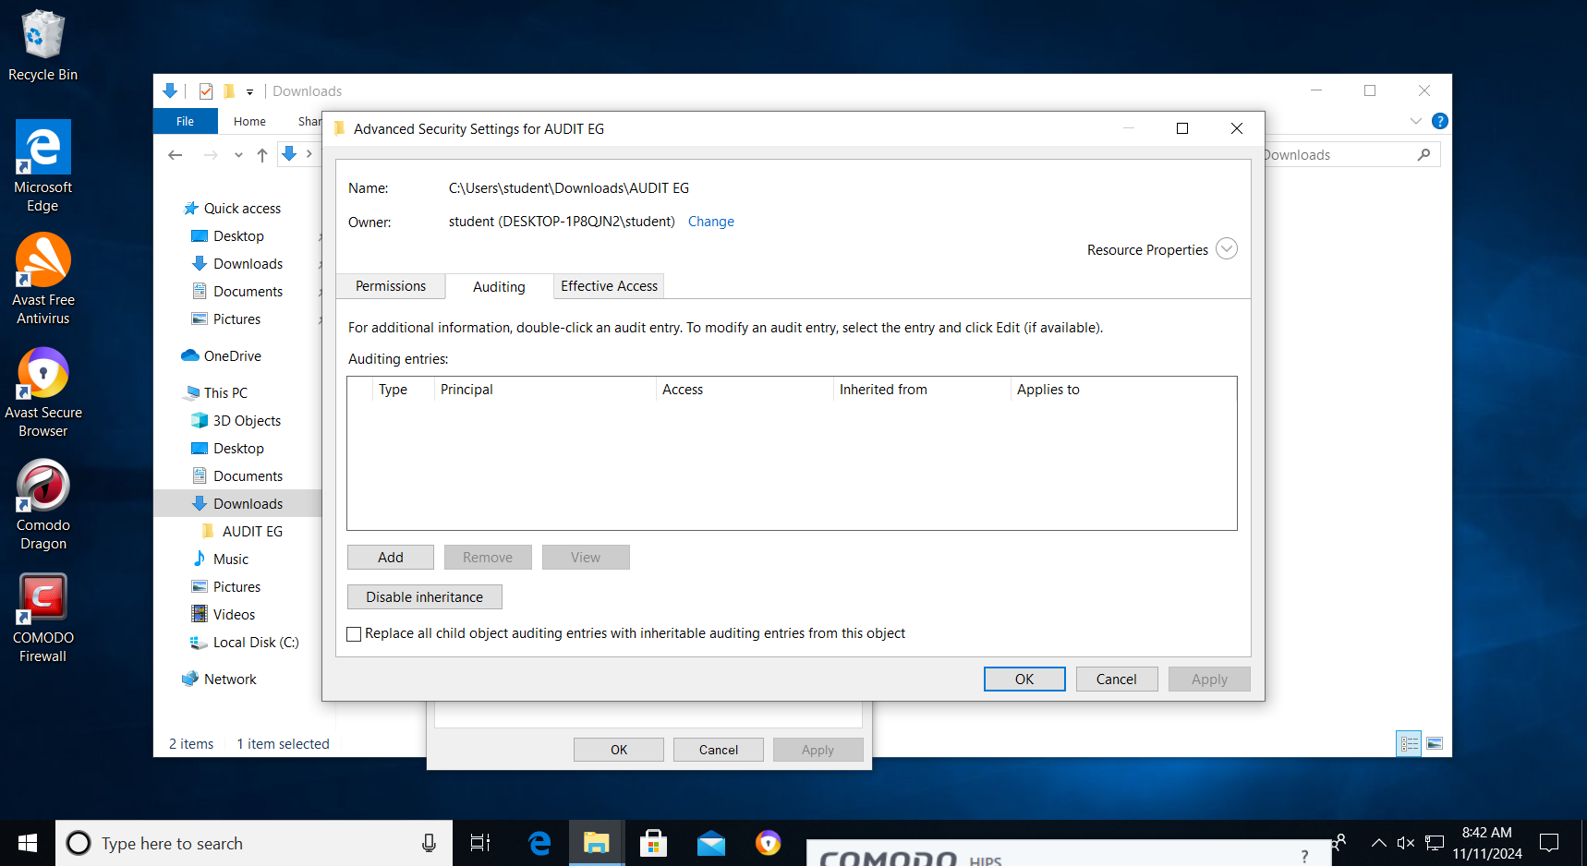
5. Click on ‘Particular groups’,then enter the object as ‘everyone’, click check names, and ok. Tick the boxes you want to audit.E.g-Read, Write and Modify, and Click ok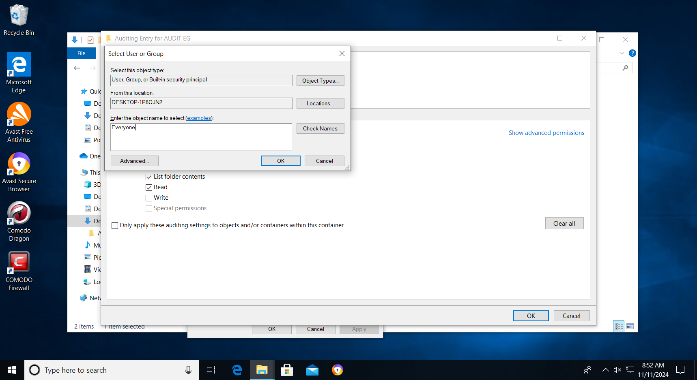

**CHECK FOR AUDIT**

1. Press Win + X and select Event Viewer.

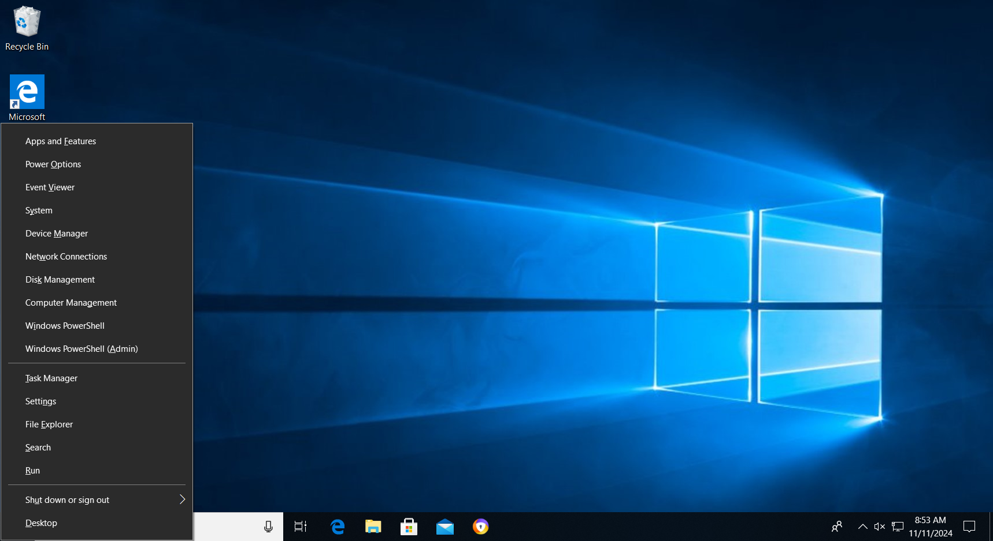

1. In Event Viewer, navigate to Windows Logs > Security. Look for event ID 4663 (Which is logged for file access attempts). You can filter the logs to only show relevant events, such as file access and modifications, to quickly track activity on sensitive data.

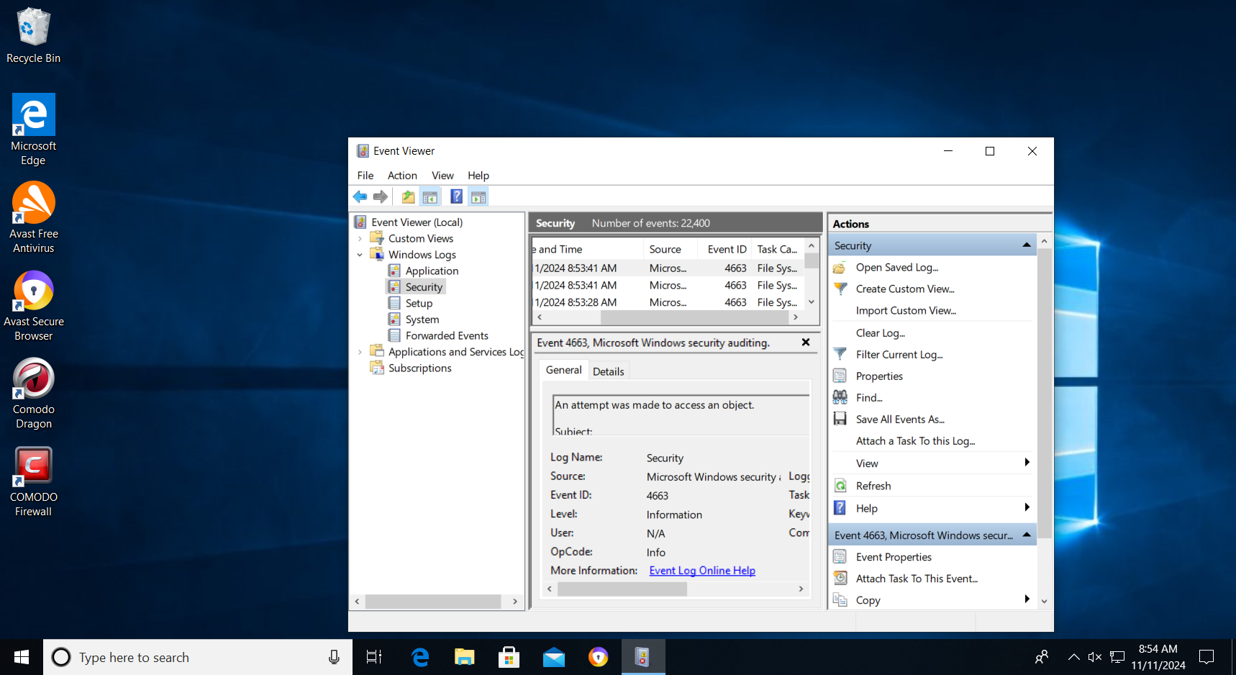

### (37) Memory Integrity (Jun Lin)

1. Windows Security > Device security > Core isolation details  
   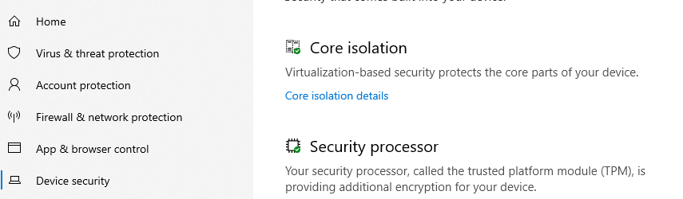
2. Switch on ‘Memory integrity’ then restart.

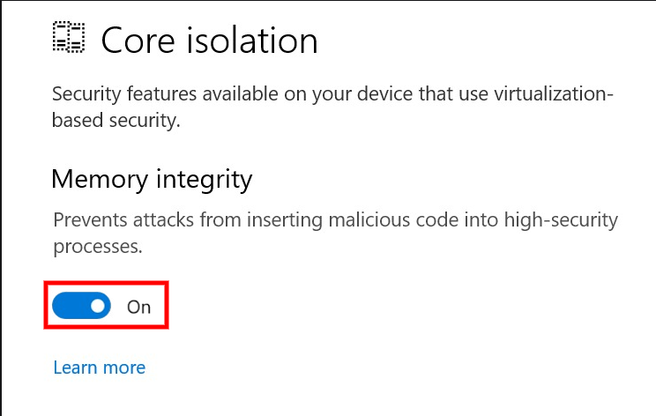

### (38) Disabling Auto login (Jun Lin)

1. Open Registry Editor

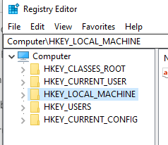

1. Navigate to this path: HKEY_LOCAL_MACHINE\SOFTWARE\Microsoft\Windows NT\CurrentVersion\Winlogon

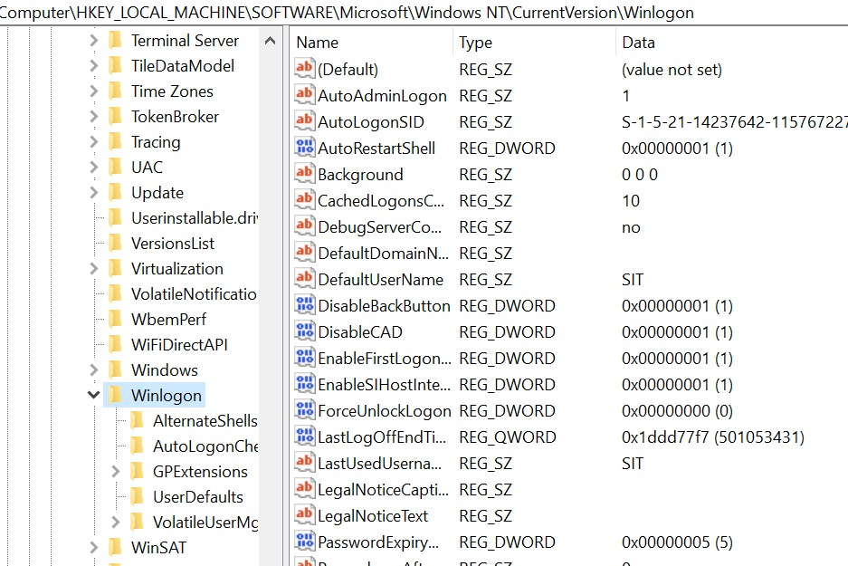

1. Double Click on AutoAdminLogon

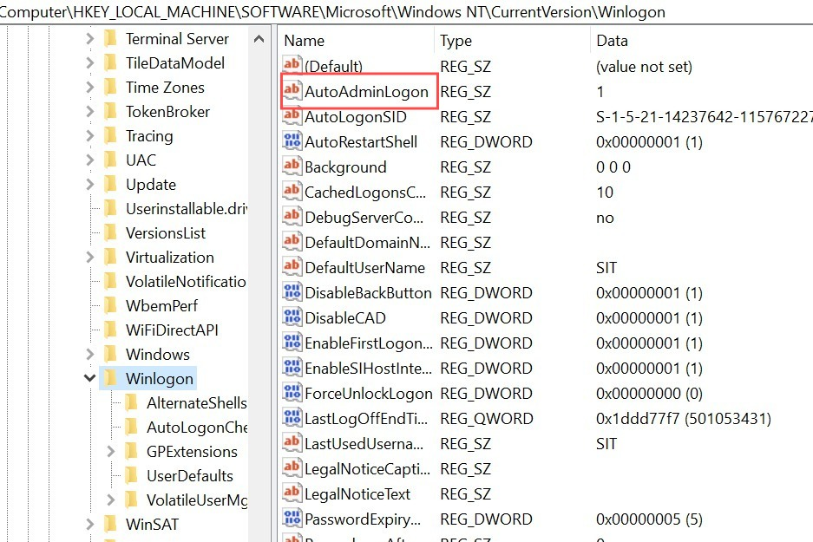

1. Change the value to 0  
   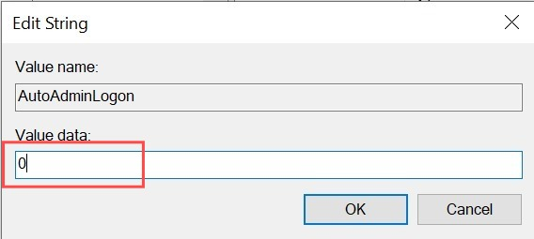
2. Double Click on DefaultUserName

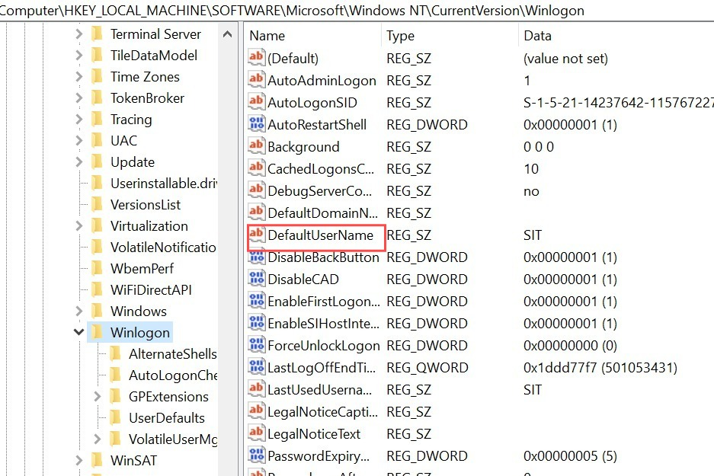

1. Clear the value so it is blank

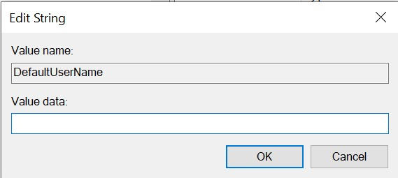

1. Repeat steps 5 & 6 on DefaultDomainName

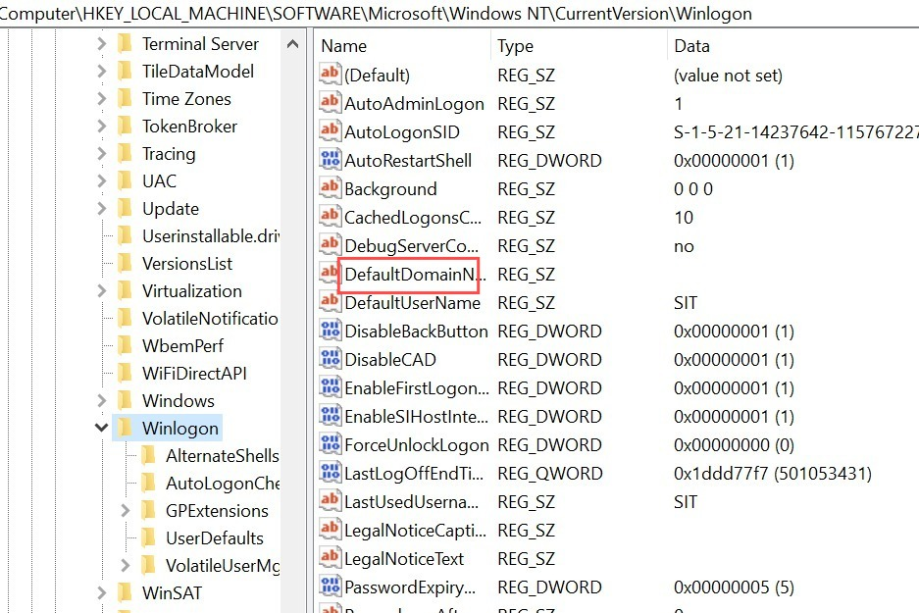

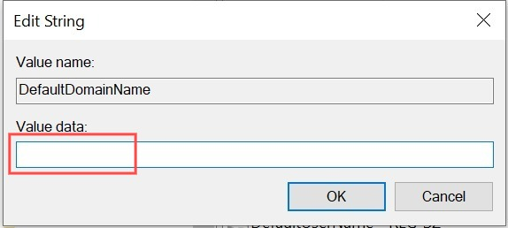

# _END